**Question 1). What is your business venture about and also mention your target market. ?**

**Answer 1).**

**What is your business venture about?**

My business venture is about an unbiased financial education website [www.financialgyan.in](http://www.financialgyan.in), the purpose of the website is educating investors online about the entire process of investment life cycle, making them understand the importance of Financial Planning and Wealth Management. We will also provide investors unbiased information about various financial products in a simple and concise manner. The world is fast embracing the concept of FINTECH, which is a marriage of Finance and Technology. Its therefore important to use technology in reaching out to people to make them understand the concepts of finance.

**What is your target market?**

The target market for our website www.financialgyan.in would be as under:

Age: 20-70 years

Location: India.

Sex: Unisex.

Education: Minimum Graduate (any stream).

Occupation: Fresh graduate/ working professional/ close to retirement/retired

**Question 2.) Define your business objective in under 50 words.**

**Answer 2).** The objective of our business is to be a one stop information about all the information needed to an investor during his investment life cycle. We wish to provide information about the entire Financial Planning Process like Cash Flow Management, Debt Management, Goal Setting, Insurance Planning, Tax Planning, Estate Planning, Investment Planning, we will also provide information about various investment products.

**Question 3.) Create the Buyer’s persona as per the template shared (HubSpot).**

**Answer 3.)** Our target audience has been mentioned above, the buyer’s persona for the targeted audience will be as mentioned below:

We have divided our target audience further into three category which is:

20 years to 40 years old

41 years to 60 years old

61 years to 70 years old

The buyer’s persona of the above three categories with respect to the target audience already mentioned above will be as under.

|  |
| --- |
| 20-year-old to 40-year-old |
| Objective: collecting information as they are new to the field and open to investing online. Because they are young can invest major portion in equity or equity mutual funds. |
| Active on social media |
| Active on smart phones |
| Impulsive buyer |
| Easily embraces technology |

|  |
| --- |
| 41-year-old to 60-year-old |
| Objective: Have good knowledge of investments, but want to update to new financial products like mutual funds and stocks, cautions on investing online. Partially invest in equity/ equity mutual funds and partially in debt. |
| Partially social media presence |
| Active on laptop and desktop |
| Detail oriented and thoughtful buyer. |
| Needs some handholding in embracing technology. |

|  |
| --- |
| 61-year-old to 70-year-old |
| Objective: Have invested all their lives, wish to keep track on changes in tenure and interest rate of investments, primarily 100% investors in fixed deposits and debt investment |
| Partially social media presence |
| Active on laptop and desktop |
| Detail oriented and thoughtful buyer. |
| Resistant to technology, comfortable with paper investments. |

**Question 4) What will be the Go to market strategy? (Describe the idea to execution with different promotional channels etc.?**

**Answer 4)** The go to market strategy for our educational website www.financialgyan.in will be to position the website as the preferred site for financial education in India. We will do this by having experts like Management Graduates and Certified Wealth Advisors Working with us. They have first-hand knowledge about all the financial concepts like Financial Planning and Wealth Management and also all the requisite knowledge about various investment products. We will also have inhouse team of technical experts so that our website has maximum up time and the load time of the website is minimal.

We will promote our website thru various mediums both conventional like newspaper, paper flyers and also thru digital mediums like laptop/desktop and mobile phones. With help of our inhouse team will create content as per requirement of our target audience. Then we will develop a website using WordPress and upload the necessary content. The website will the periodically update. We will also be doing Search Engine Optimization of our website so that that it appears in first page of google search. We will also use social media channels like Facebook, LinkedIn, twitter and YouTube to create our advertisements on these channels, these channels help us to target to a specific customer segment that will find our course appealing.

**Question 5) How will you use digital marketing for your business?**

**Answer 5)** Digital marketing will be at forefront in our strategy to market our services as Financial Information Website. Digital marketing encompasses various specialised approach to the solution, such as:

**Content Creation, Website Development and SEO:**

We will start with content creation and then move to website development, once website is developed, we will use our On page SEO and off page SEO to drive traffic to our site. On page SEO will be done with developing great content, HTML Structure, and website architecture. Other important techniques for On page SEO include Title Tag, Meta description, Header tag, keyword placement, using ALT Image tag, and also faster page loading. The site should contain both HTML Sitemap and XML sitemap. We should not use techniques like hidden text, keyword stuffing, cloaking or anchor text repetition. We have to use OFF Page SEO using social networks like Facebook, LinkedIn, YouTube, blogs, online articles etc to get traffic on our site. We also need to tie up with other education/financial and youth centric website to get back links to our site. We will also have lead capture facility on our website

**AdWords:**

We will be using google AdWords to develop search and display campaign for our website, for this we will have to do good keyword research and proper targeting for users to be directed to our website from google network.

**Facebook:**

We will create a Facebook page for our website, we will add content on this page and also add our logo and other pictures. We will also create a advertisement using Facebook and run it as Facebook campaign, with the help of this advertisement, targeted users will be directed to our website and be our customers.

**YouTube:**

We will make a video about our website, this video has to be short and concise, we will upload this video on YouTube and then run a AdWords campaign for this YouTube video, as users see our advertisement on YouTube, some of them will click on the link and visit our website and by this way we can create awareness among targeted audience about our service offering.

**Mailchimp:**

We will be using the email services of MAILCHIMP, we have set up a lead capture facility on the website, to this lead list we will send email campaign, informing them about our services, the email should be email and concise, we will provide link on the email for the user to be directed on our website. We also have facility in MAILCHIMP to see the reporting.

**Google Analytics:**

After running our campaign thru various digital mediums, we will analyse our data on google analytics with respect to various parameters like gender, age, location, device, geography, demography, funnel, bounce rate, new sessions, and many such parameters, this analysis will help us target our customers more precisely or help us make changes on our website content. Also google analytics will also help us track our goals and will get to know how many goals have we achieved using various digital marketing channels.

**2.**

**Submit of all the properties created:**

**Website:**

[**www.financialgyan.in**](http://www.financialgyan.in)

**Facebook Page:**

**Financial Gyan:** [**https://www.facebook.com/Financial-Gyan-230025174152420/?ref=aymt_homepage_panel**](https://www.facebook.com/Financial-Gyan-230025174152420/?ref=aymt_homepage_panel)

**Youtube Video:**

**Financial Gyan Video:** [**https://www.youtube.com/watch?v=NVSg83jjWCI**](https://www.youtube.com/watch?v=NVSg83jjWCI)

**PROJECT 1:**

**Going to the Market:**

**PART 1:**

The website [www.financialgyan.in](http://www.financialgyan.in) is built using wordpress, some of the screen shot of the website are posted here, rest can be seen on live website. Only two slides are shown, other are self explanatory.

**BASICS OF FINANCIAL PLANNING:**

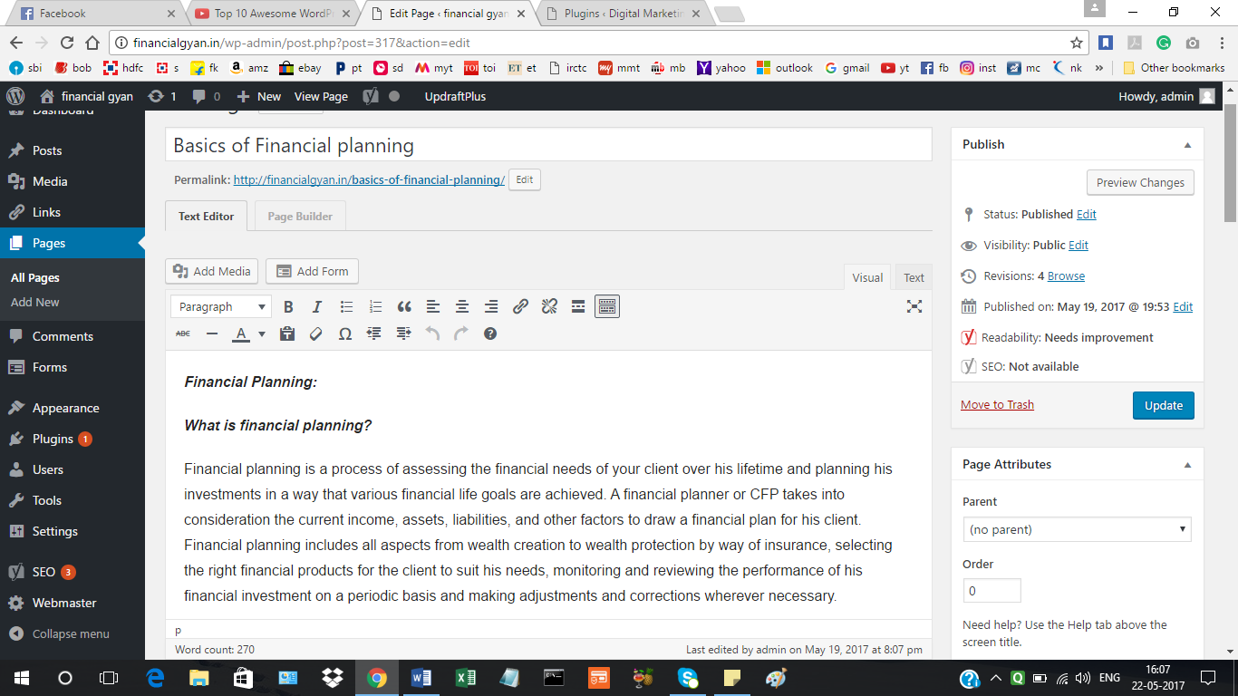

RBI BONDS:

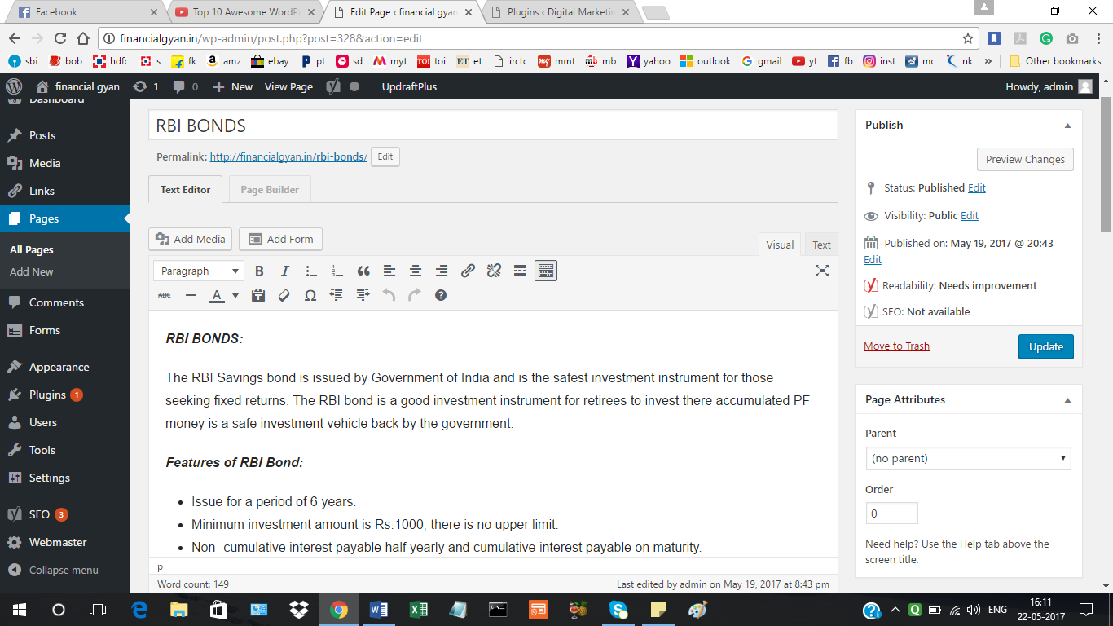

LEAD CAPTURE ON WEBSITE: CONTACT FORM:

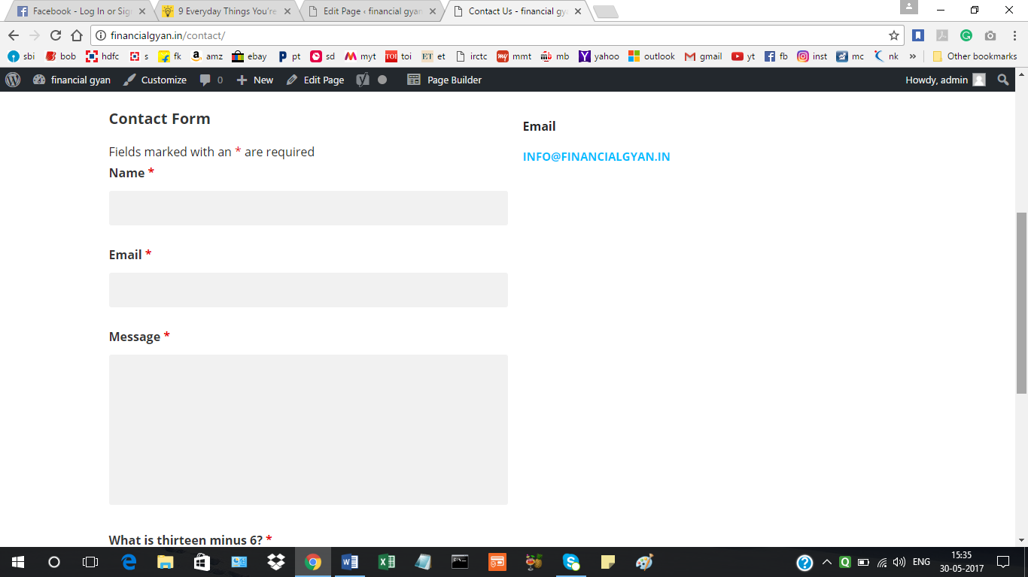

LEAD CAPTURE ON WEBSITE: EMAIL SUBSCRIPTION FOR NEWSLETTER

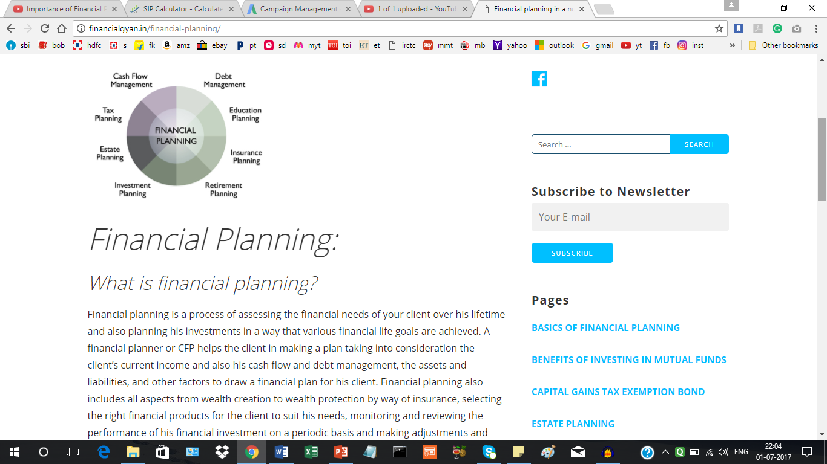

PART 2 of Project 1: two pages are shown, other are self explanatory

ON PAGE SEO OF BENEFITS OF MUTUAL FUNDS PAGE:

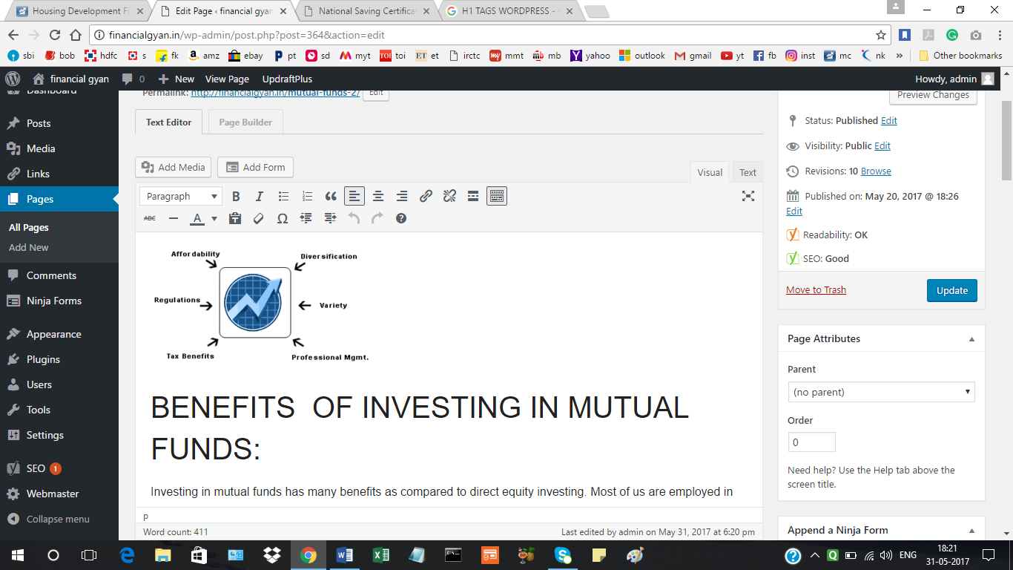

ON PAGE SEO OF FINANCIAL PLANNING PAGE:

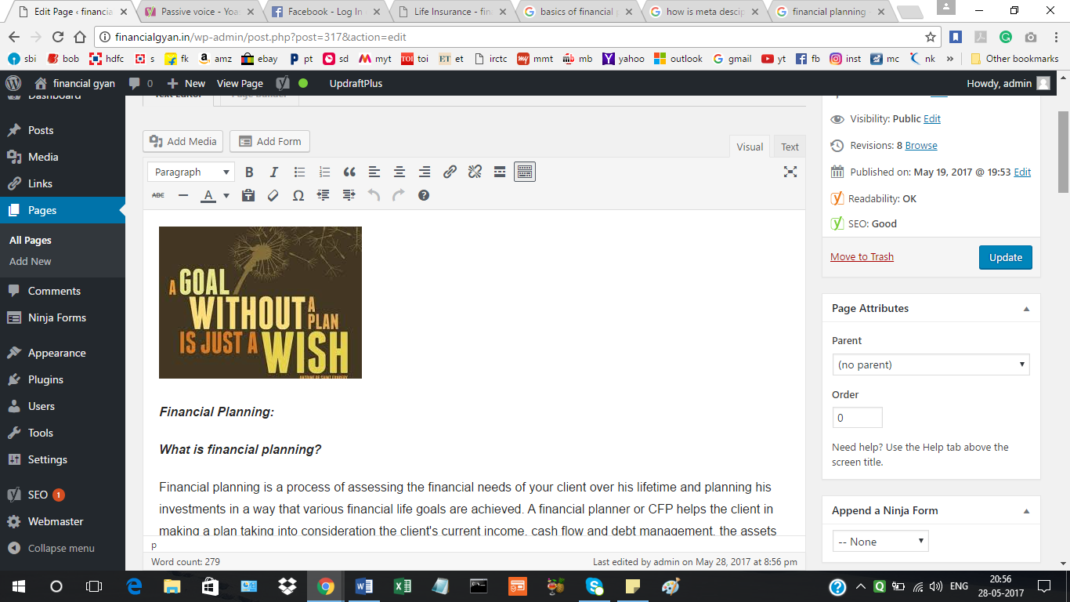

KEYWORD RESEARCH AND ANALYSIS tool KWFINDER was used to find matching keywords for mutual fund search:

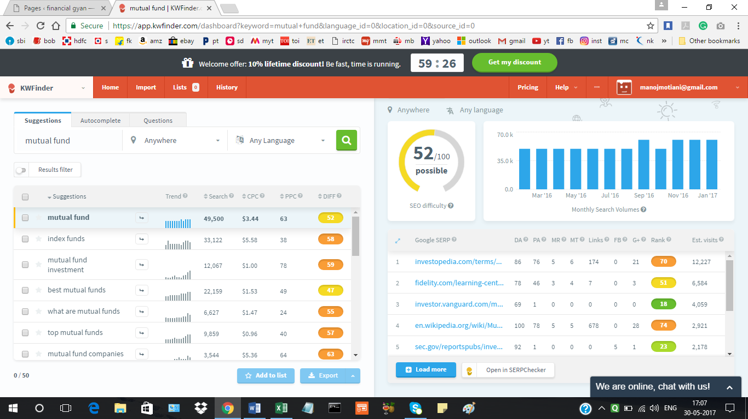

Appropriate page titles:

Basics of Financial Planning:

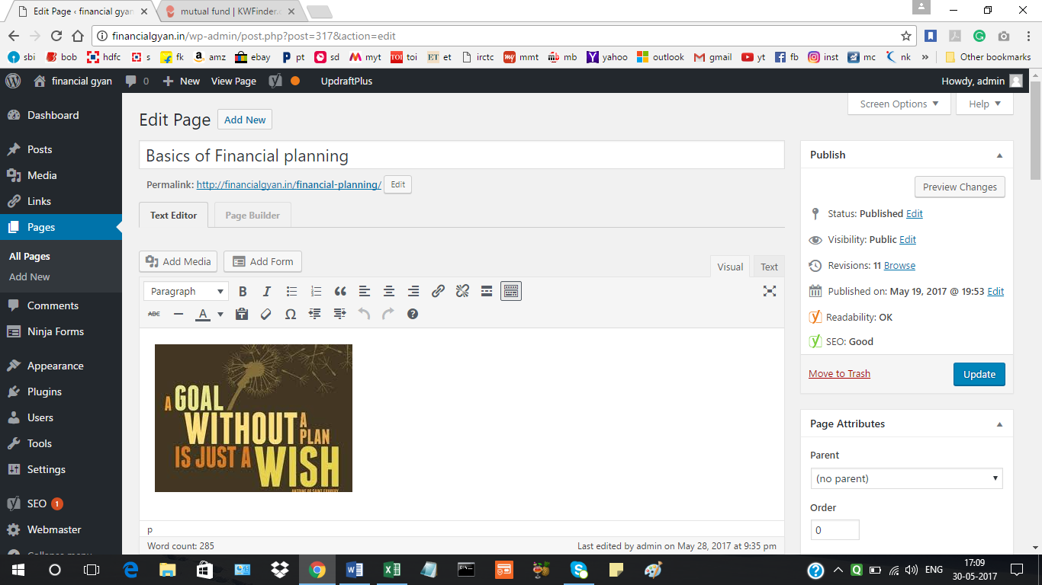

Capital gain tax exemption bond:

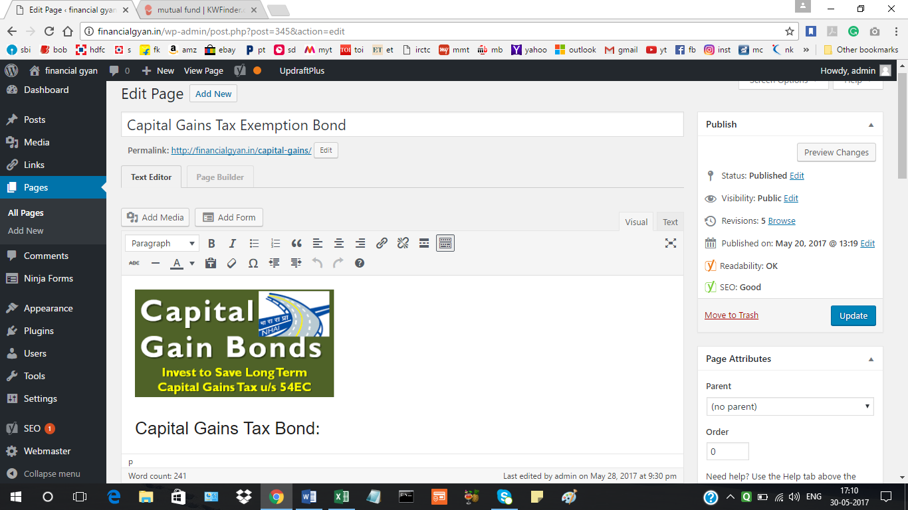

Other page titles are self explanatory

Title, meta description, h1tag, image alt tags:

SEO title and meta description of Financial Planning Page:

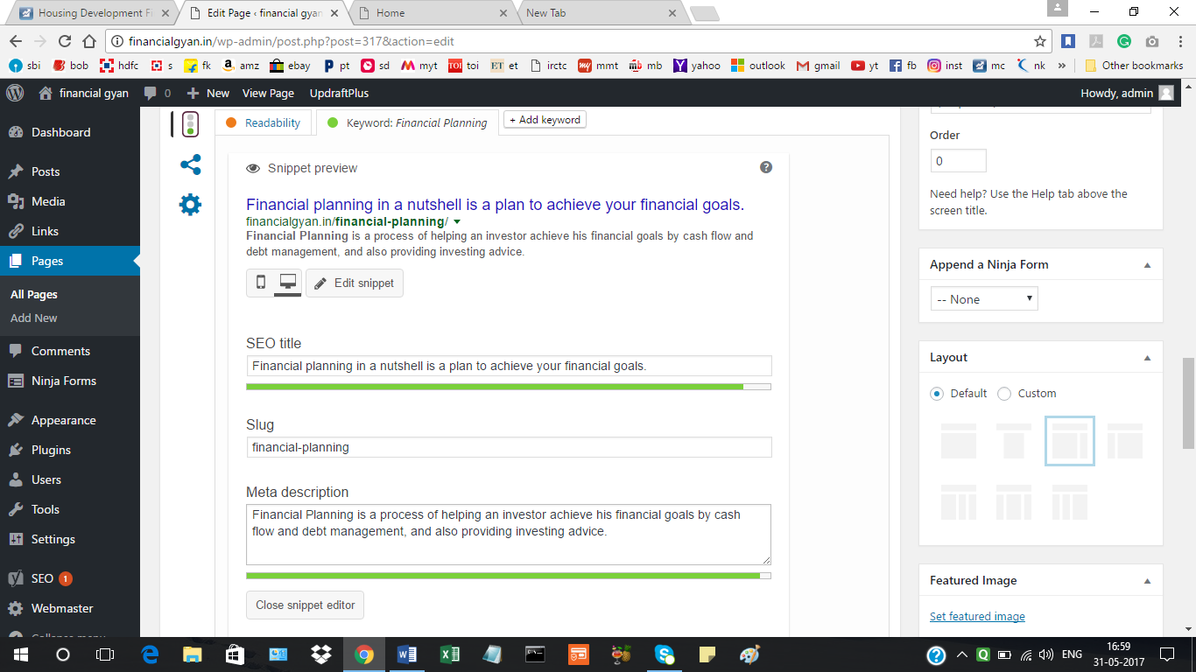

SEO title and meta description of Capital Gain Tax Exemption Bond:

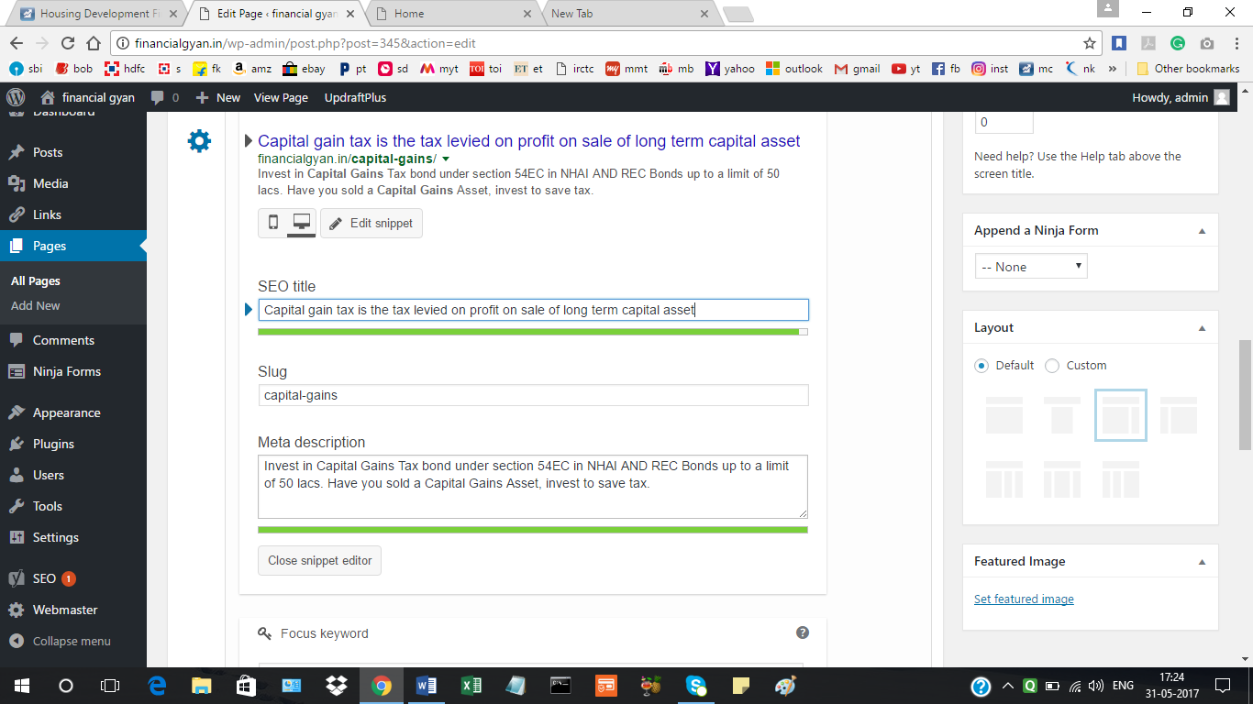

H1 TAG OF NATIONAL SAVING CERTIFICATE PAGE:

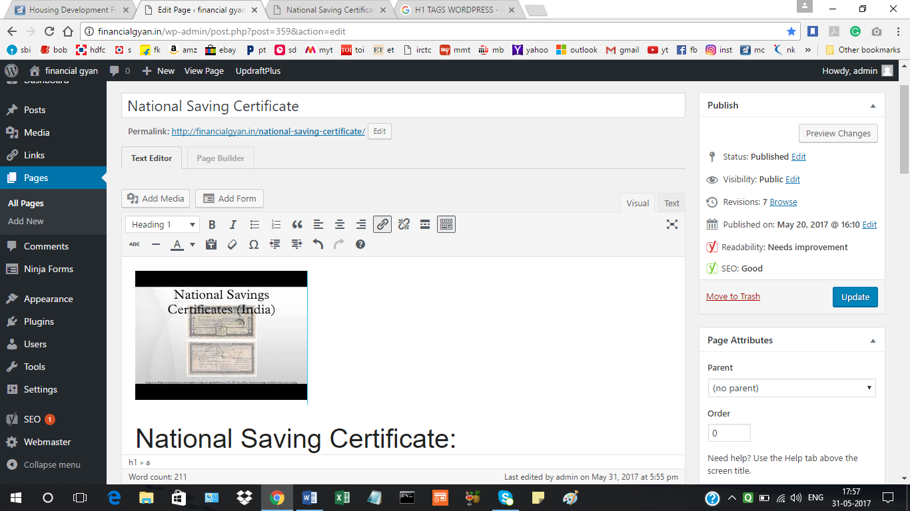

H1 TAG OF FINANCIAL PLANNING PAGE:

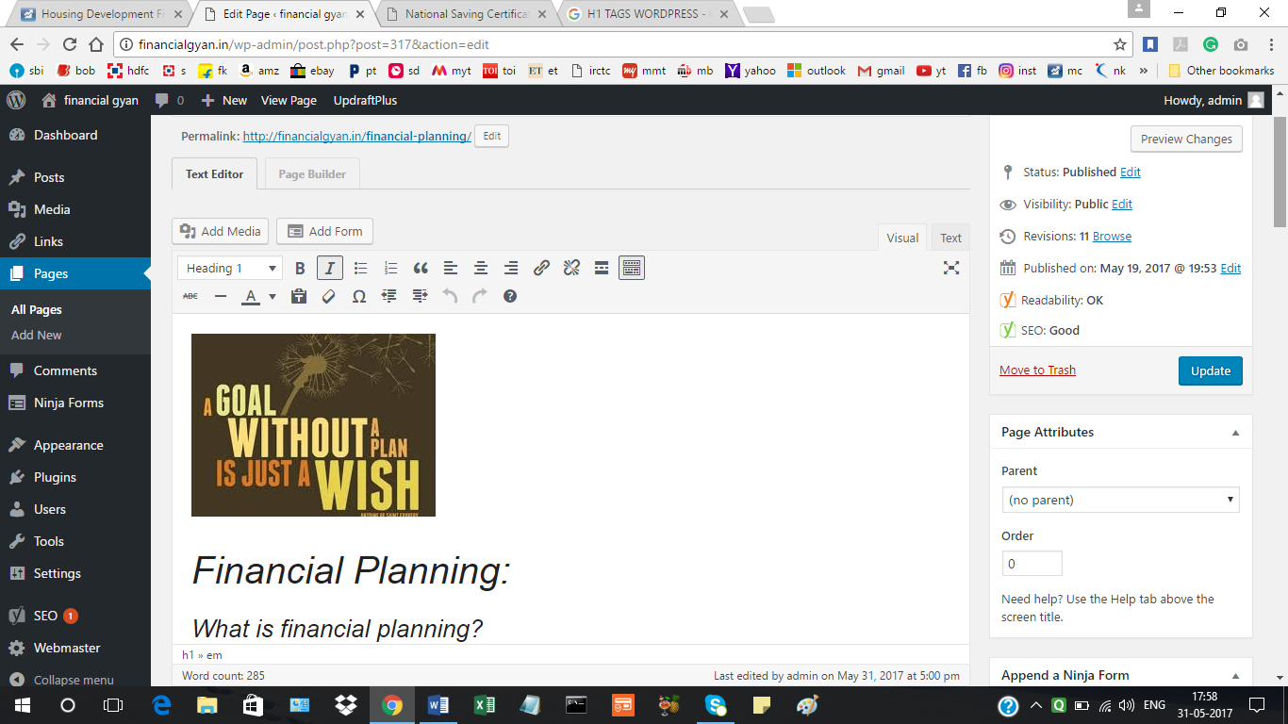

IMAGE ALT TAGS BASICS OF FINANCIAL PLANNING PICTURE:

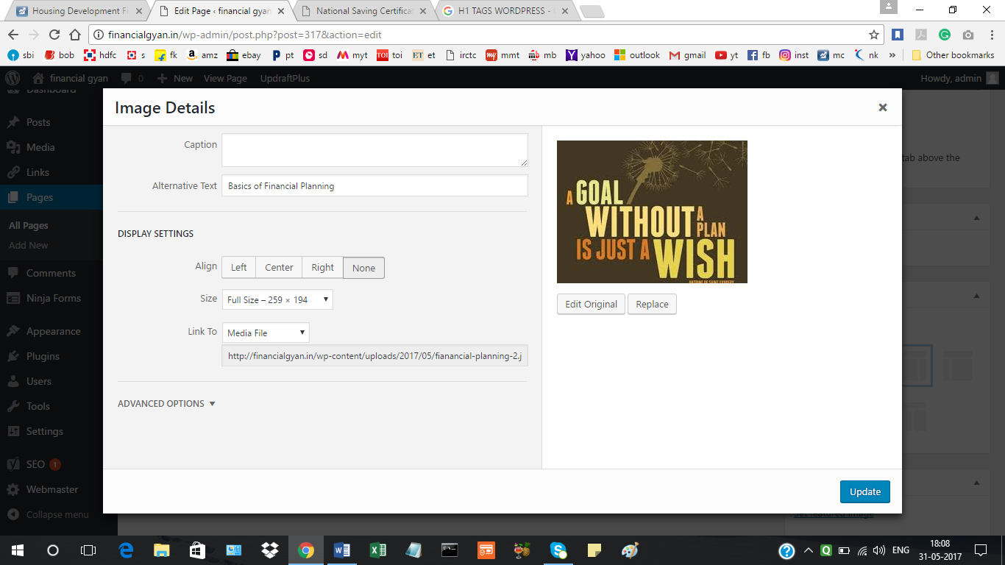

IMAGE ALT TAGS OF CAPITAL GAINS TAX BOND PICTURE:

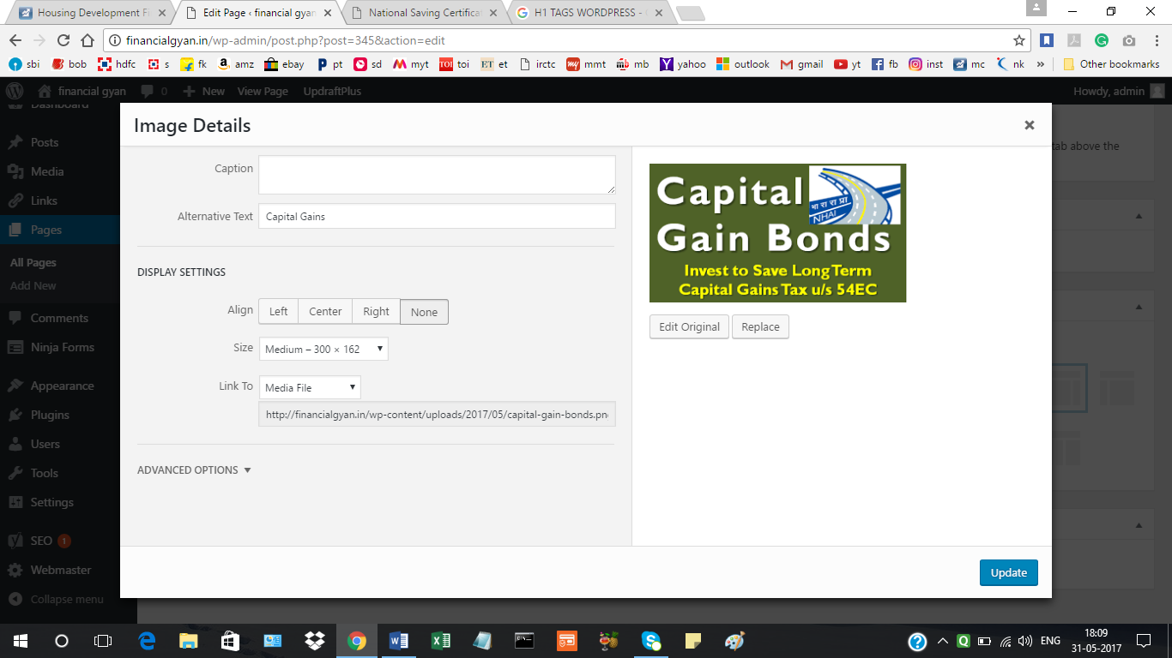

**PART 3 OF PROJECT 1:**

The slide below is for uploading the html file generated in google webmaster’s, this file is uploaded the root directory, public_html in file manager at cpanel.

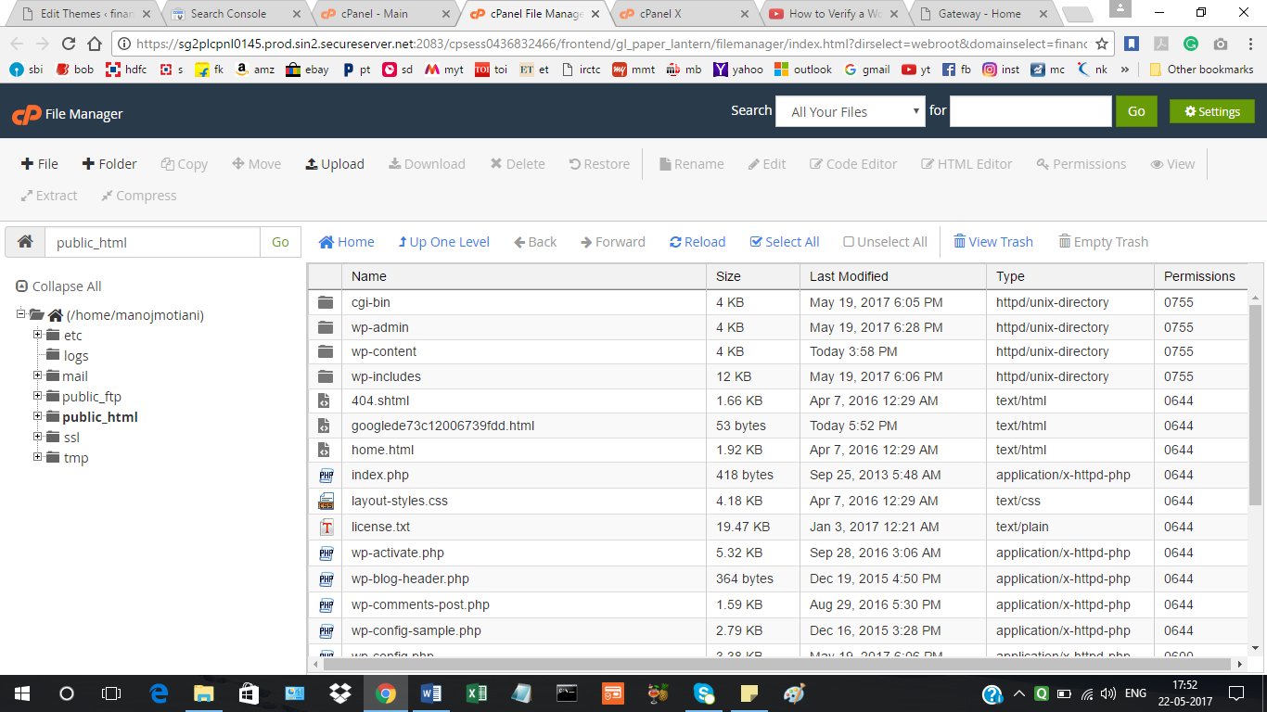

The below slide shows that the site has been verified by google webmaster.

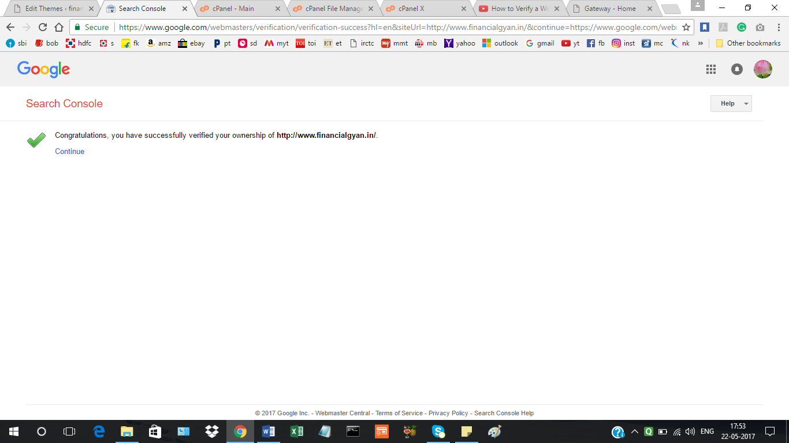

SET UP of google analystics (GA) and GA tracking code to site.

Following slide is about setting about google analytics account for the website [www.financialgyan.in](http://www.financialgyan.in)

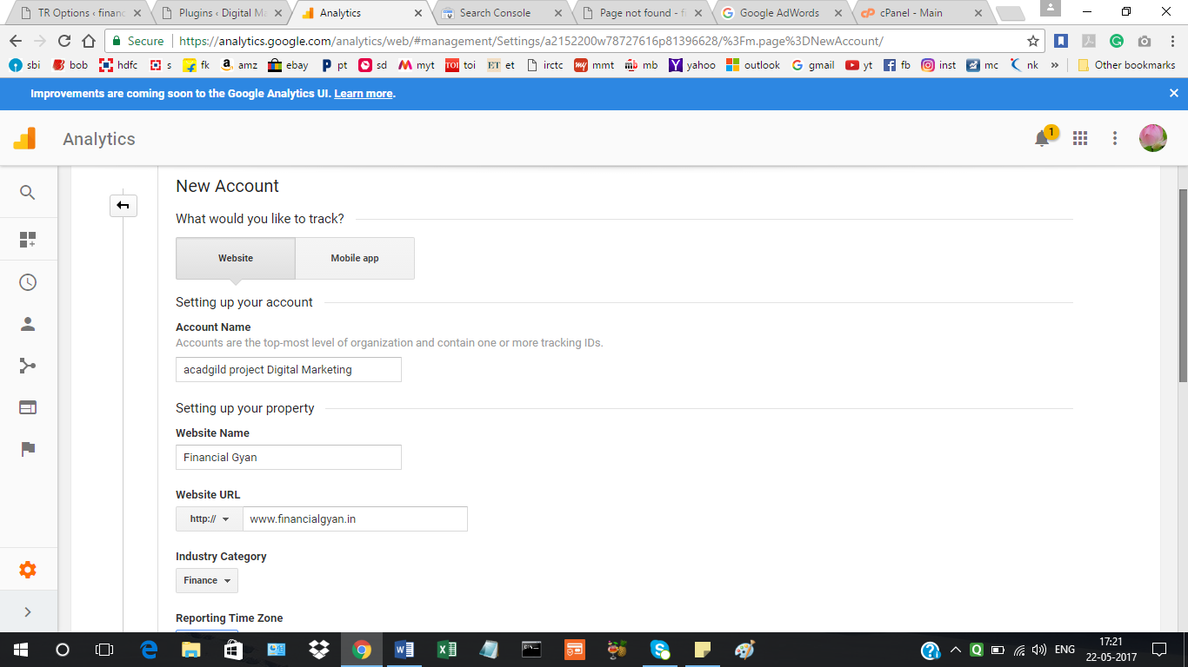

Following slide is about creating the tracking id and pasting it the google analytics plugin in wordpress.

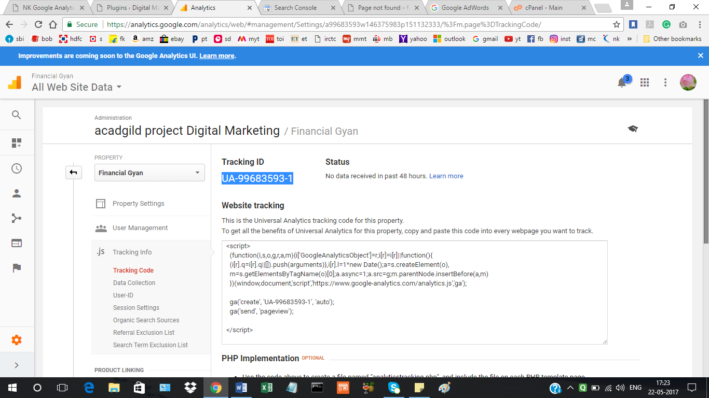

Google Analytics tracking code being inserted in Google Analytics Plugin:

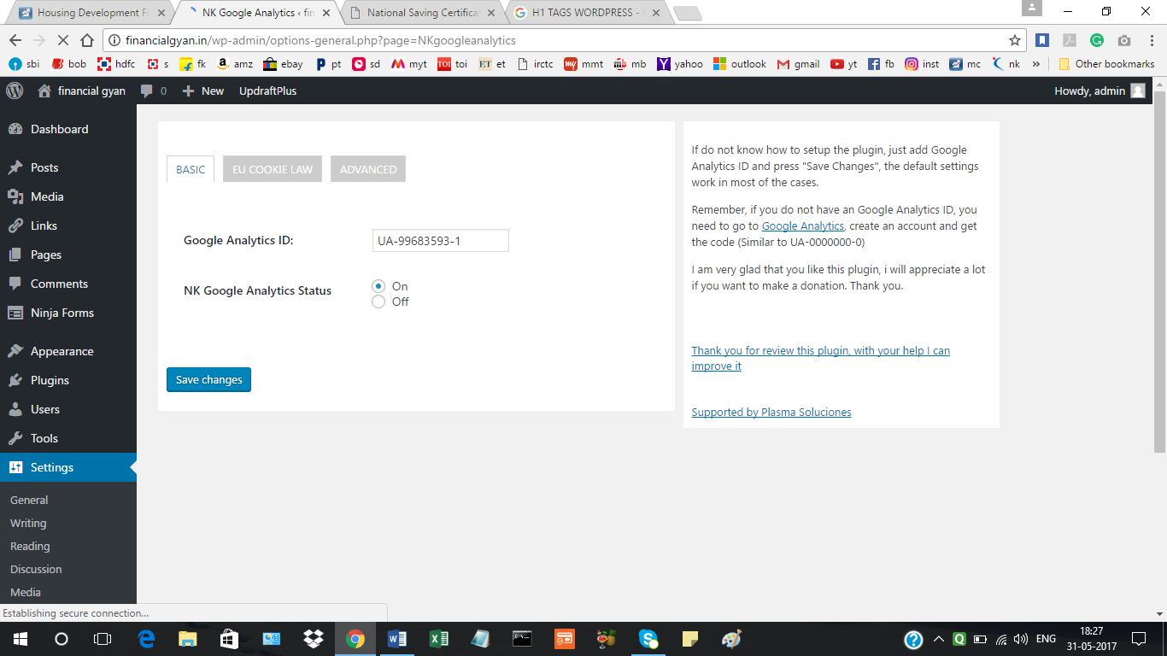

**Metrics to measure the success of the website are as under:**

1. Total number of sessions
2. Total number of users
3. Page per view
4. Page per session
5. Average session duration
6. Bounce rate
7. New sessions

The below slide is about setting up the goal, which in this case is the time spent on the site by the visitor.

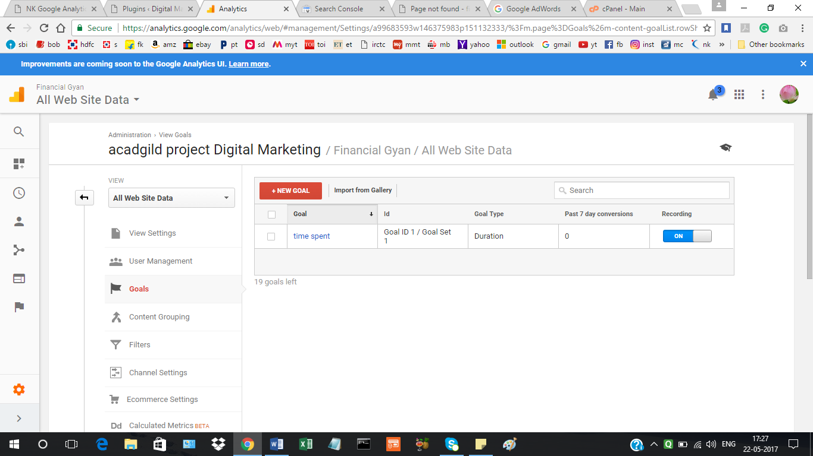

Set up of Google Adwords Account: The google adwords account was set up during the course and hence account setup screen shot was not taken that time, find below the adwords account with list of campaigns.

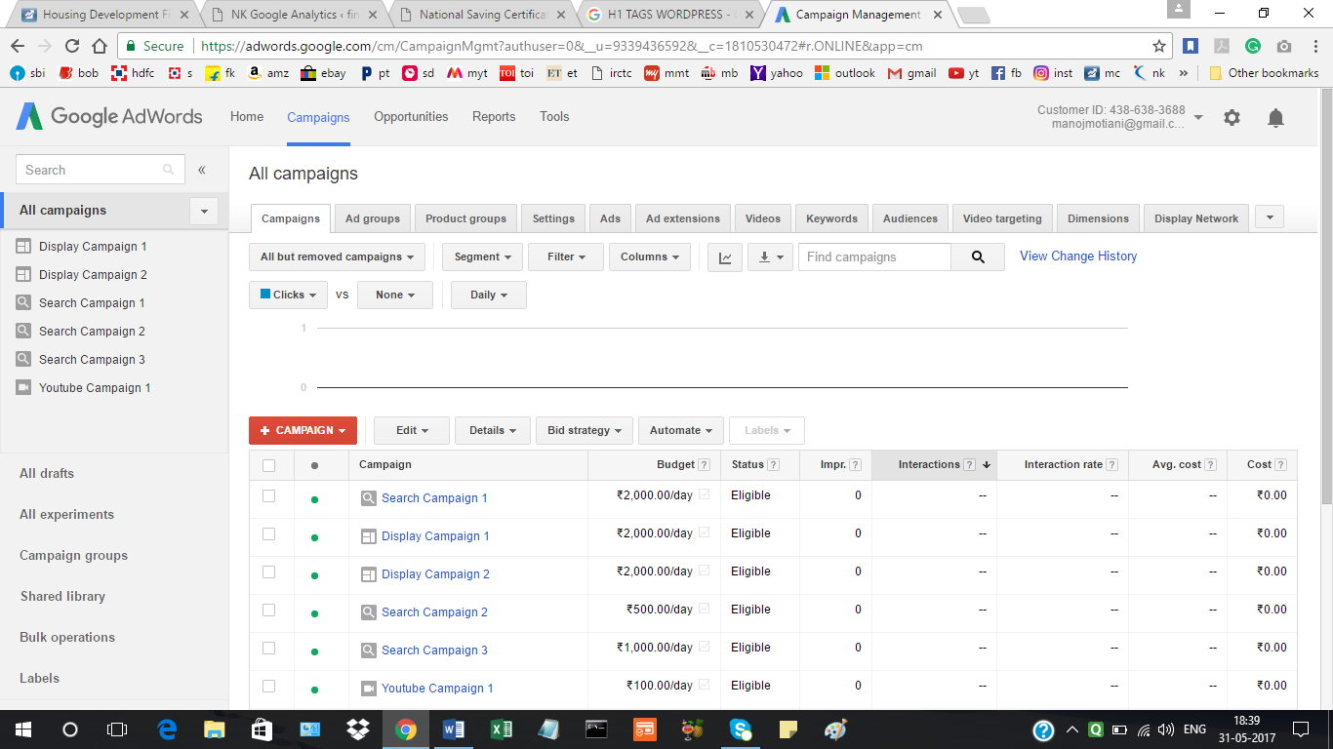

Weekly and Monthly Reporting Template:

Week 1: June 1 to June 7, 2017

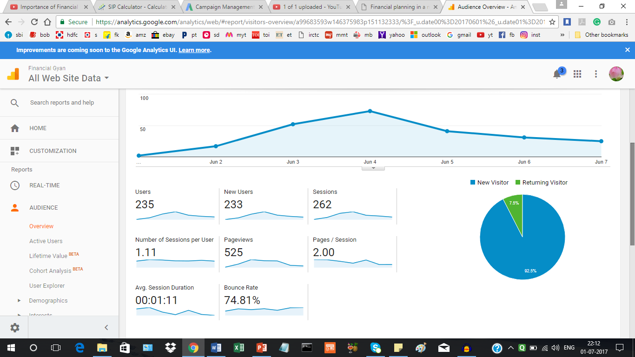

Week 4: June 25 – july 1, 2017

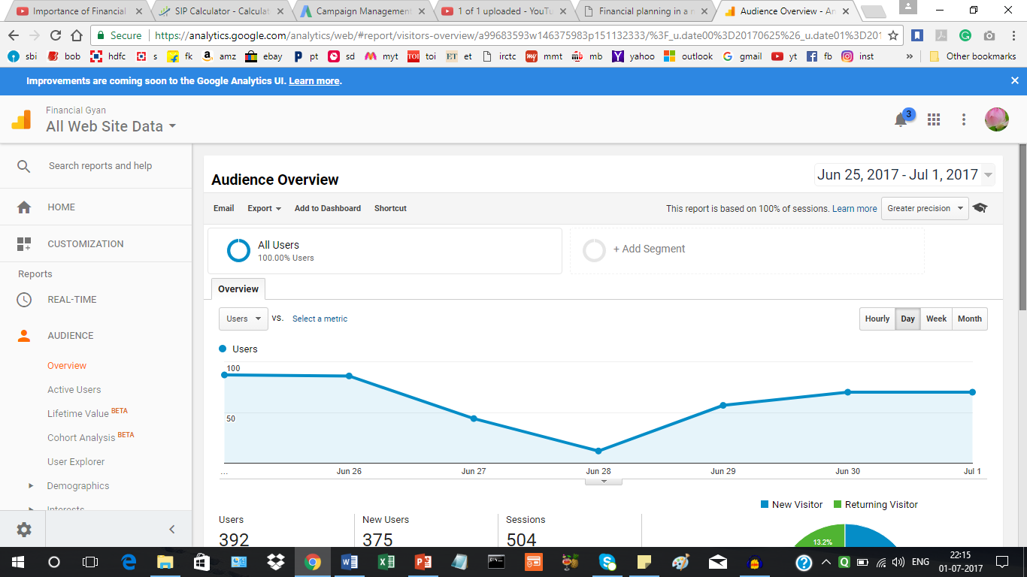

Monthly reporting template:

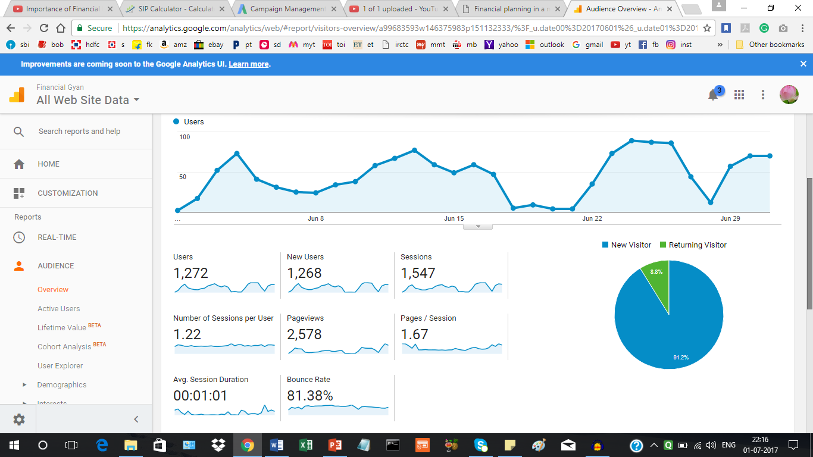

**PROJECT 2:**

**GETTING TRAFFIC ON YOUR ONLINE PROPERTY USING ADWORDS:**

**KEYWORD PLANNER:**

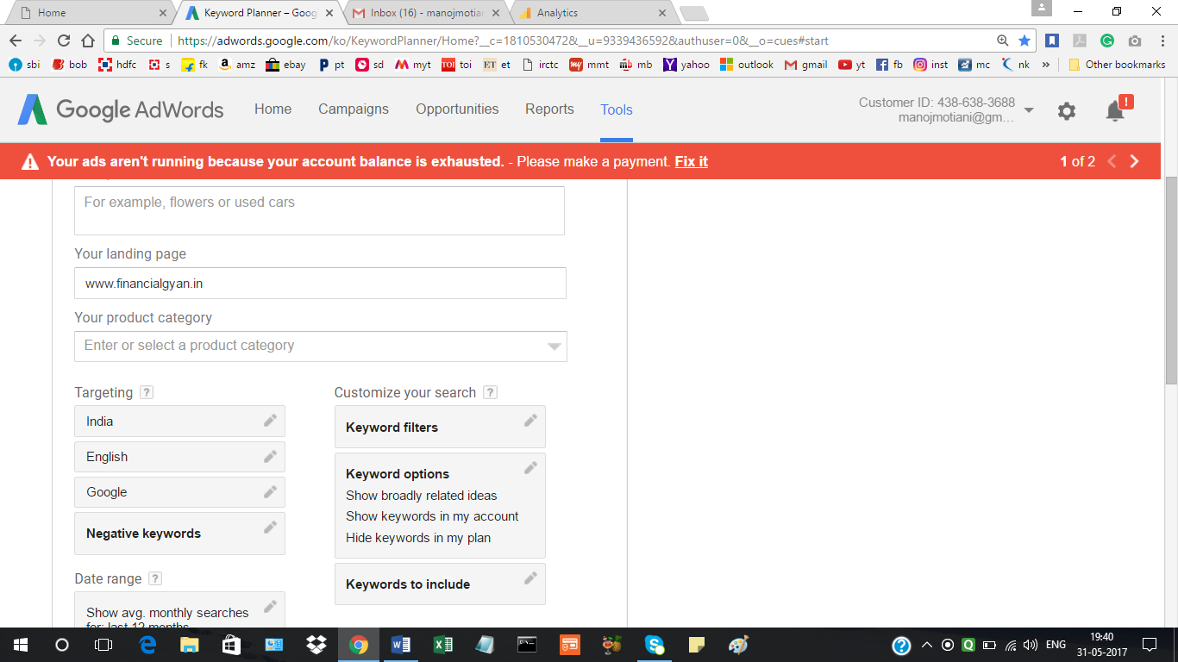

Keyword Research:

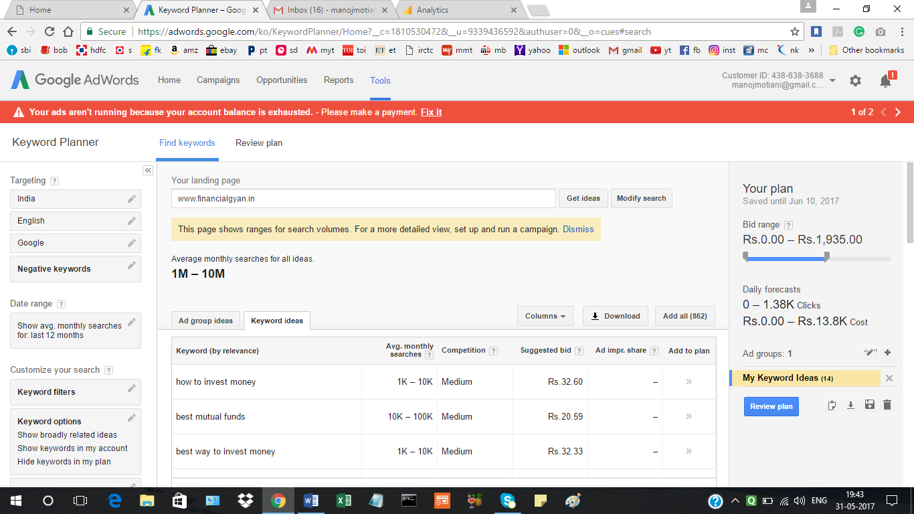+

Performance Forecasts:

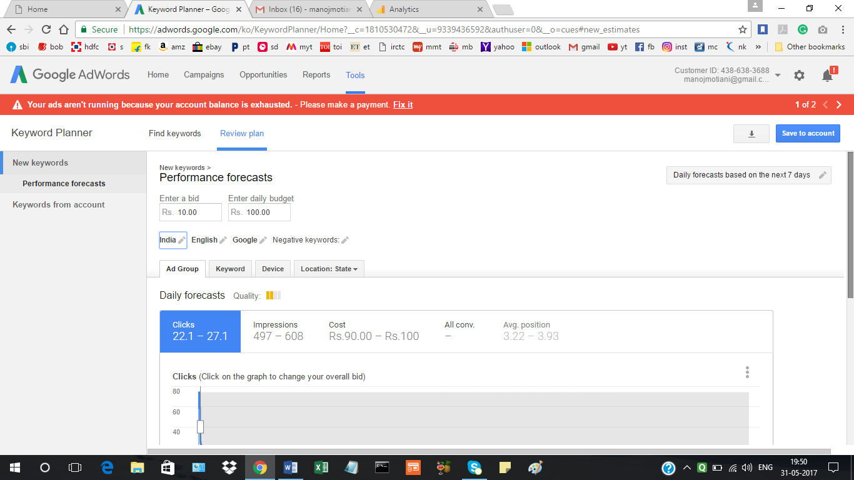

Campaing Name:

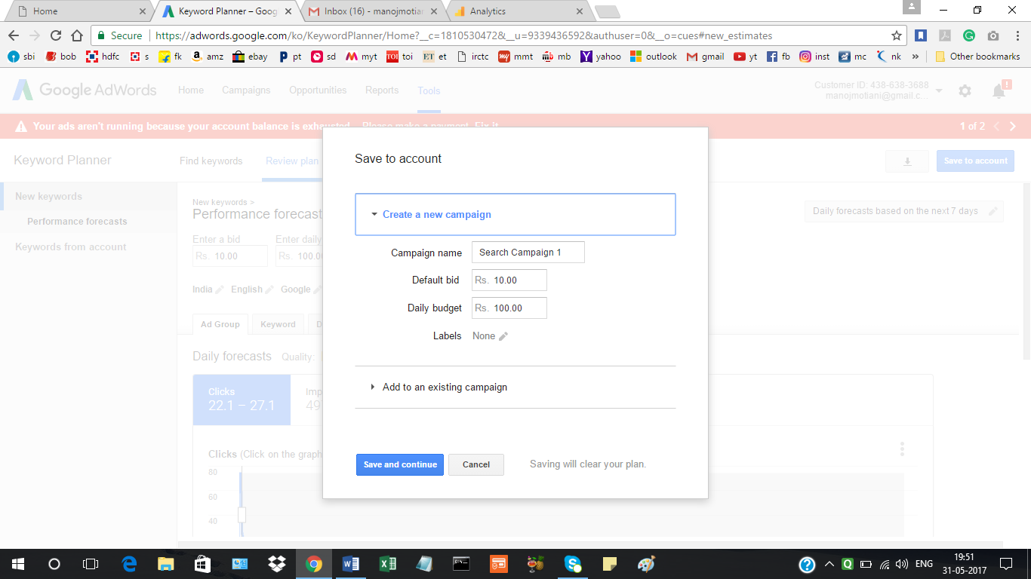

ADGROUP: financial gyan

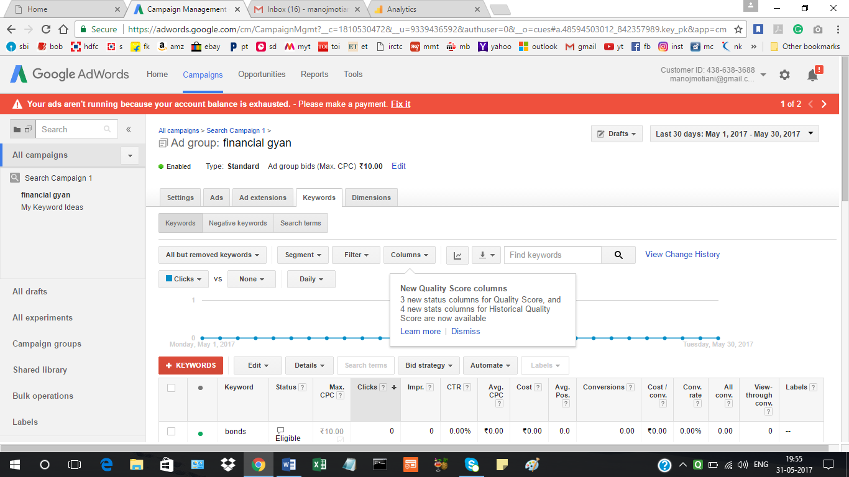

List of Keywords:

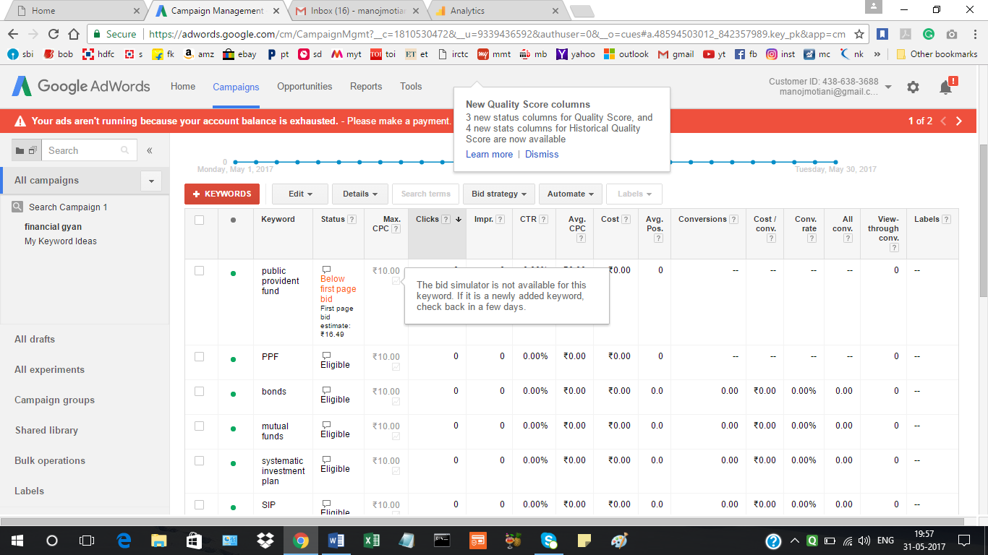

Creating the Text Advertisement:

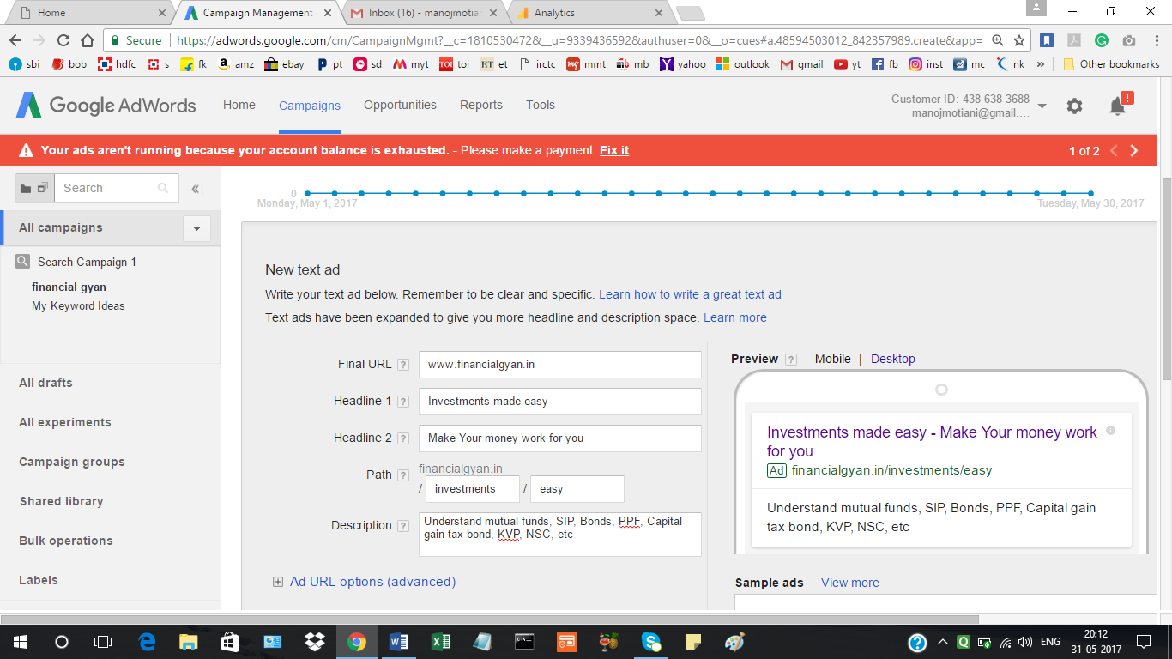

Targeting of Ads by Type, Network, Device, Location, Bid Strategy, and Budget:

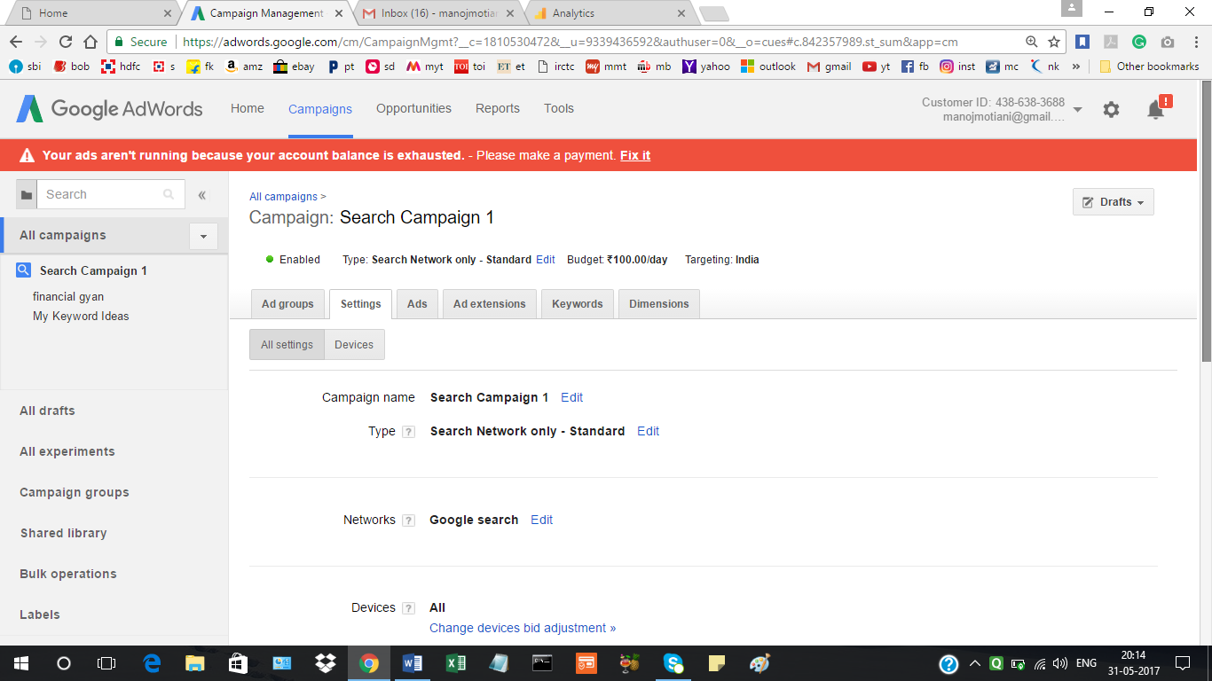

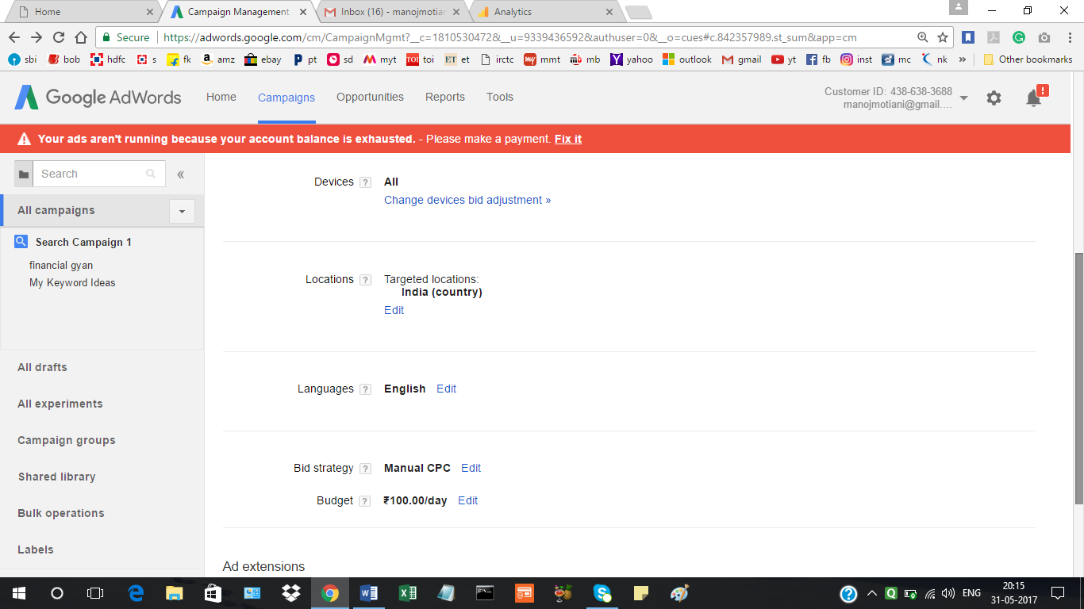

DISPLAY CAMPAIGN:

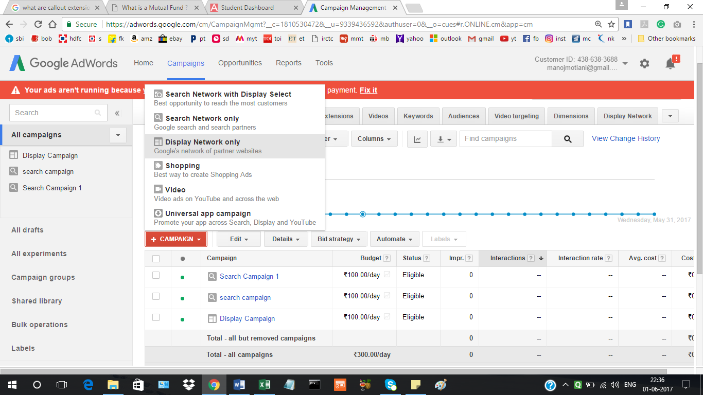

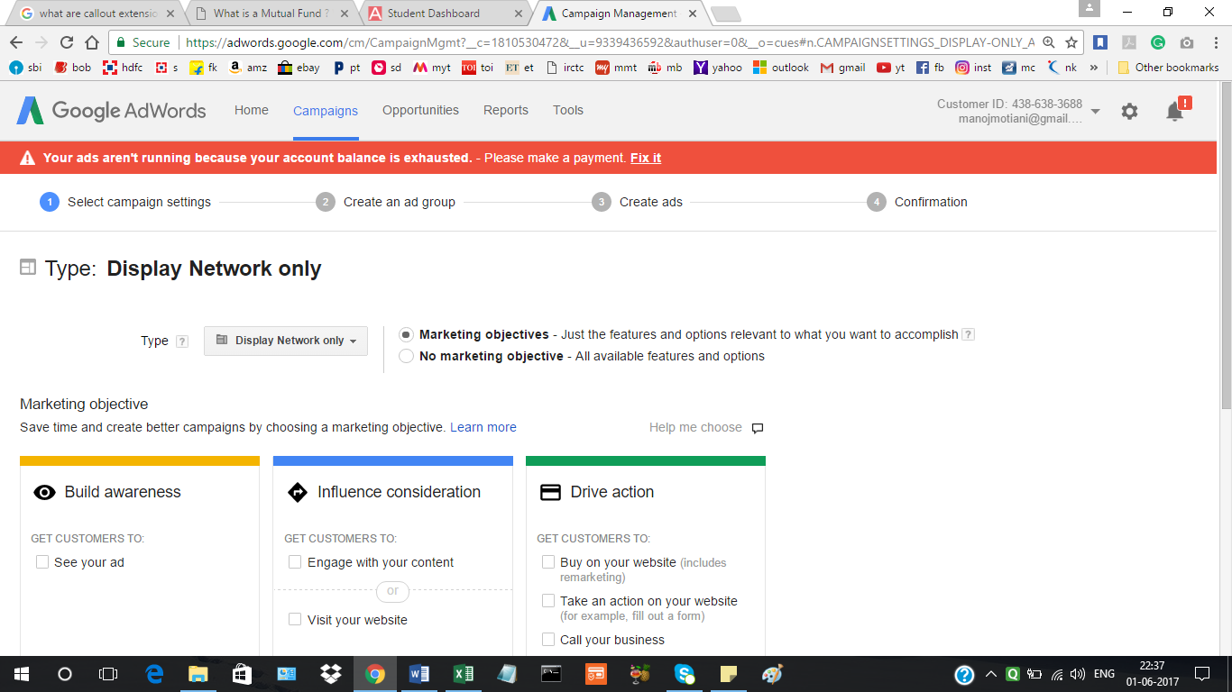

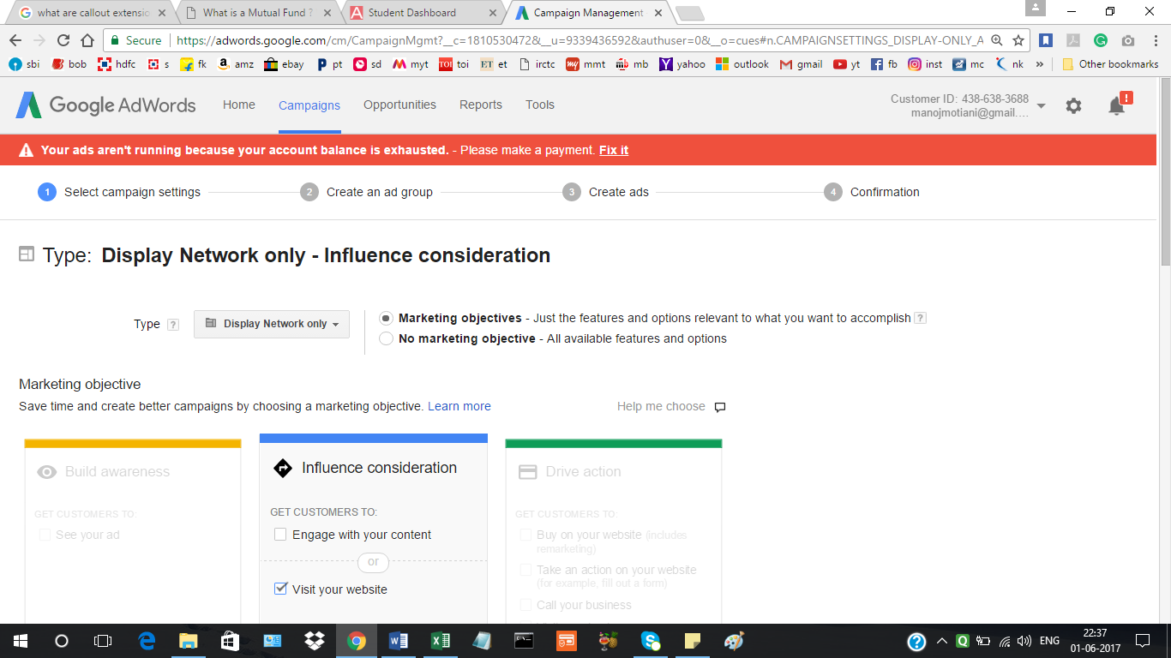

Targeting by location, language, big strategy, budget/day

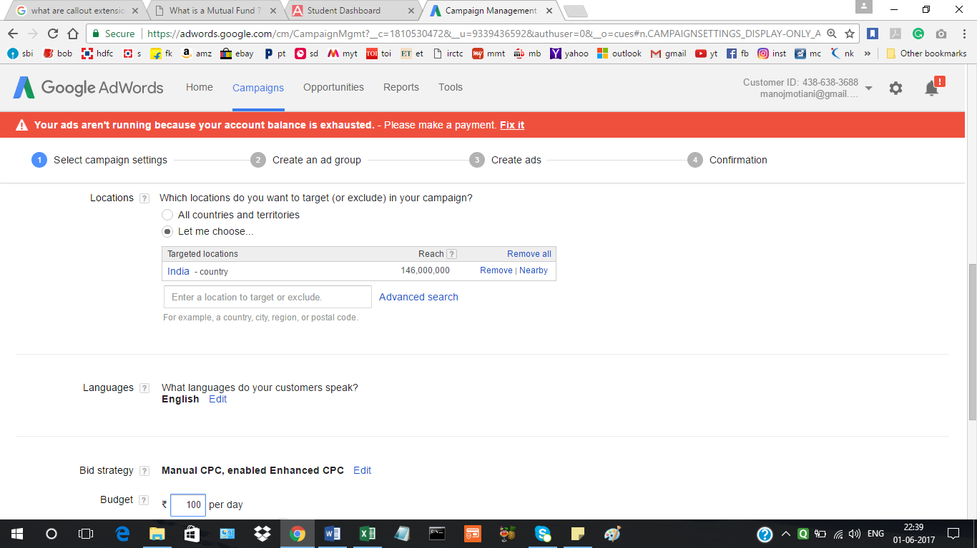

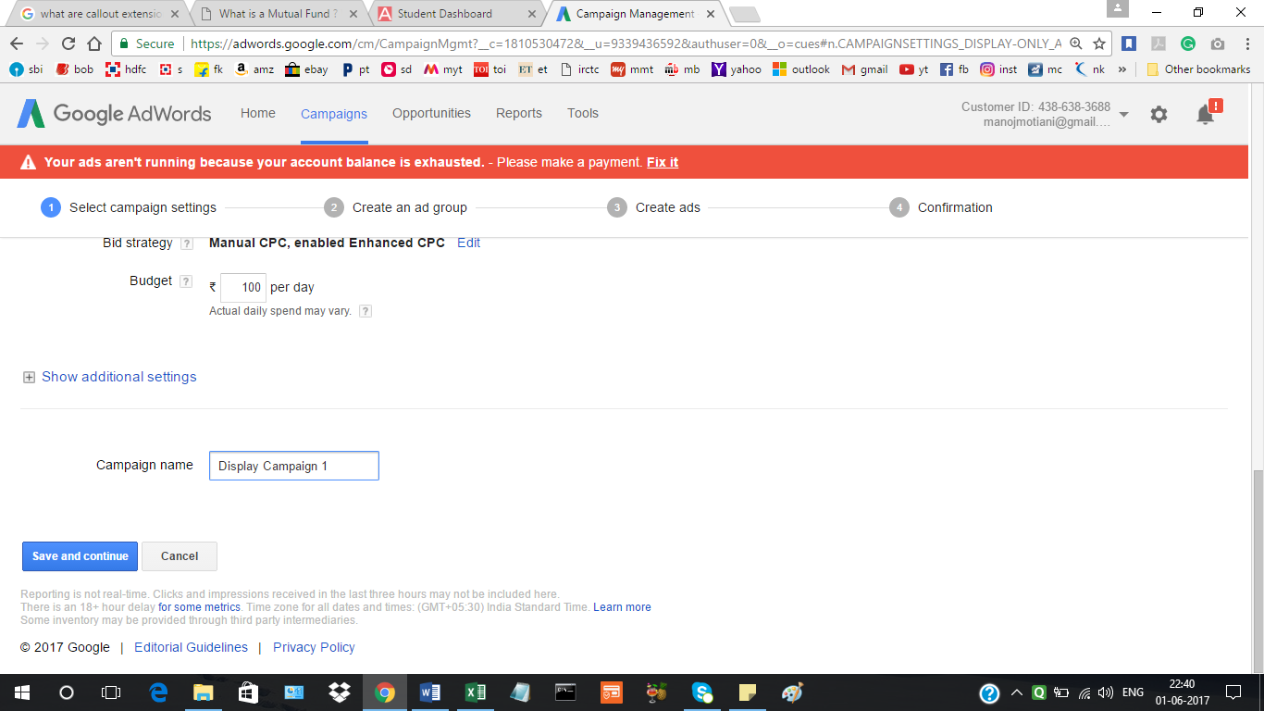

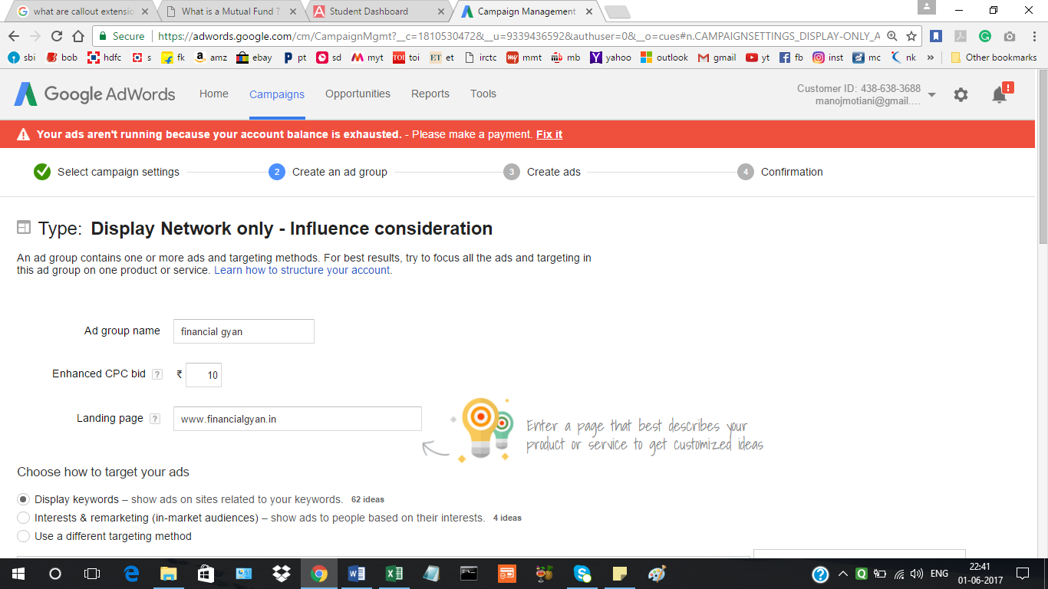

Display Keyword research:

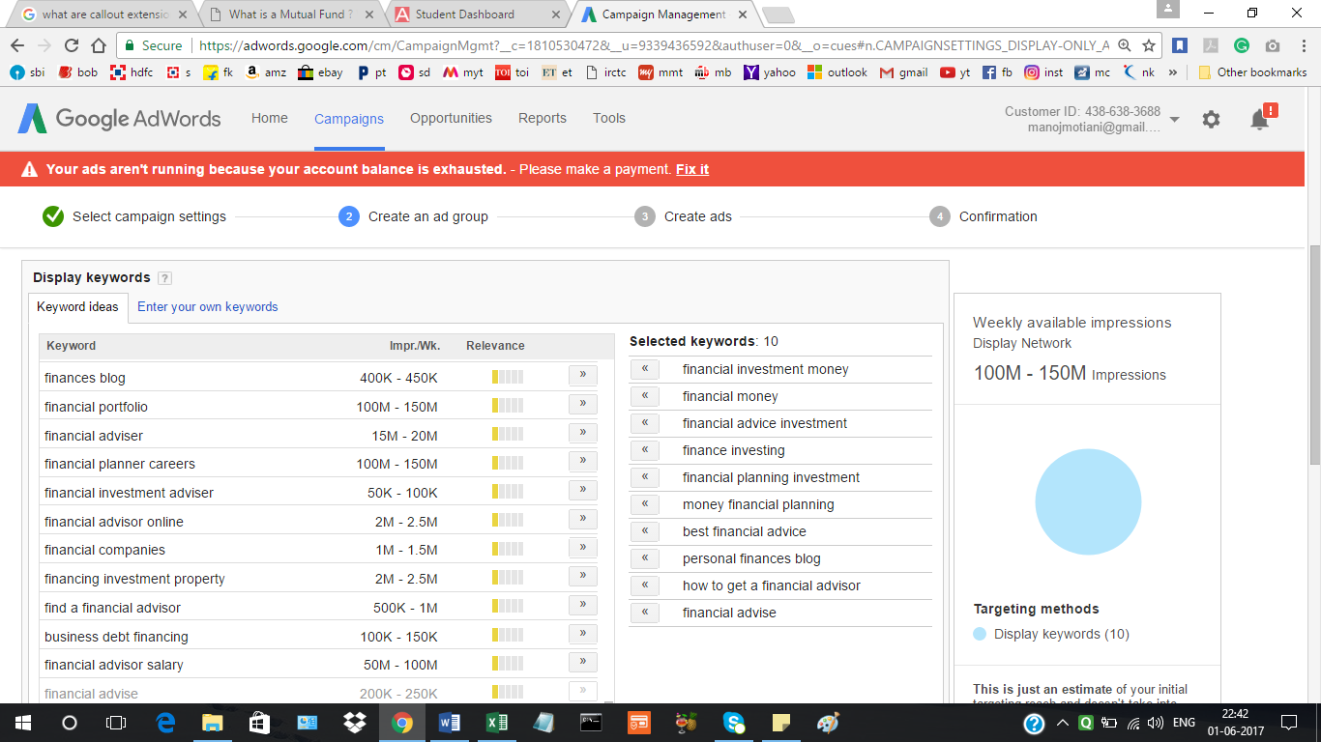

Adding display keyword manually:

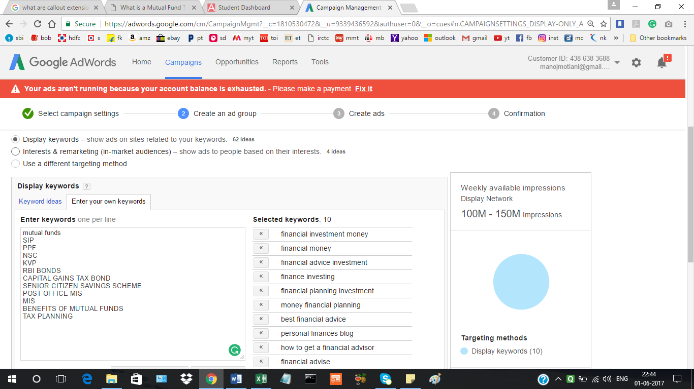

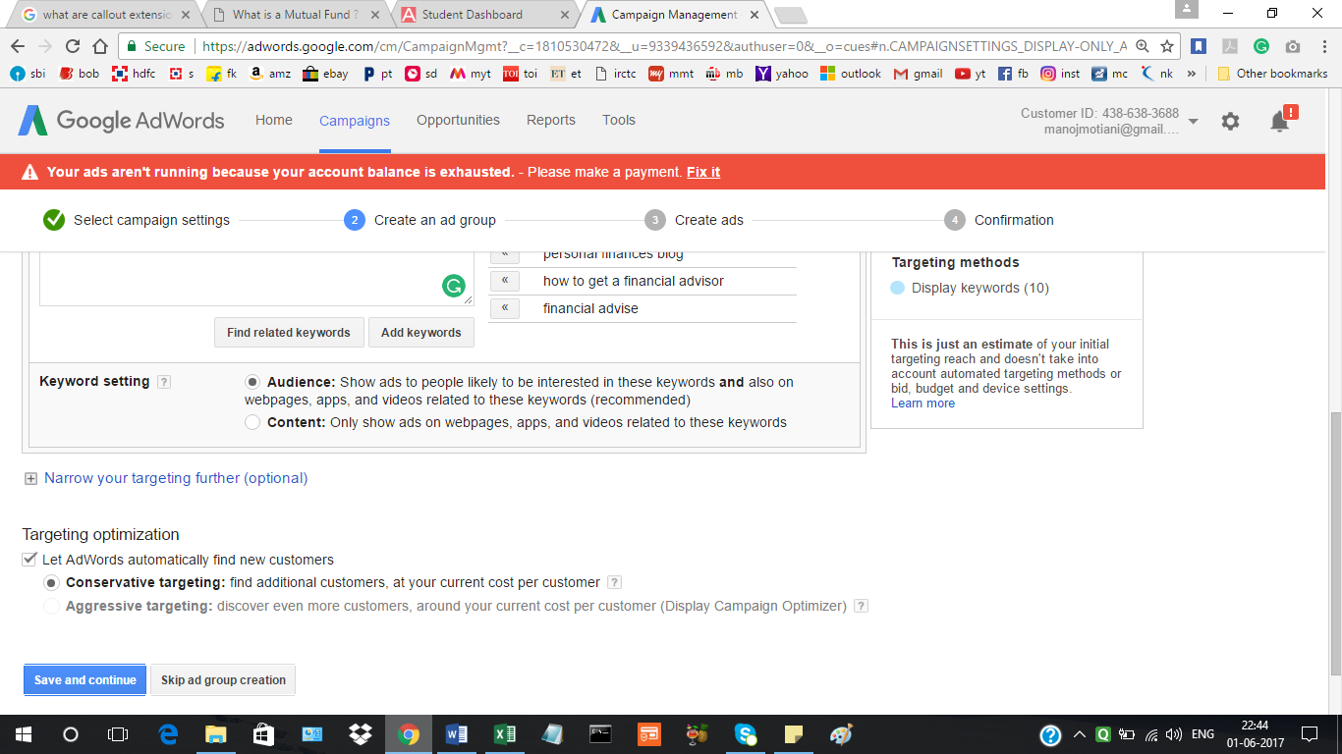

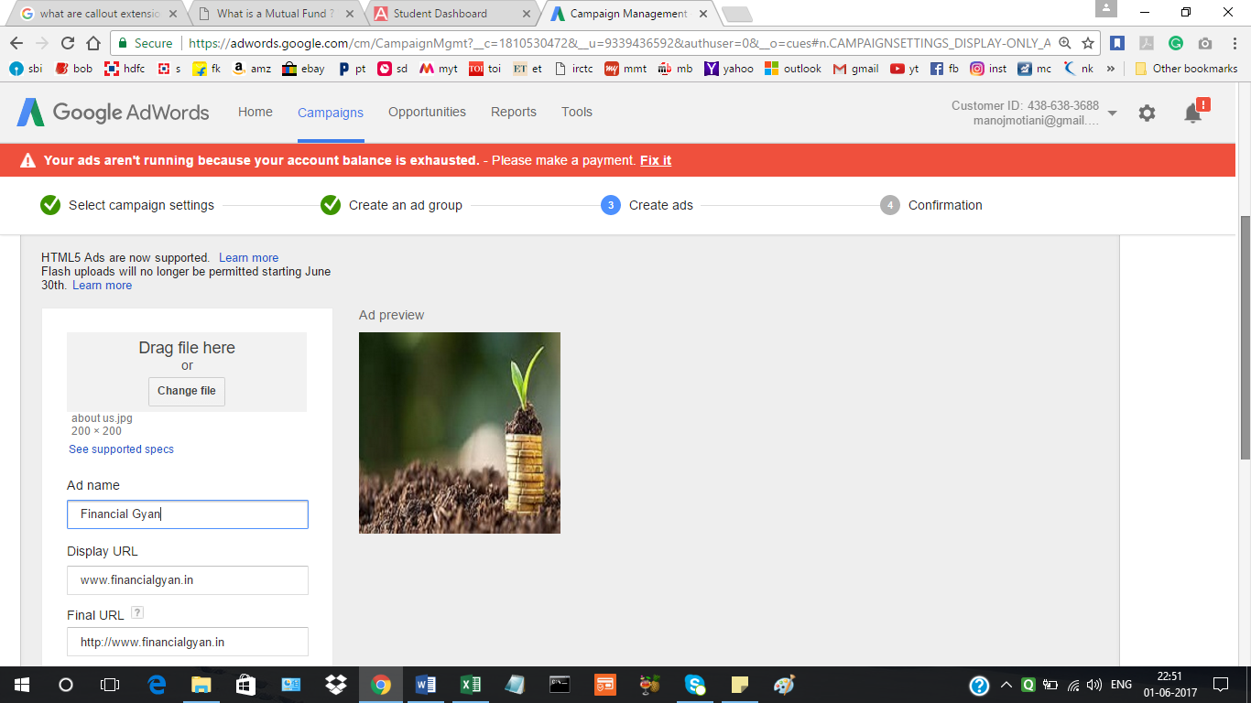

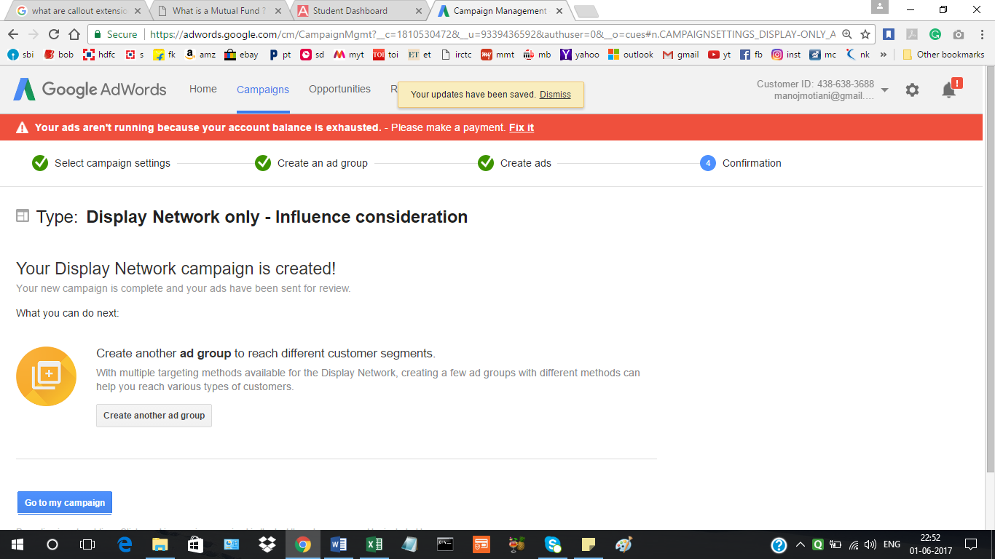

Targeting in display campaign:

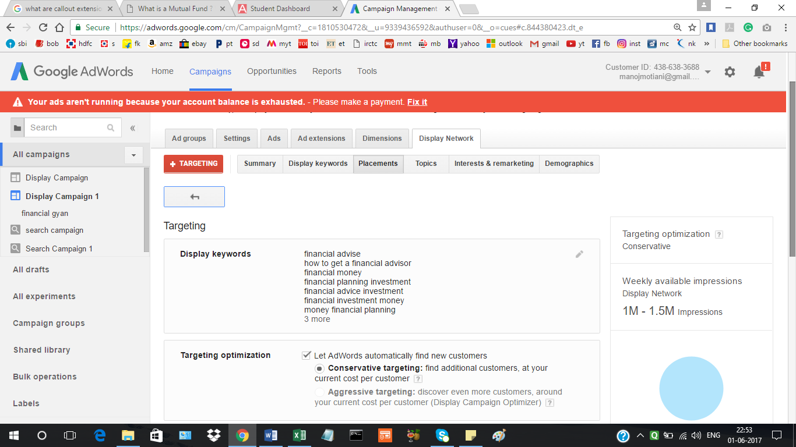

Placements on display Network:

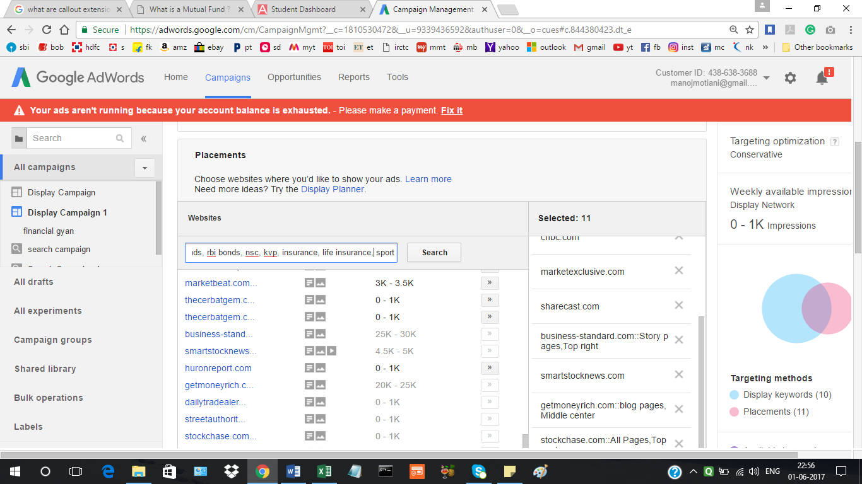

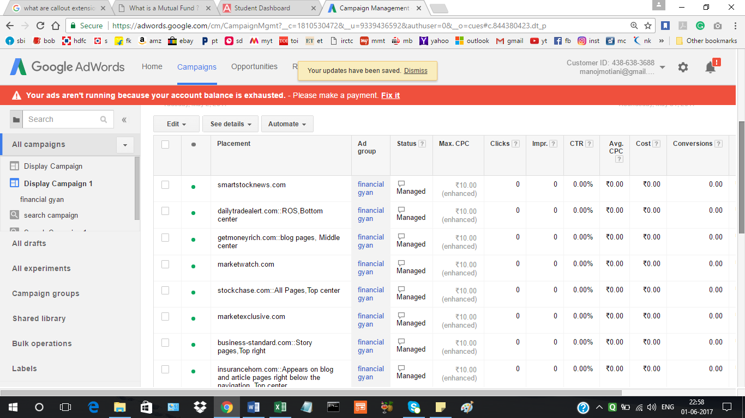

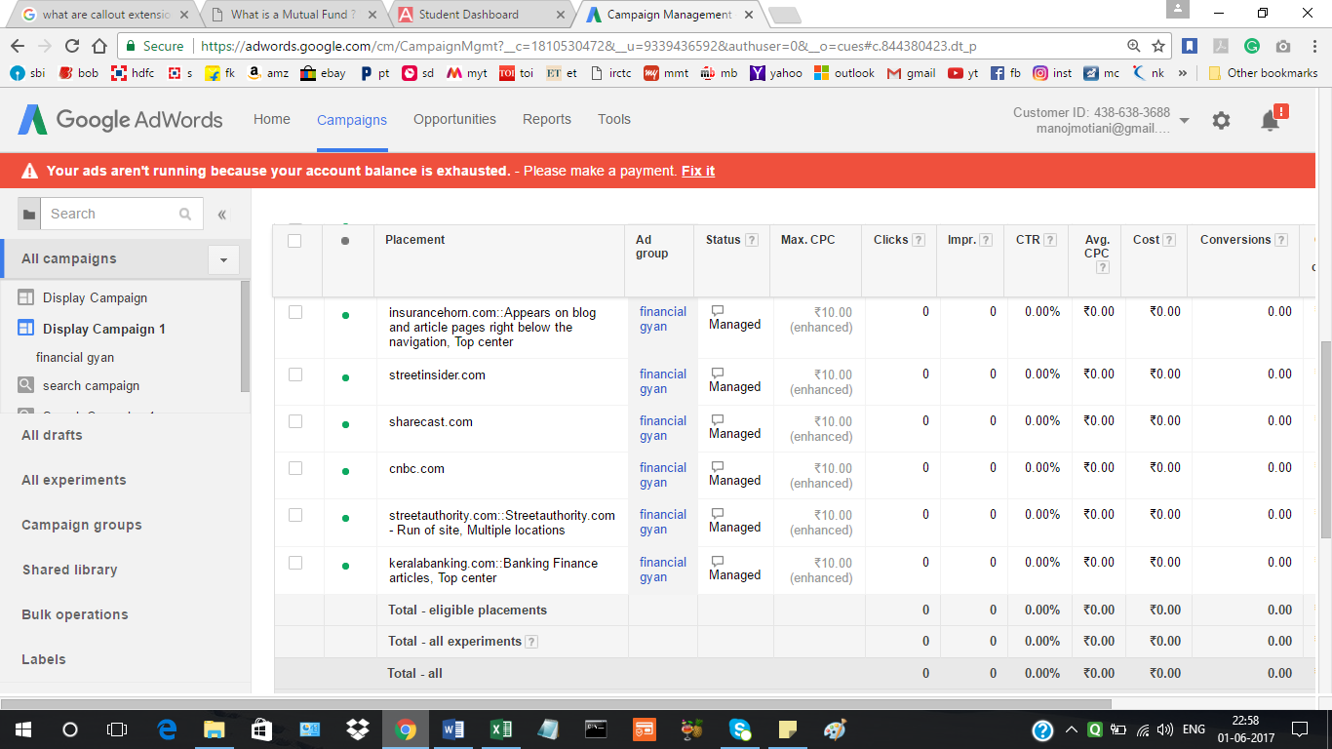

**Project 3: Facebook, YouTube and Email marketing:**

**Part 1:**

**Creating Facebook Page: Financial Gyan and sharing content**

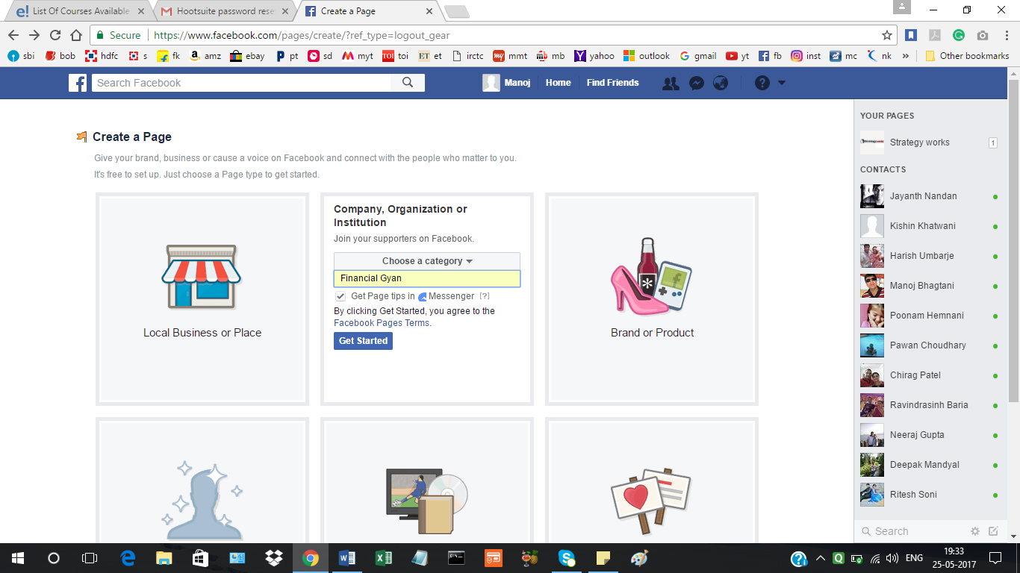

Adding logo to page:

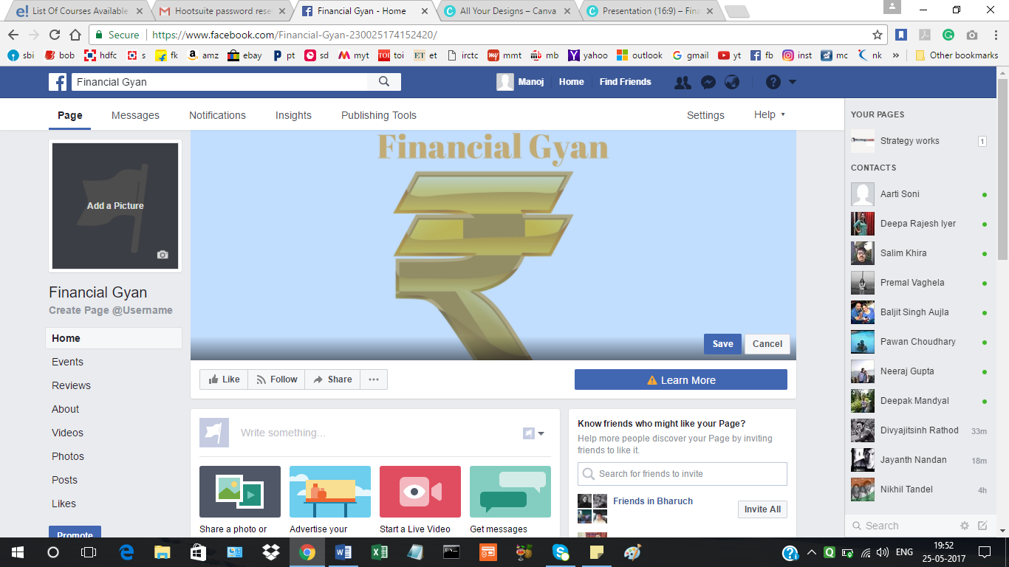

Sharing content on page about from www.financialgyan.in

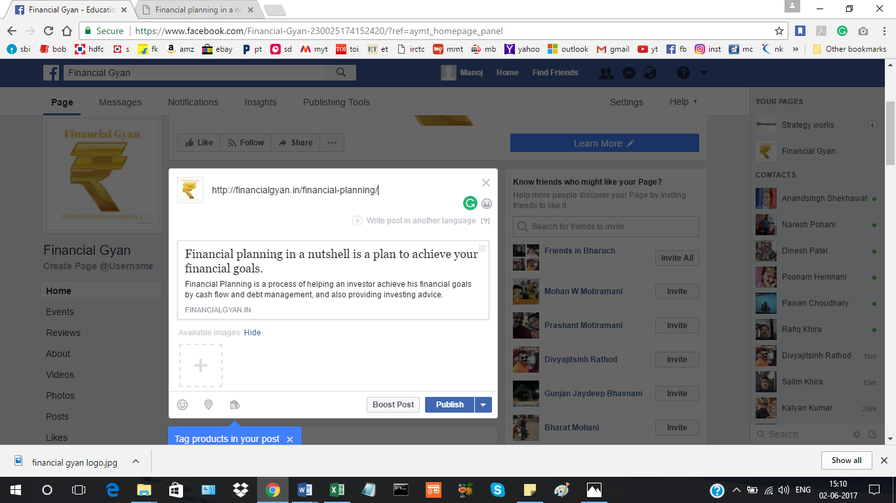

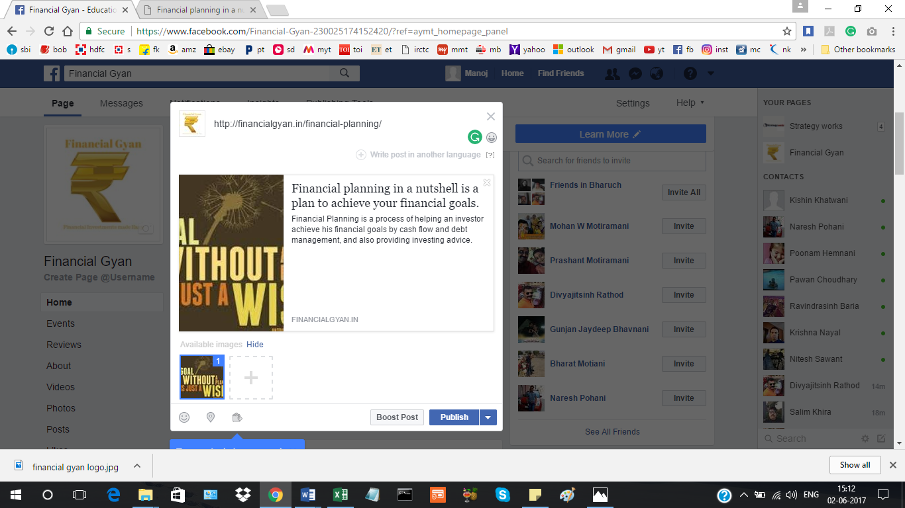

**Part 2 of Project 3:**

**Scheduling 5 posts on facebook for 1 month, showing two, other are self explanatory**

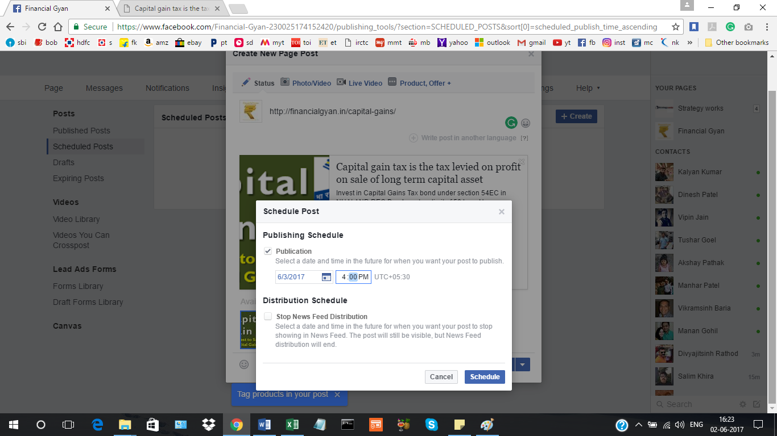

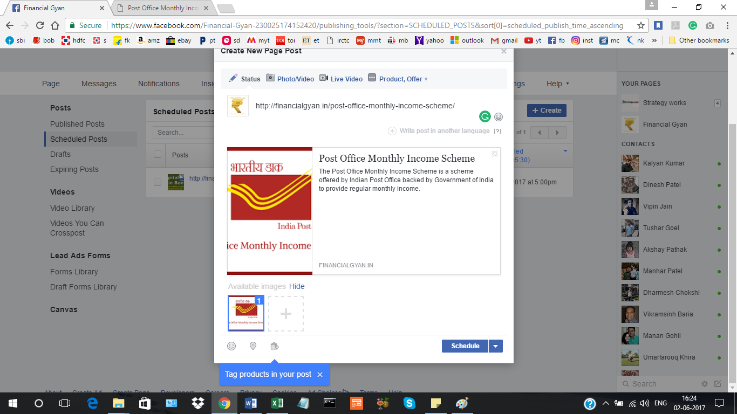

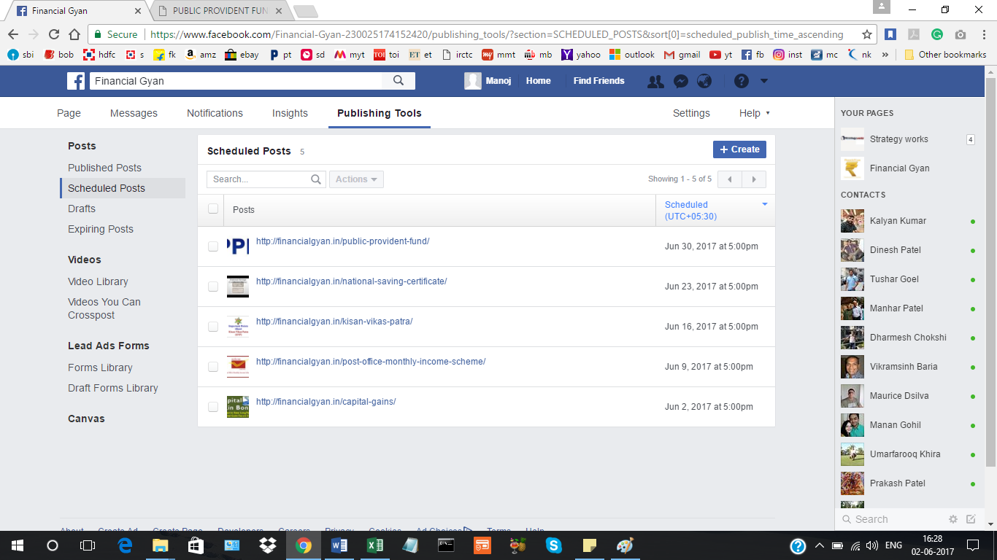

**Facebook Advertisement:**

**We chose marketing objective as Traffic under Consideration head:**

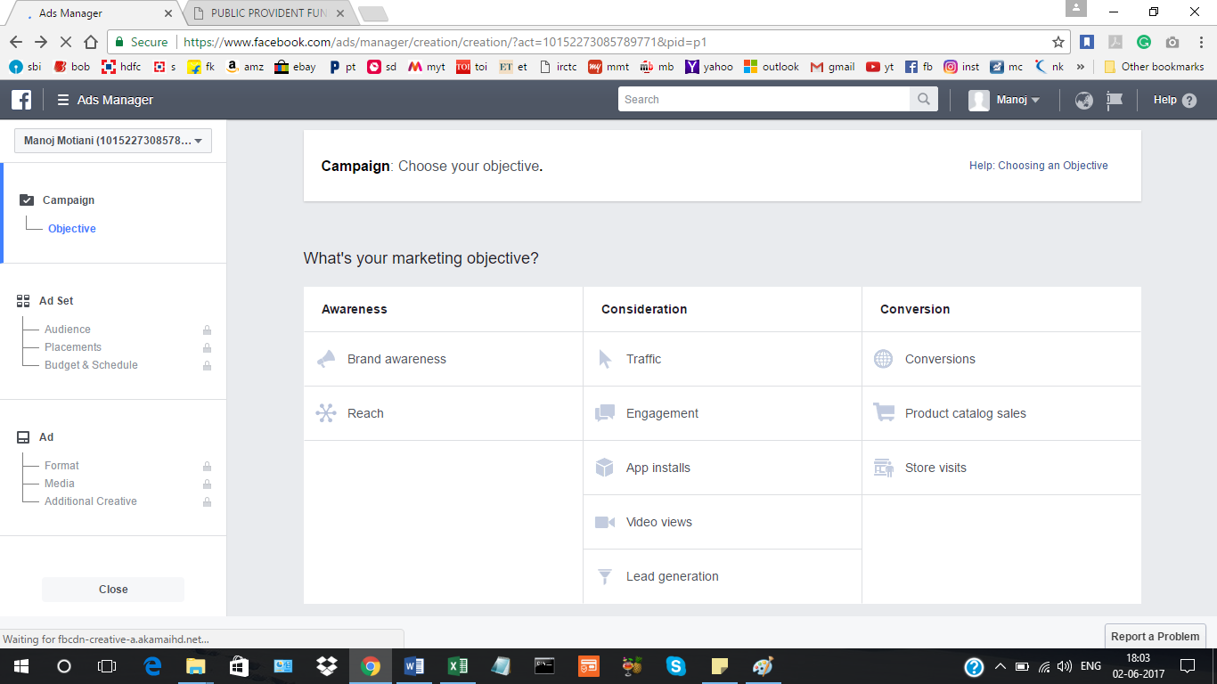

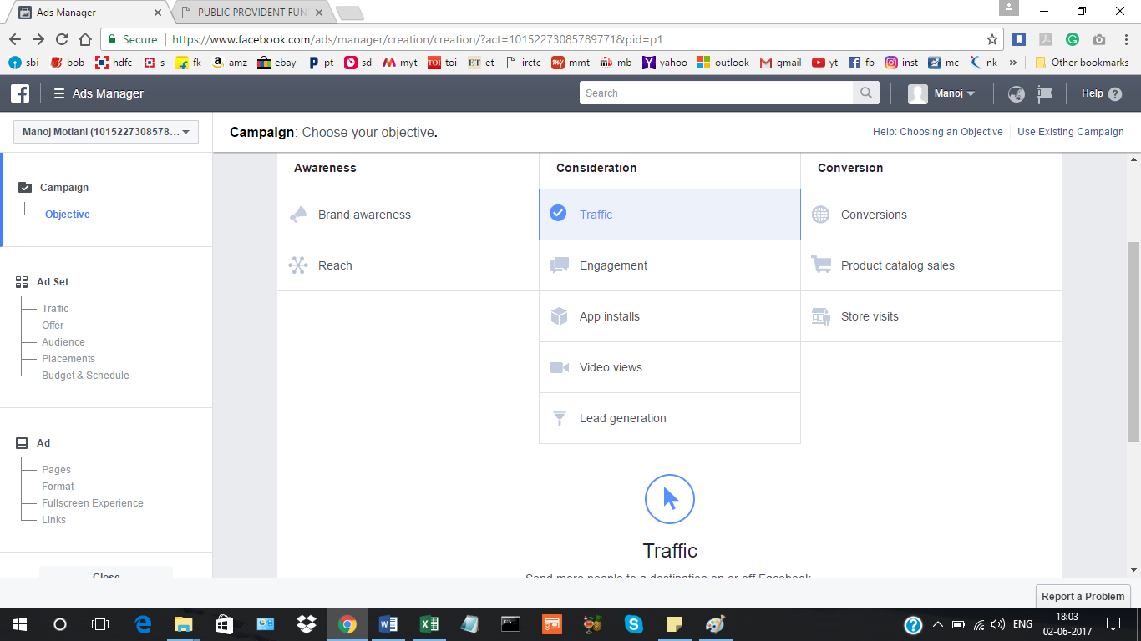

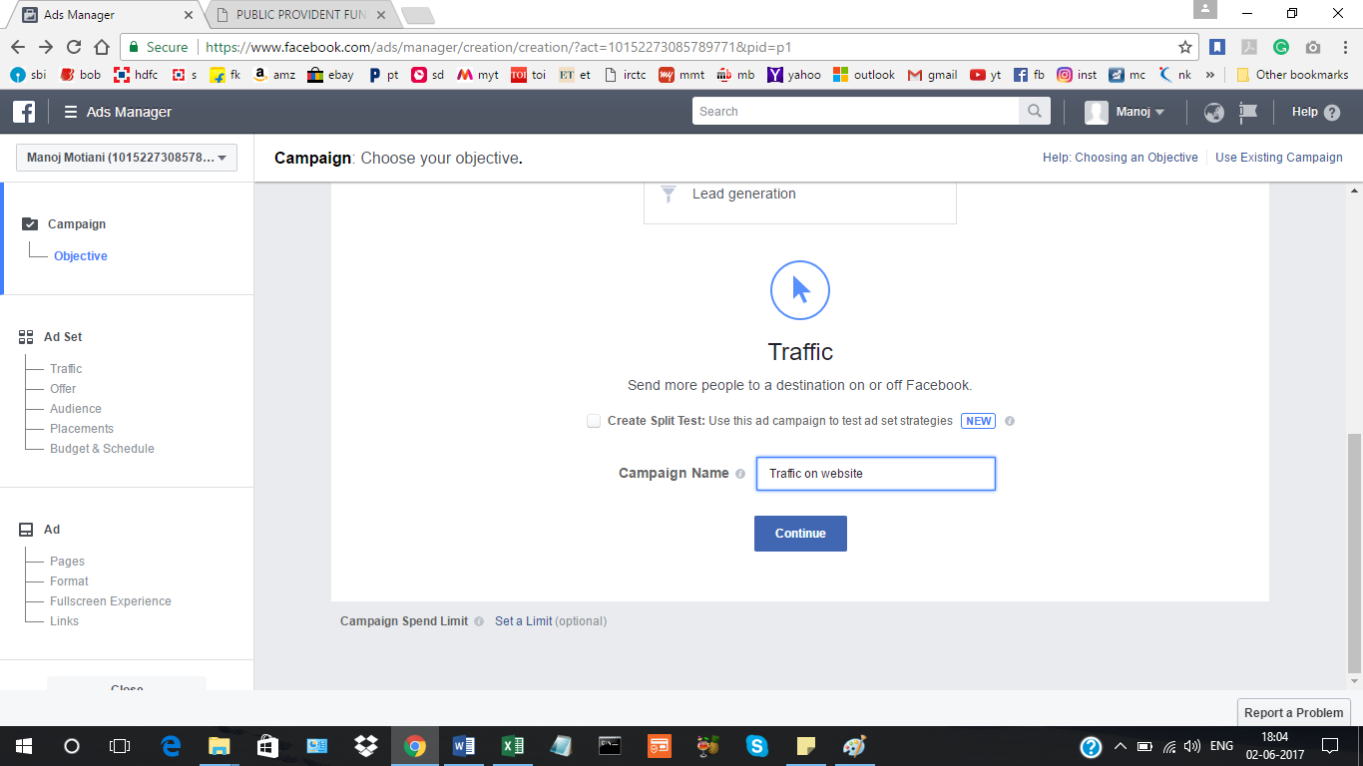

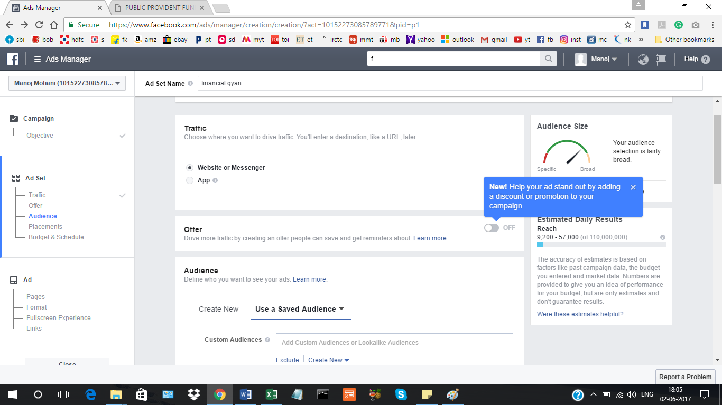

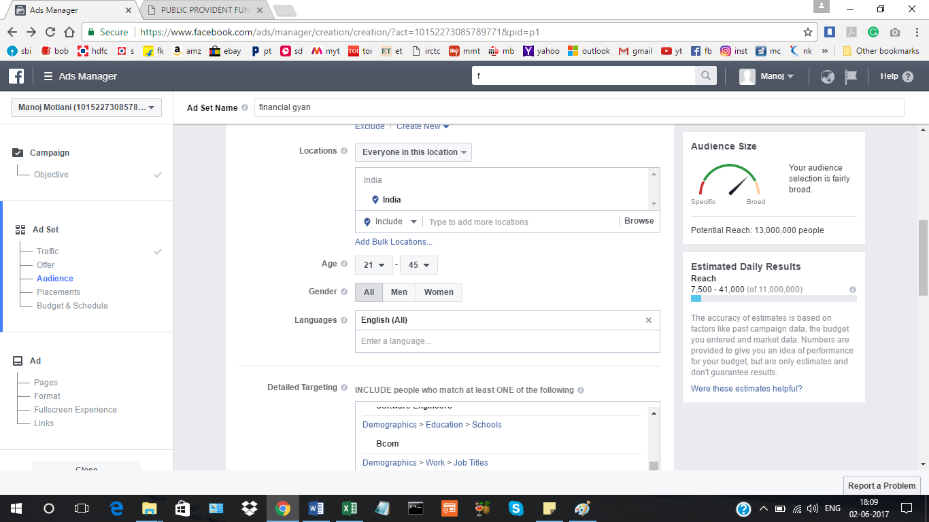

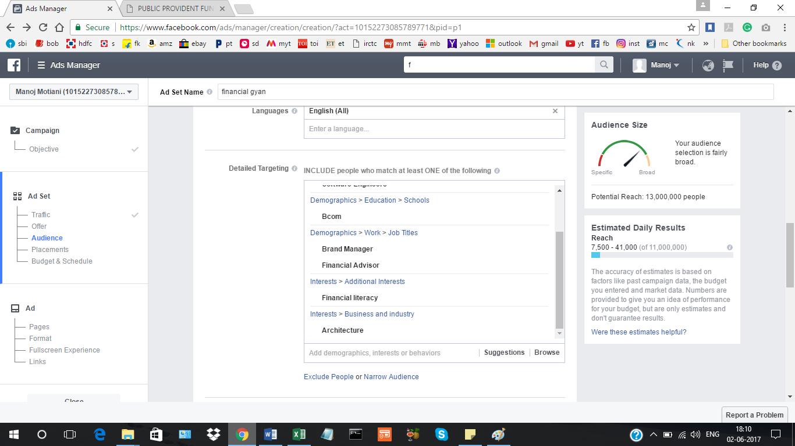

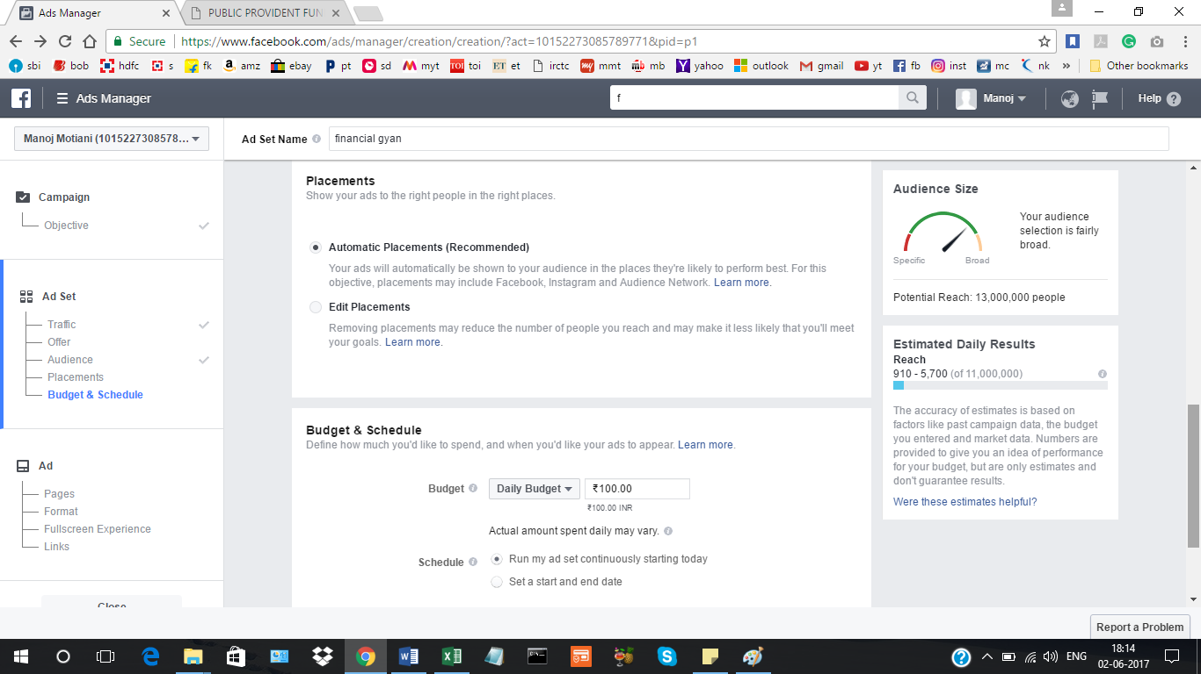

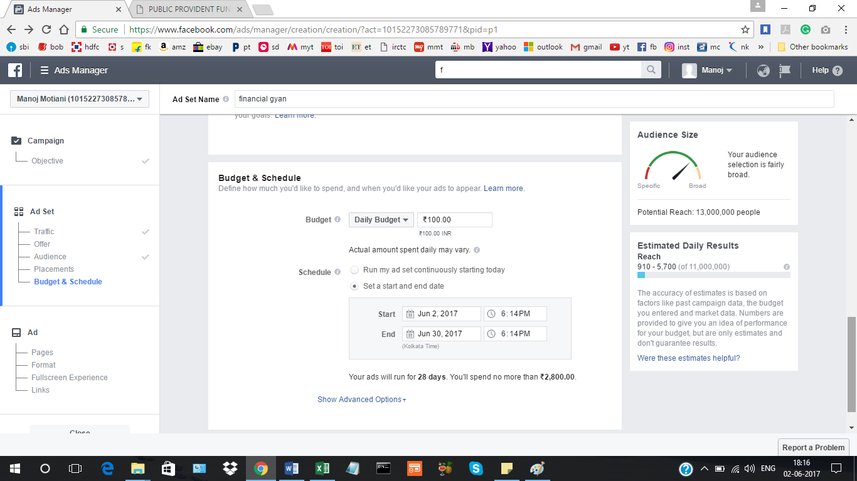

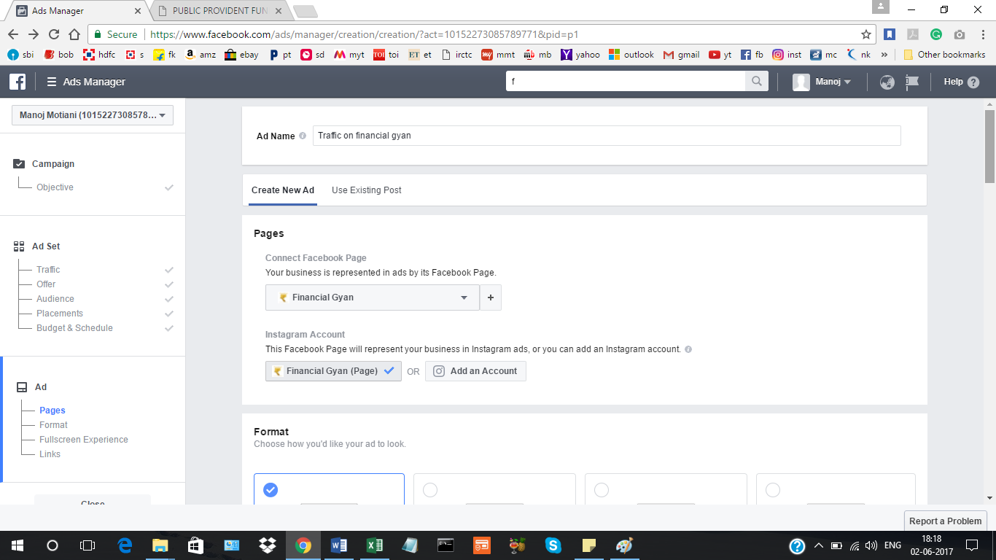

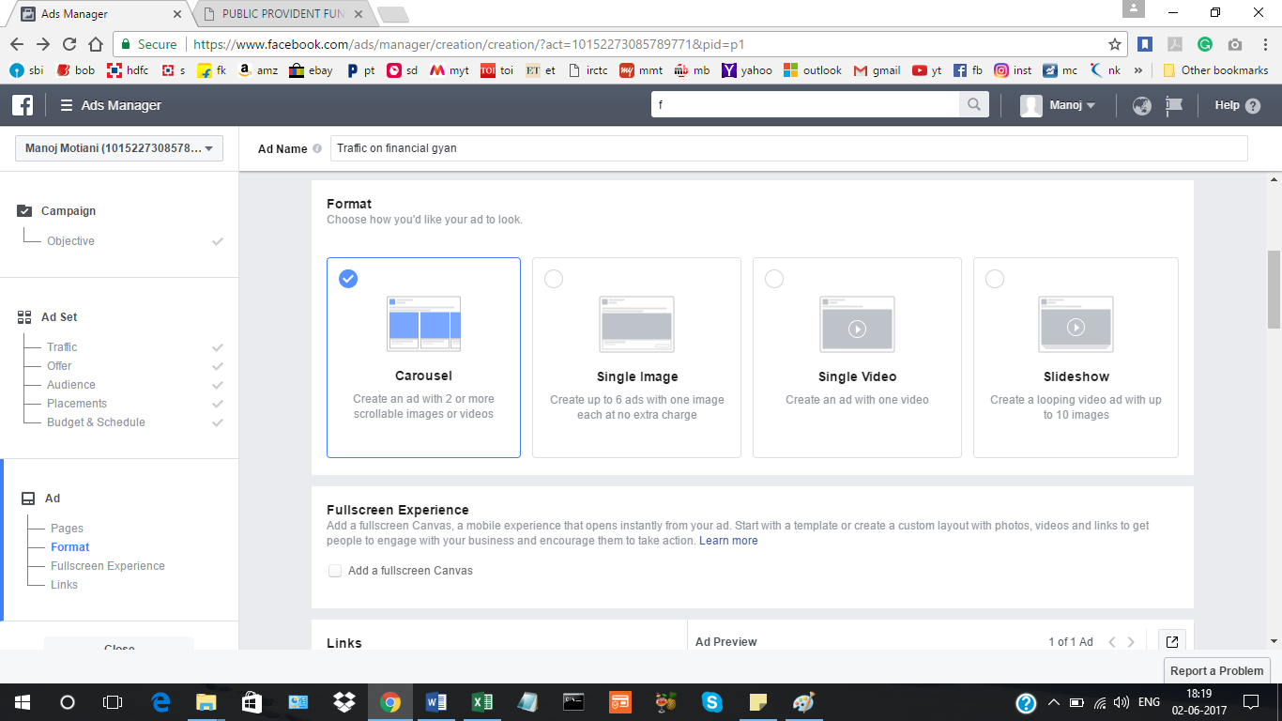

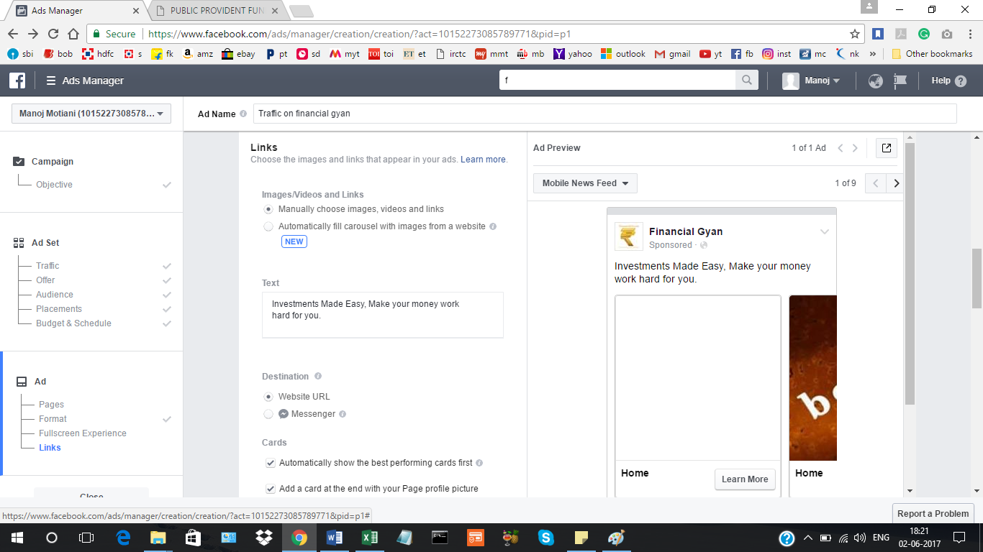

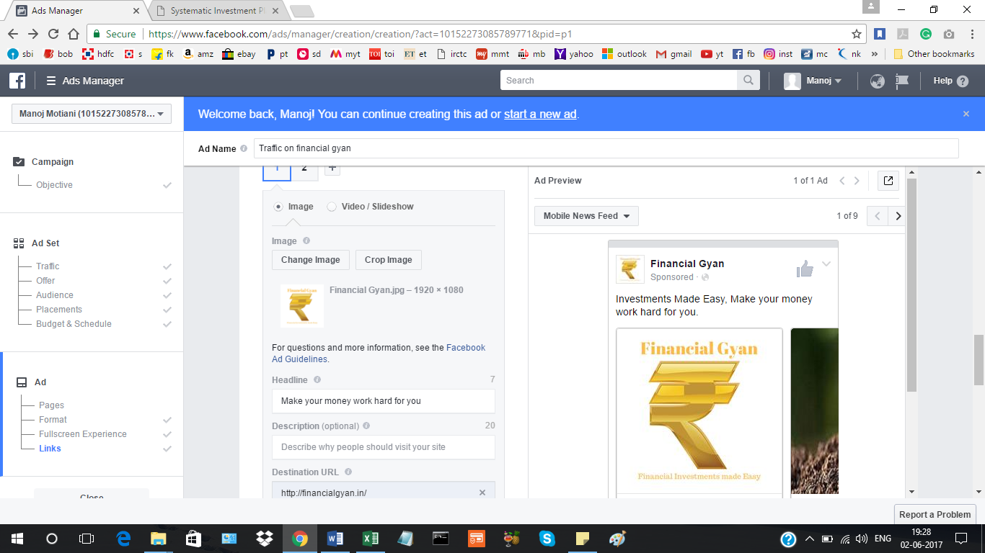

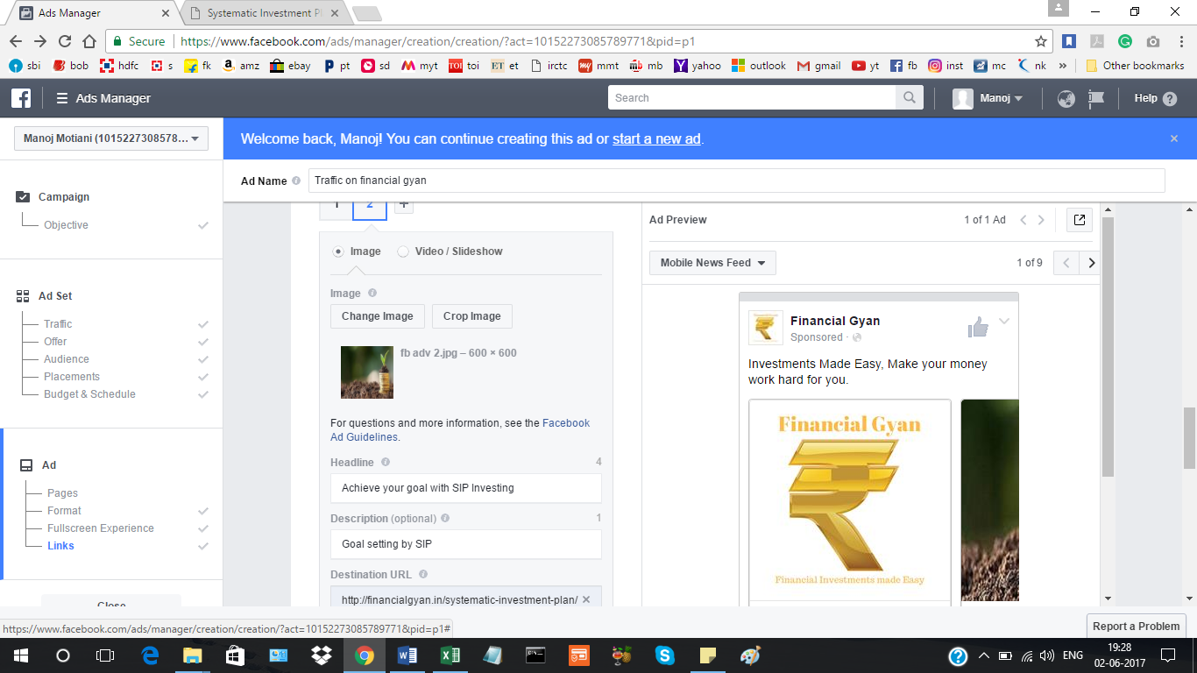

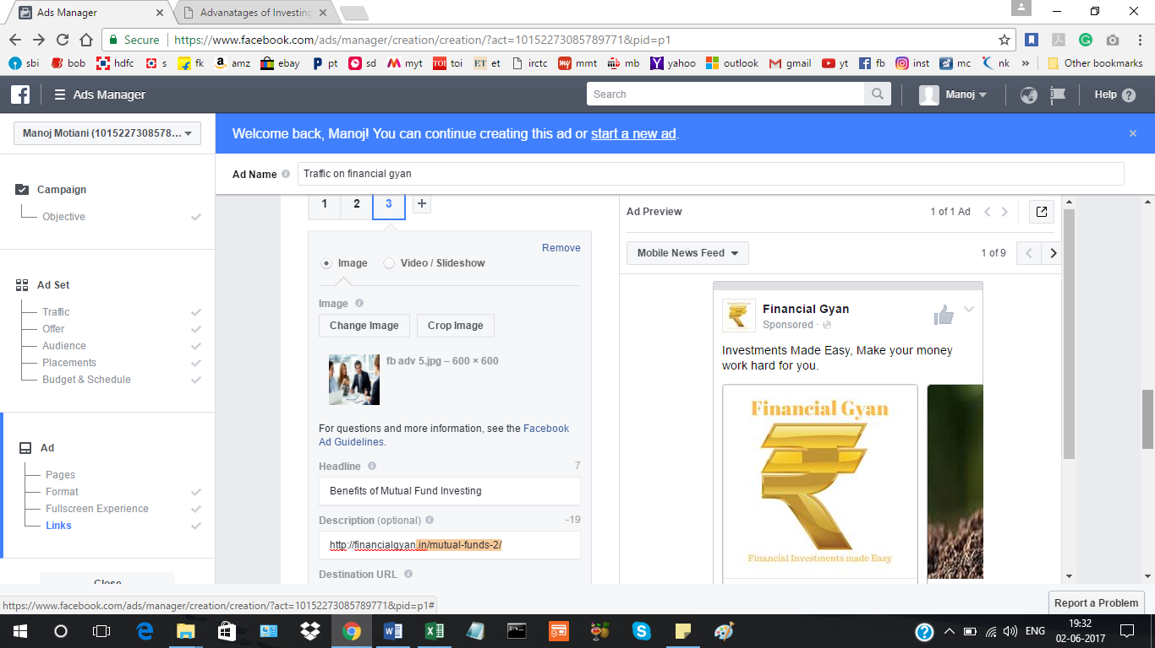

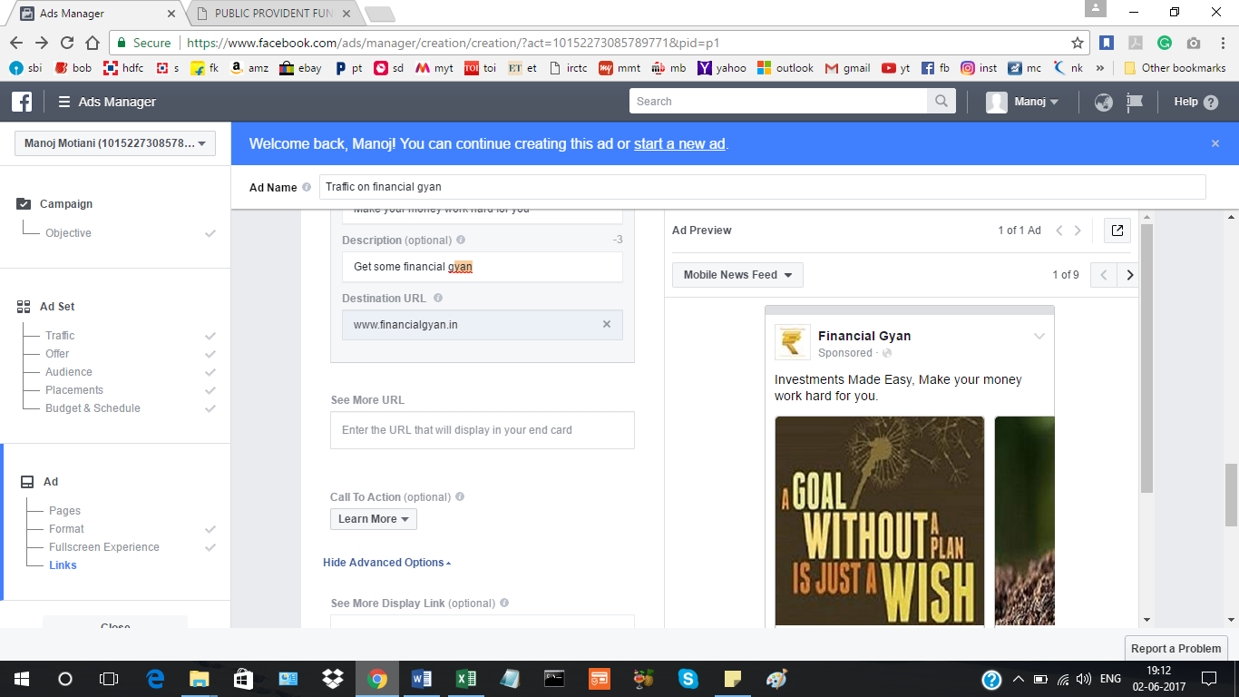

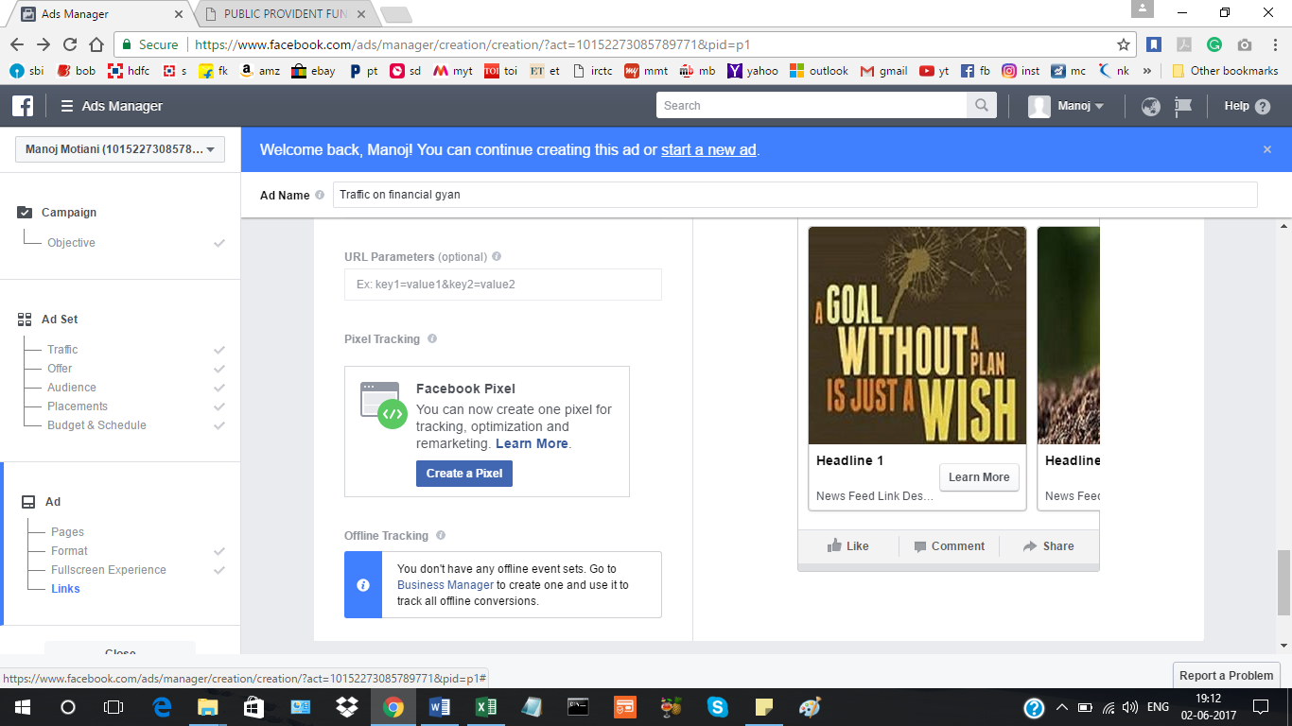

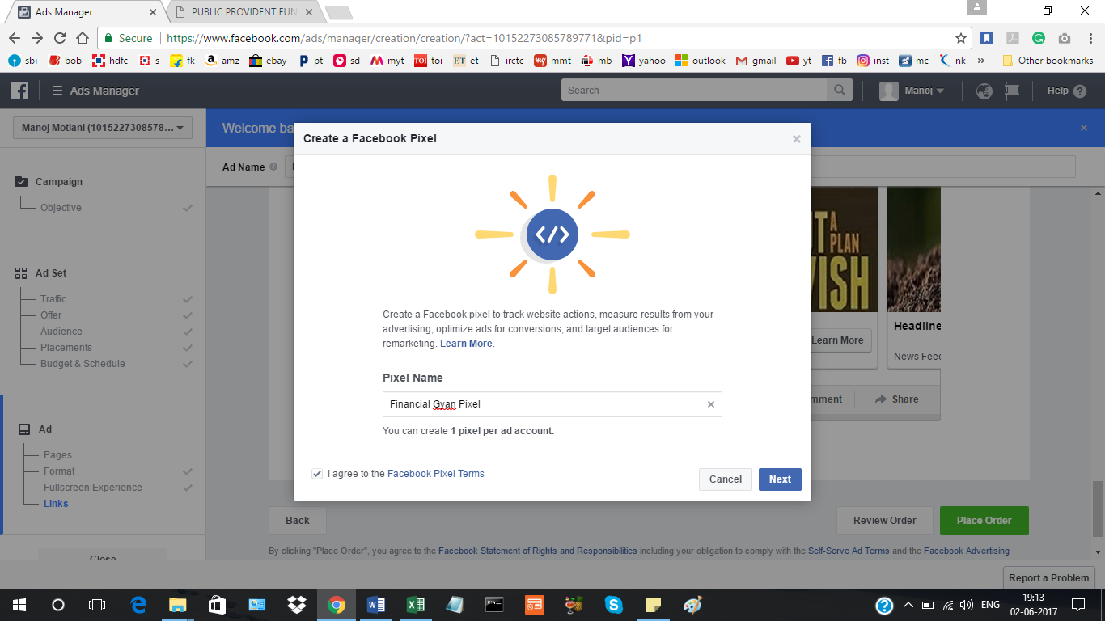

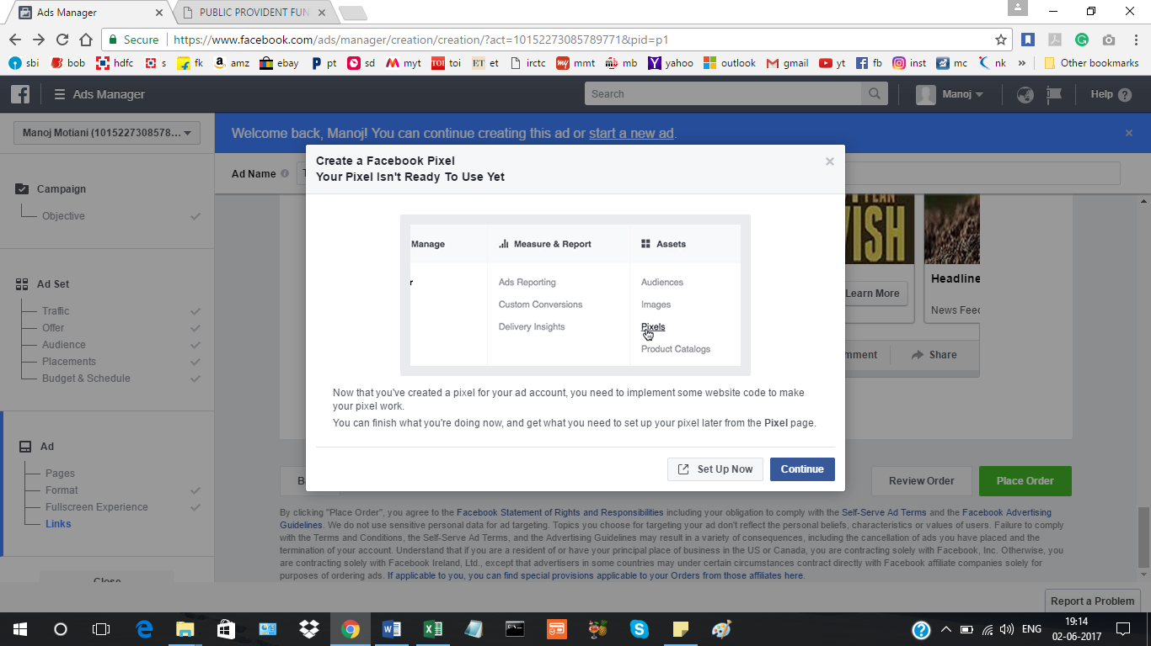

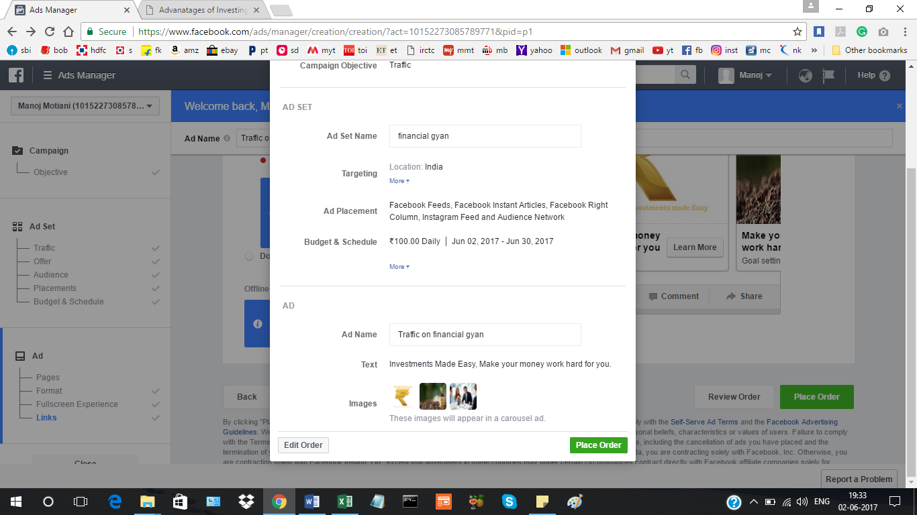

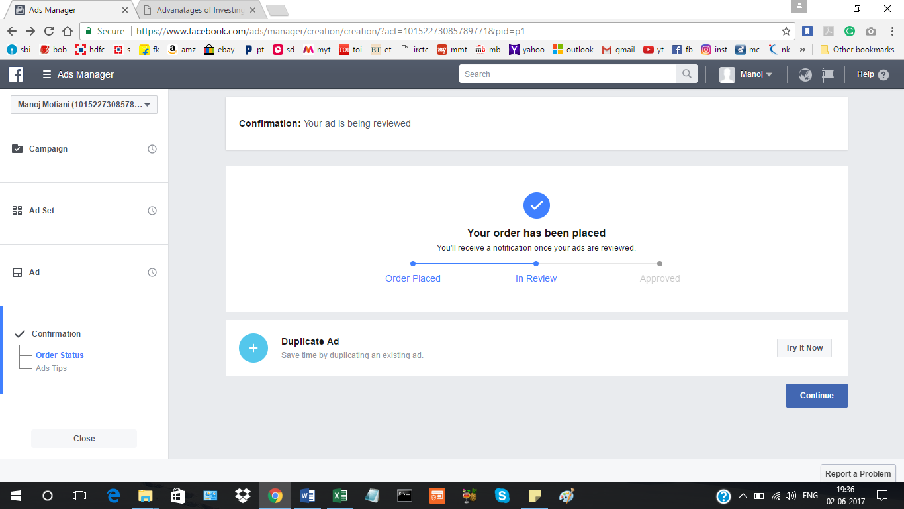

**Creating account on HOOTSUITE AND managin facebook page, scheduling 5 posts using HOOTSUITE:**

**Linking HOOTSUITE TO FACEBOOK:**

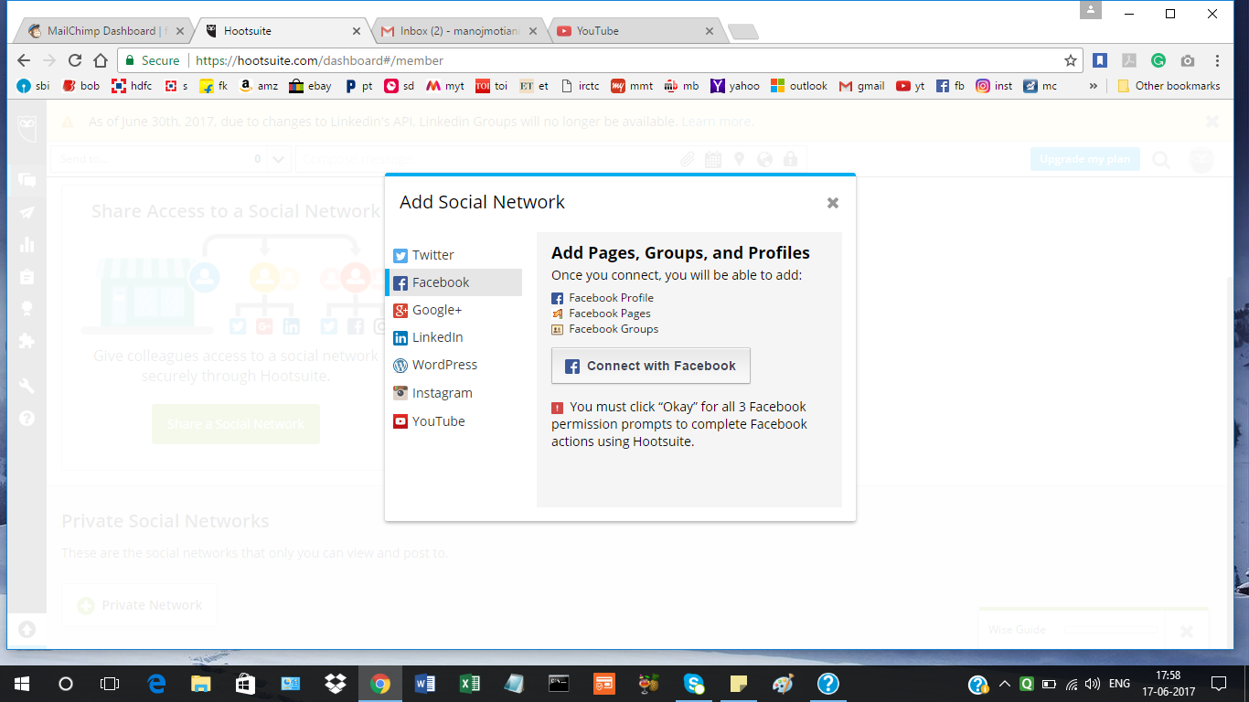

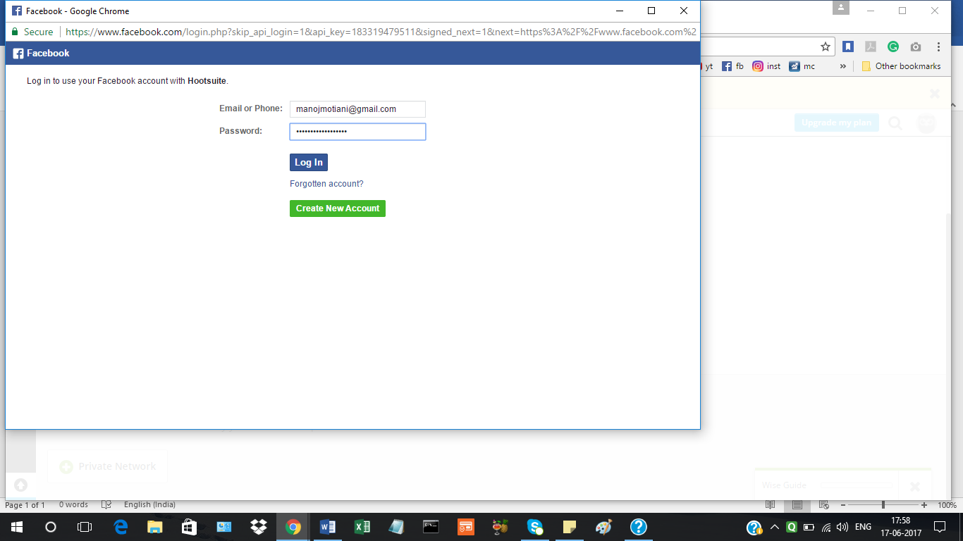

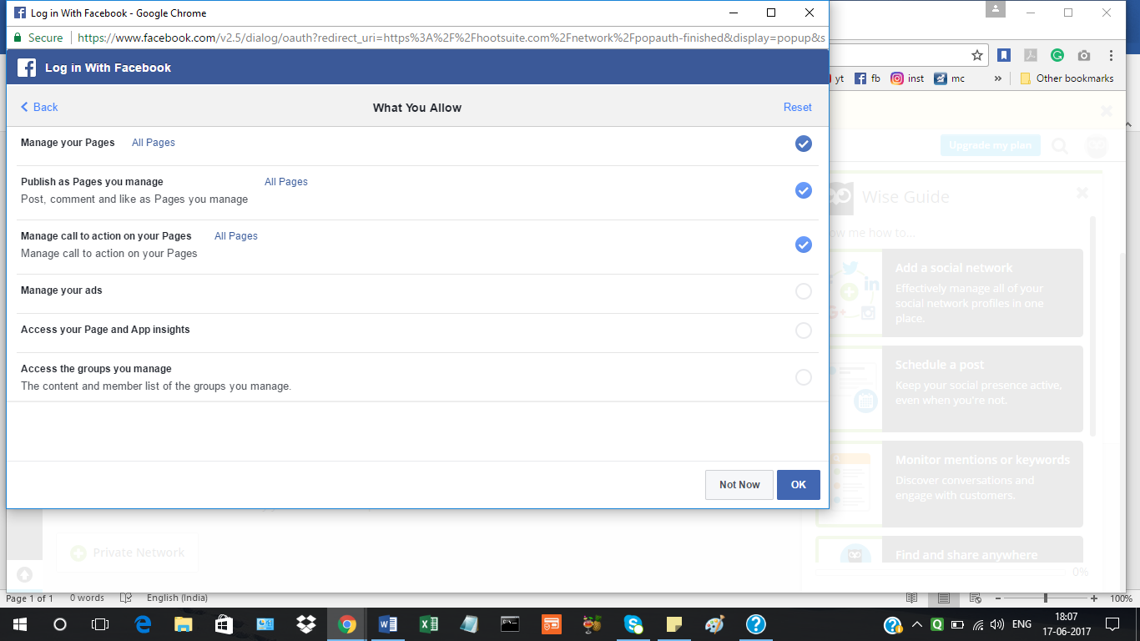

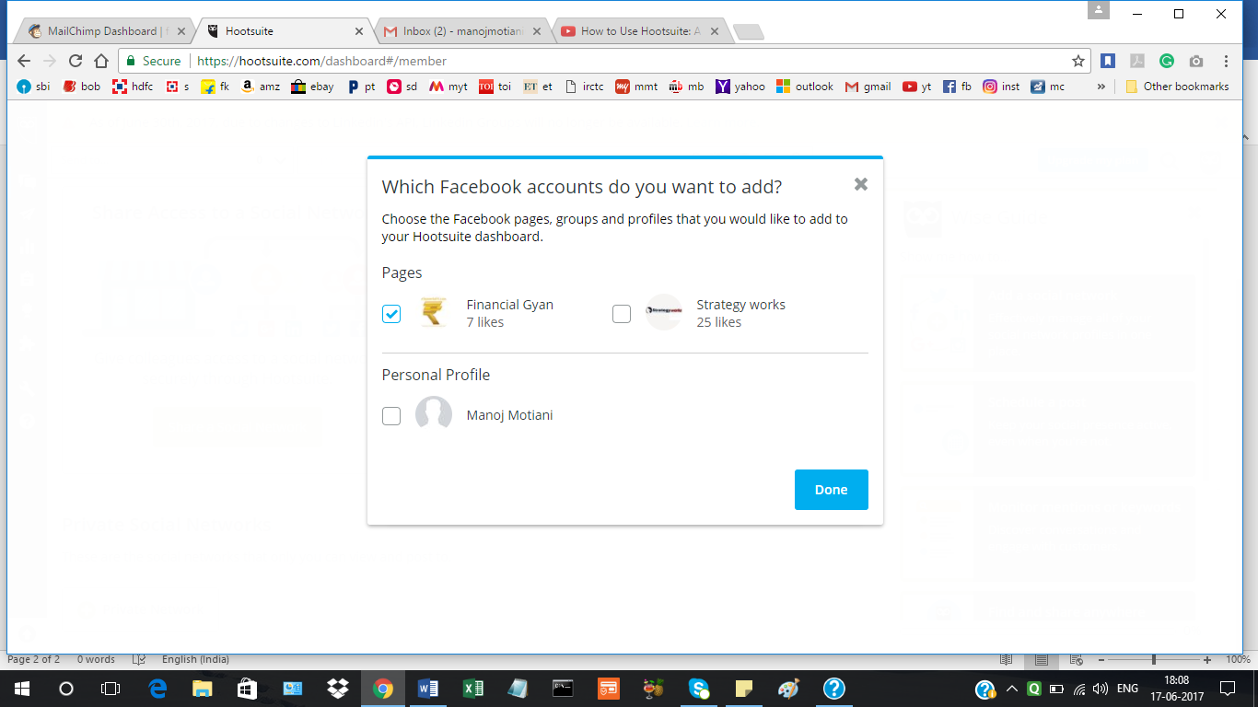

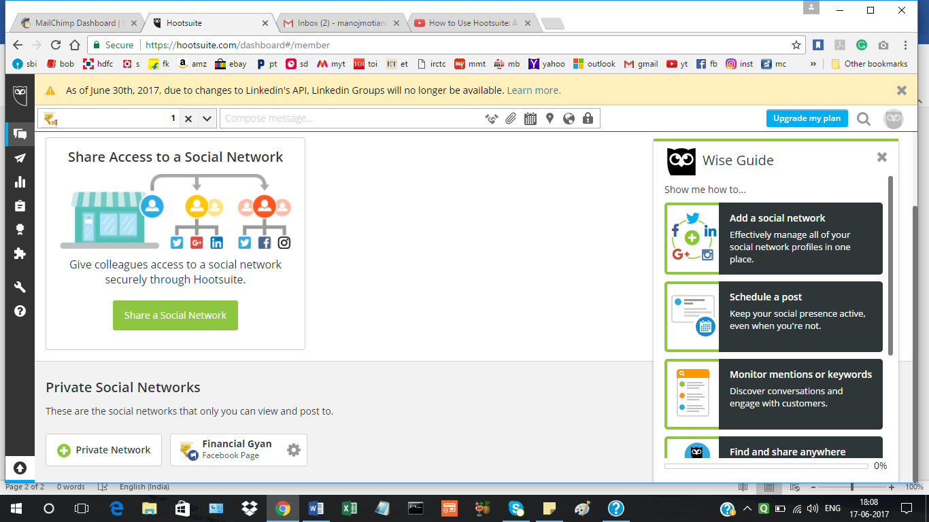

**Scheduing posts on facebook using HOOTSUITE: showing two,others are self explanatory**

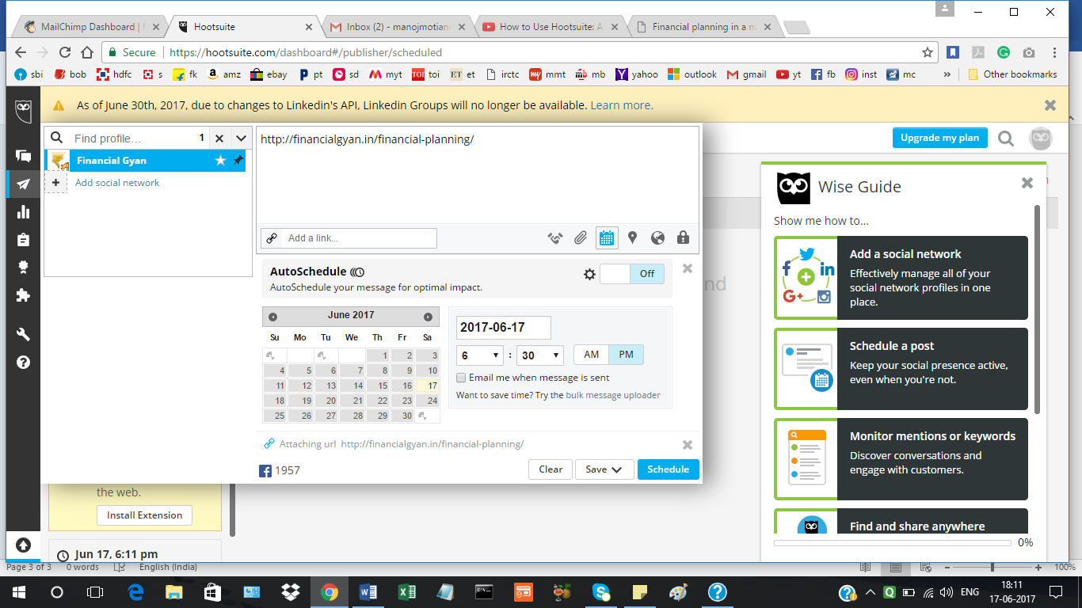

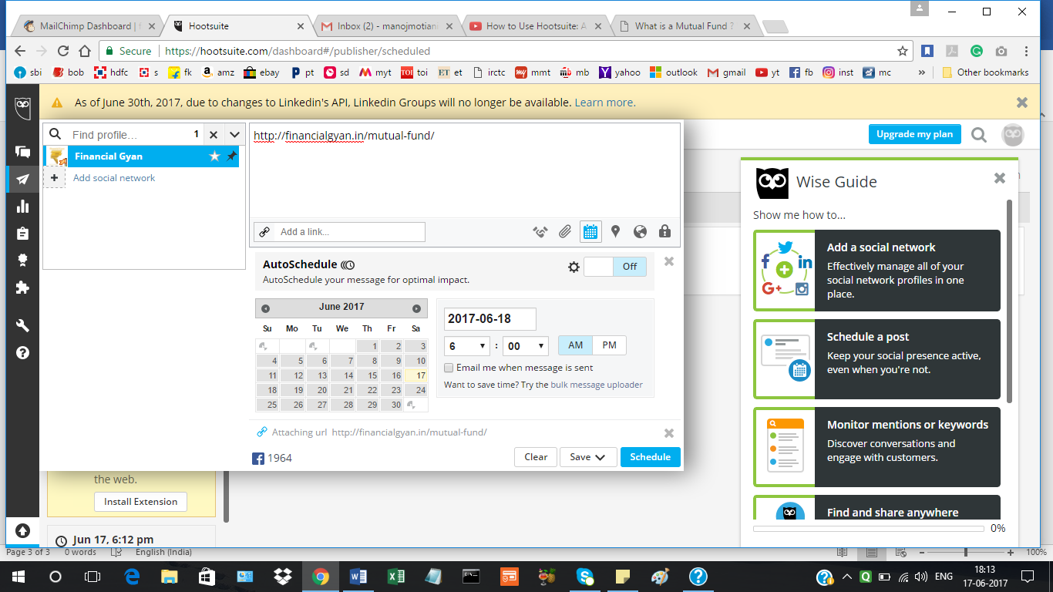

**Creating Image on Canva:**

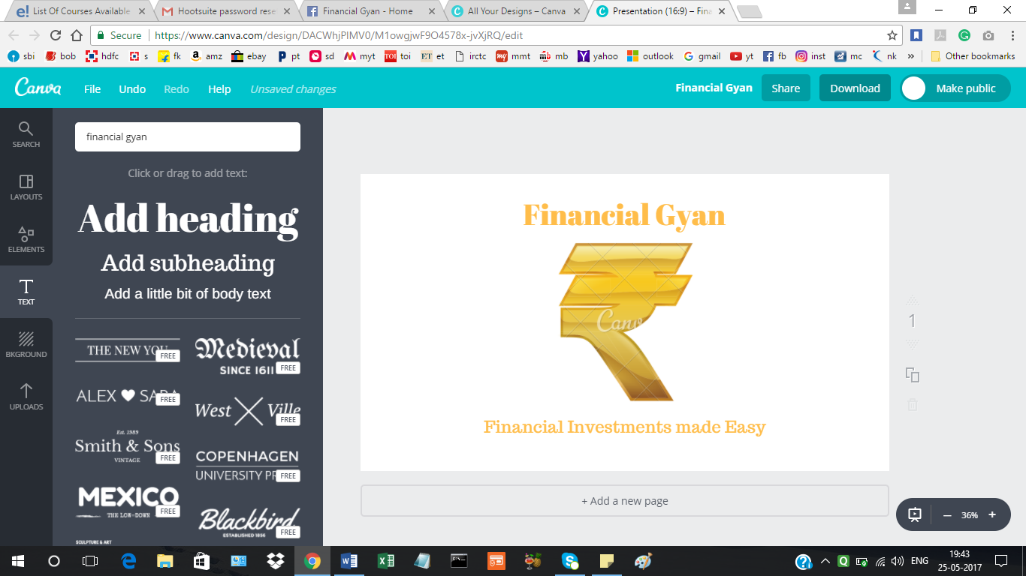

**Promoting website** [**www.financialgyan.in**](http://www.financialgyan.in) **using YouTube Campaign:**

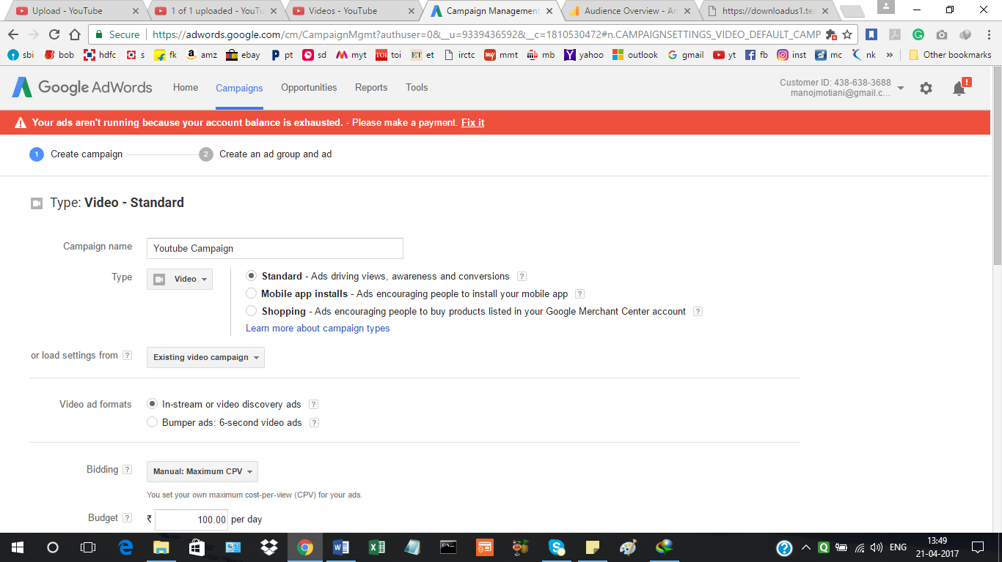

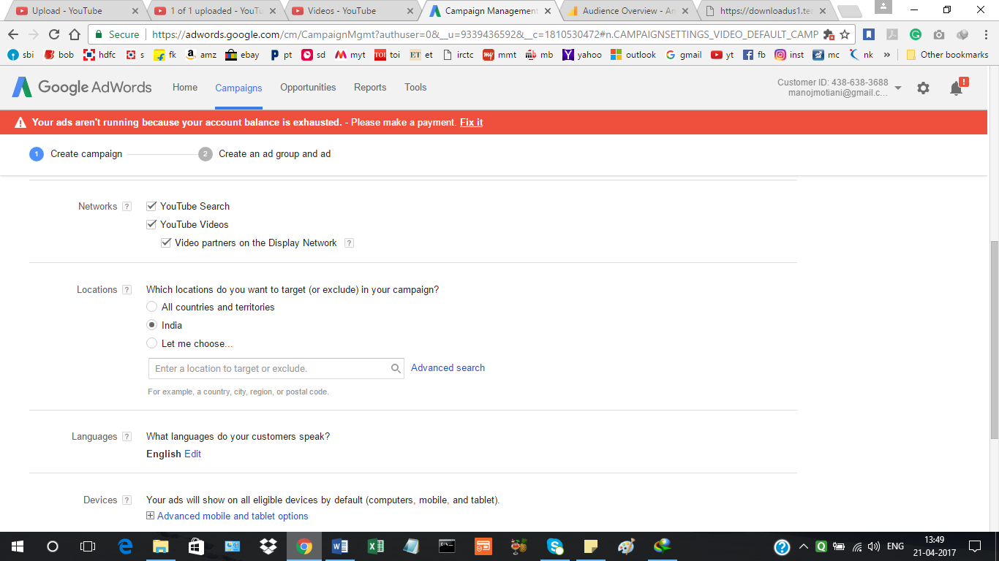

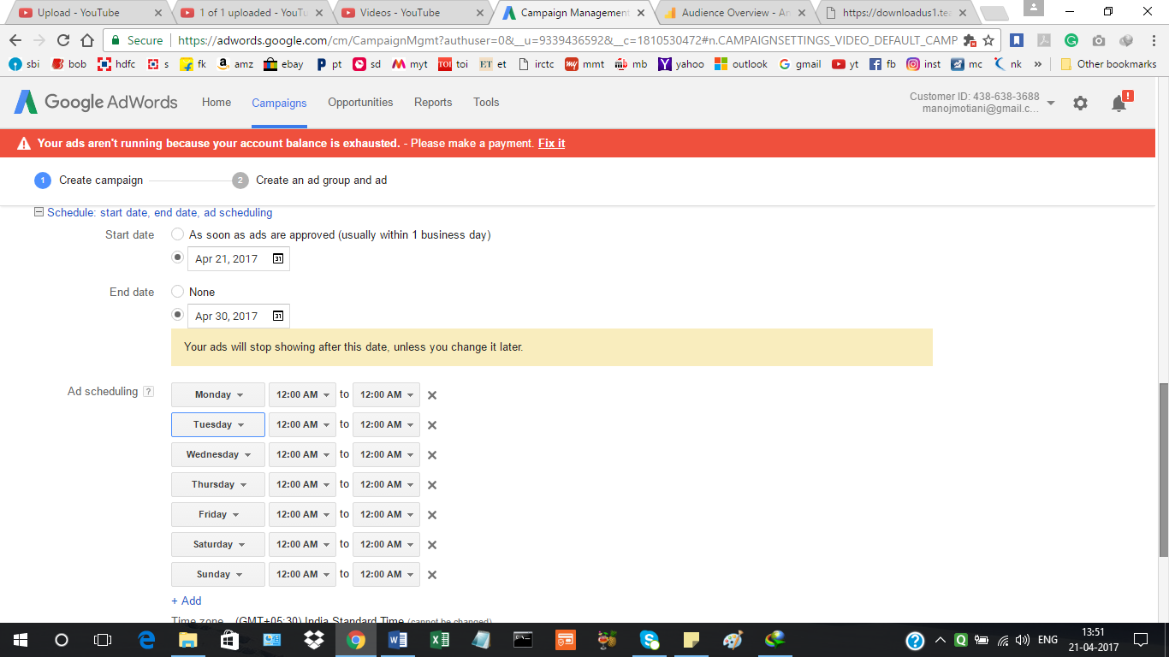

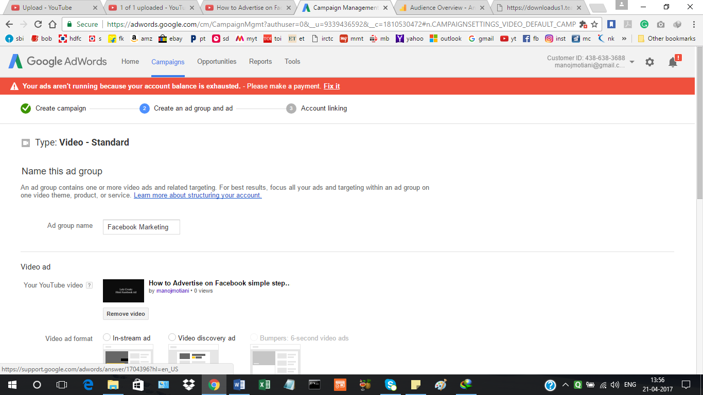

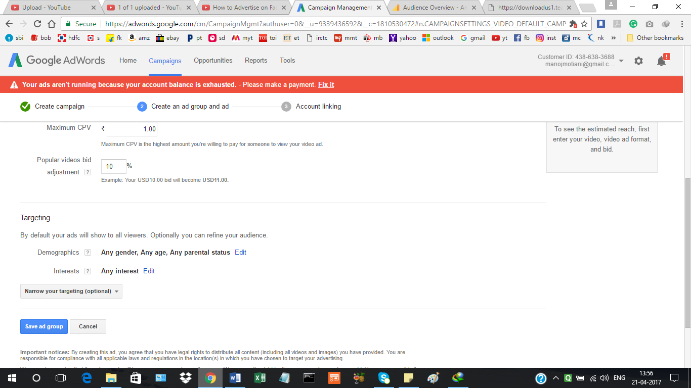

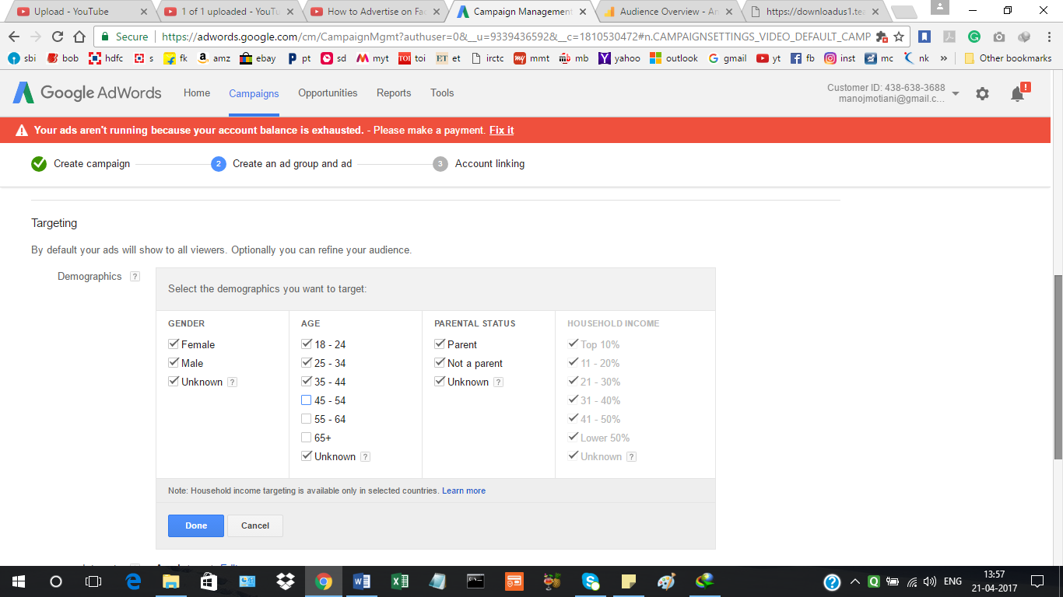

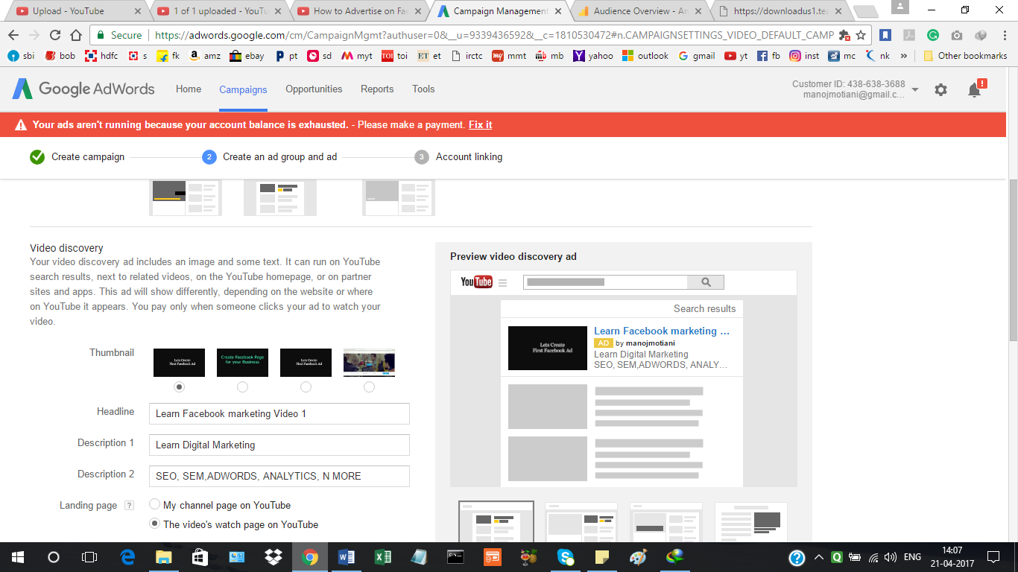

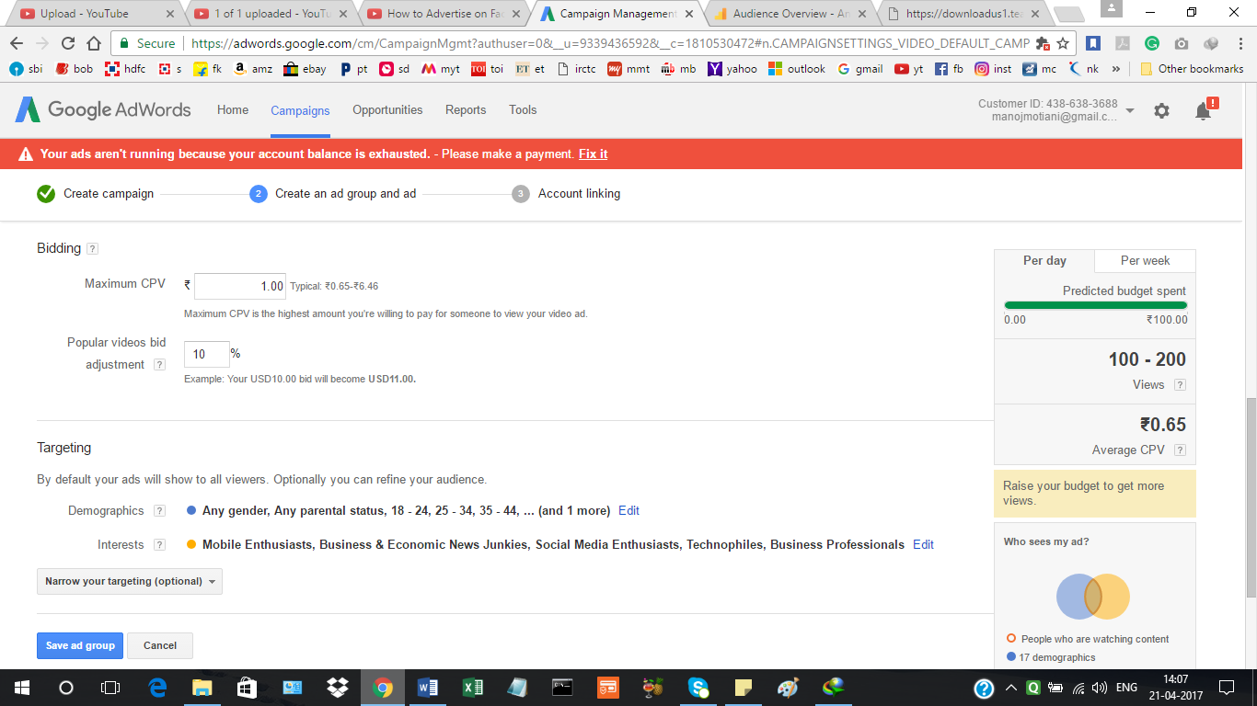

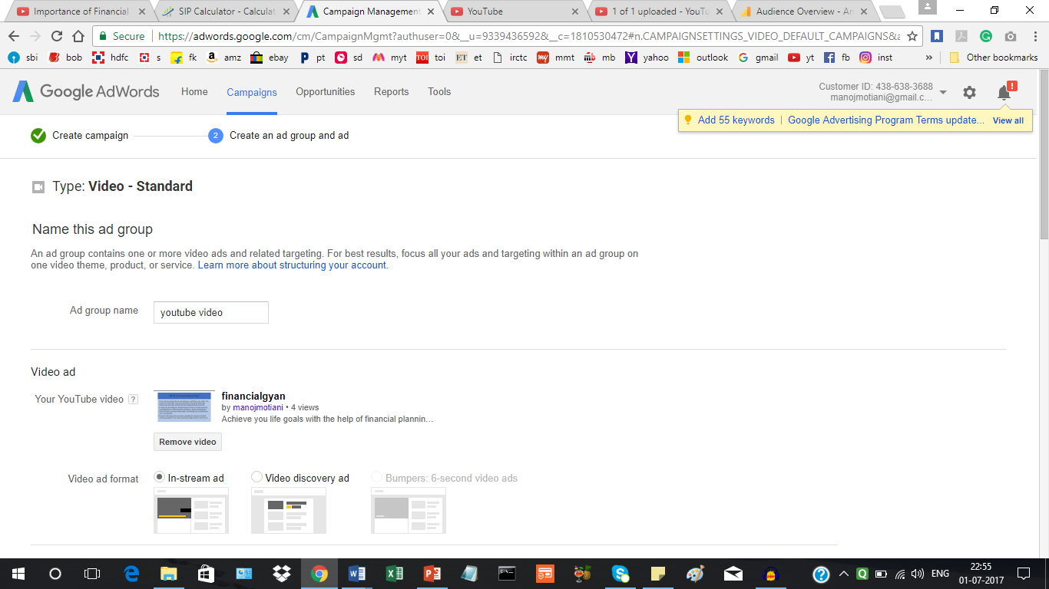

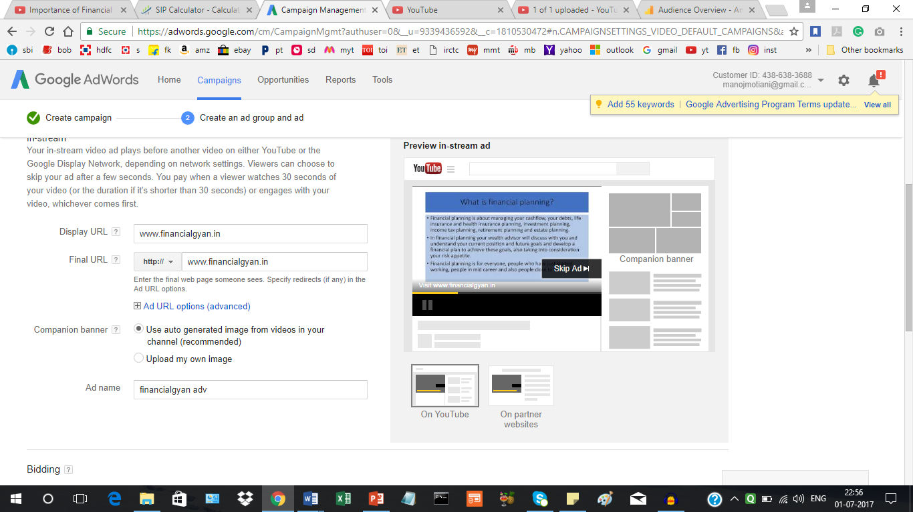

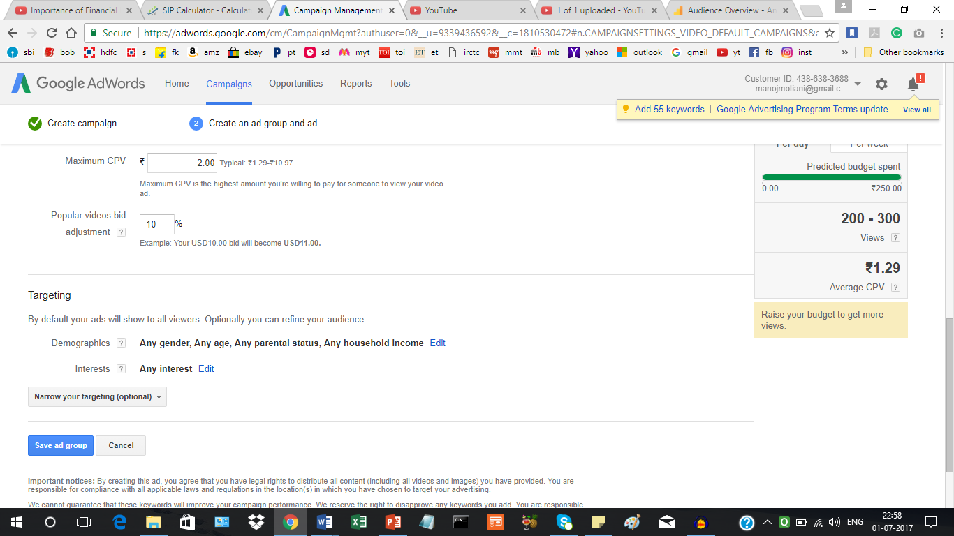

**Youtube: VIDEO UPLOADED**

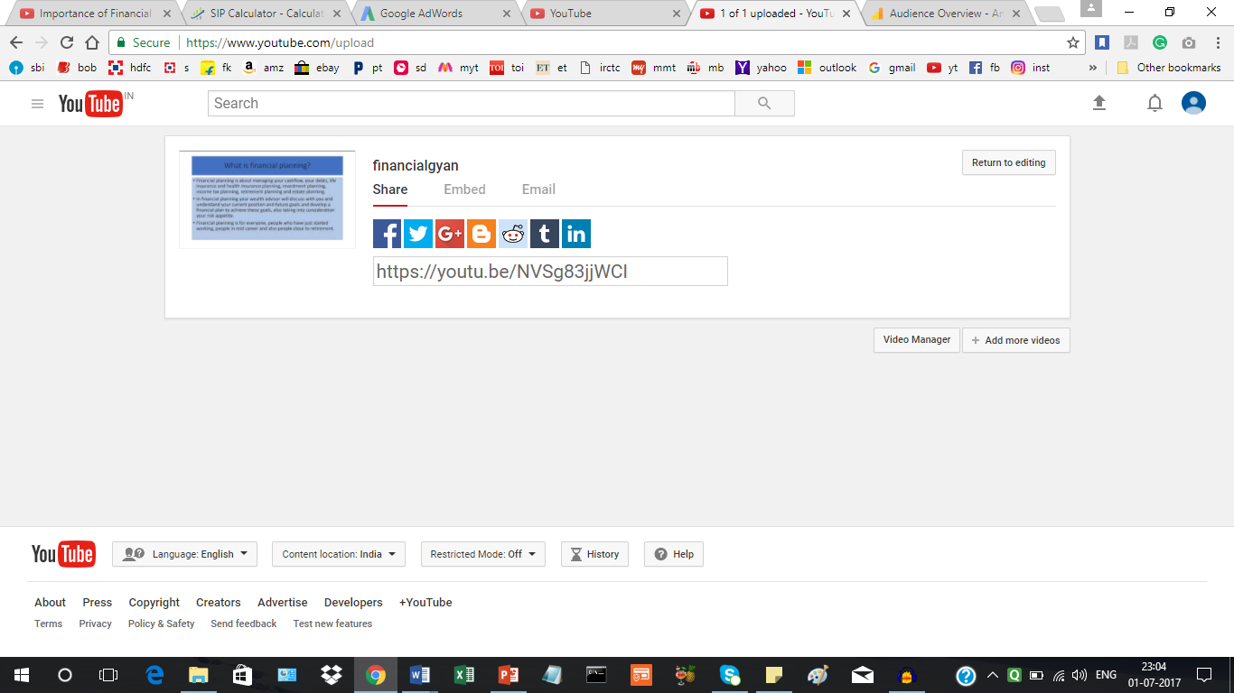

**Part 3 of Project 3: Email campaign using Mailchimp Email Service Provider:**

Building list:

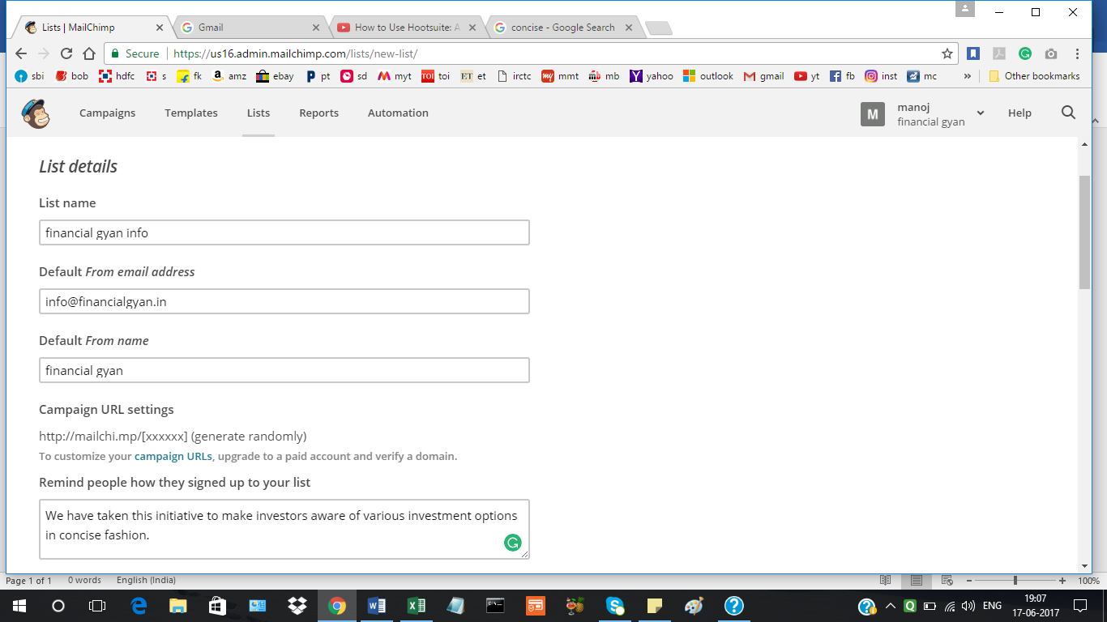

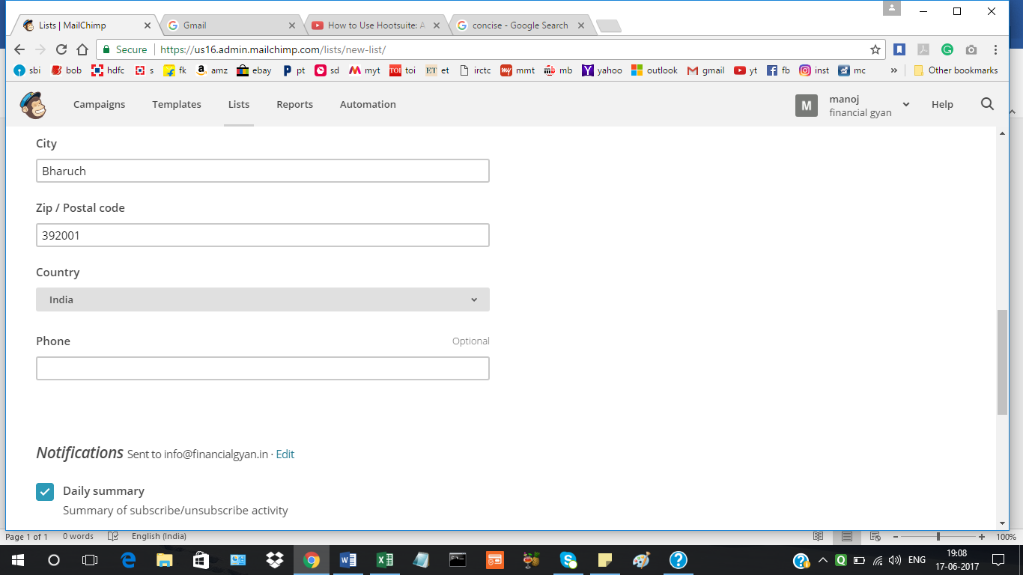

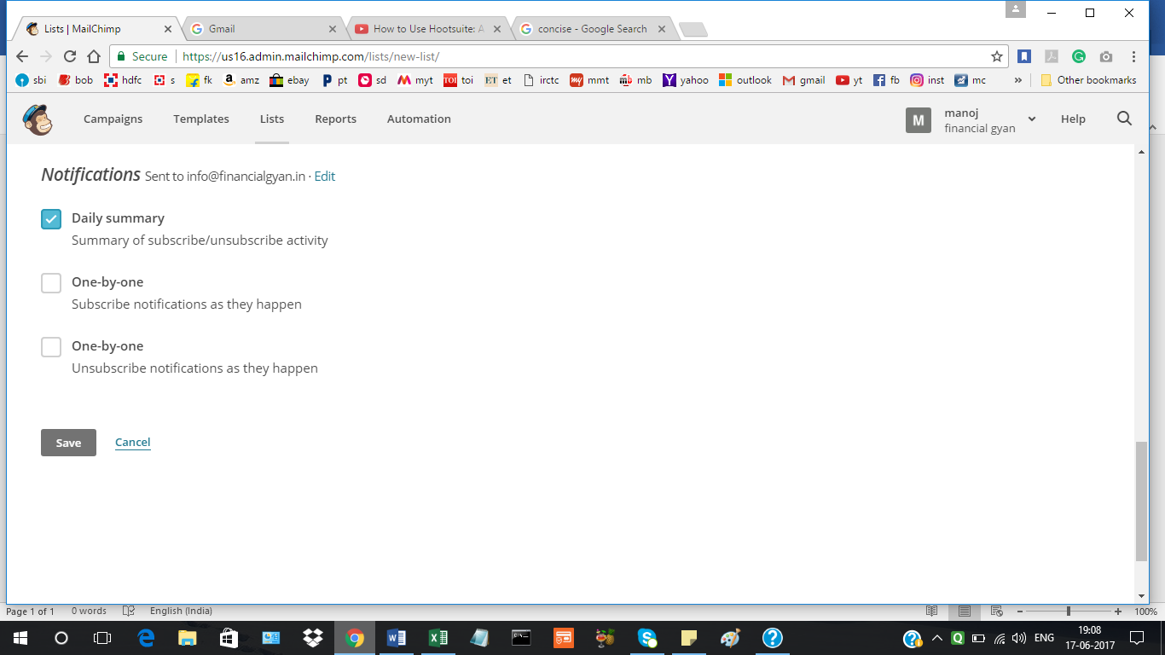

Importing LIST From Laptop:

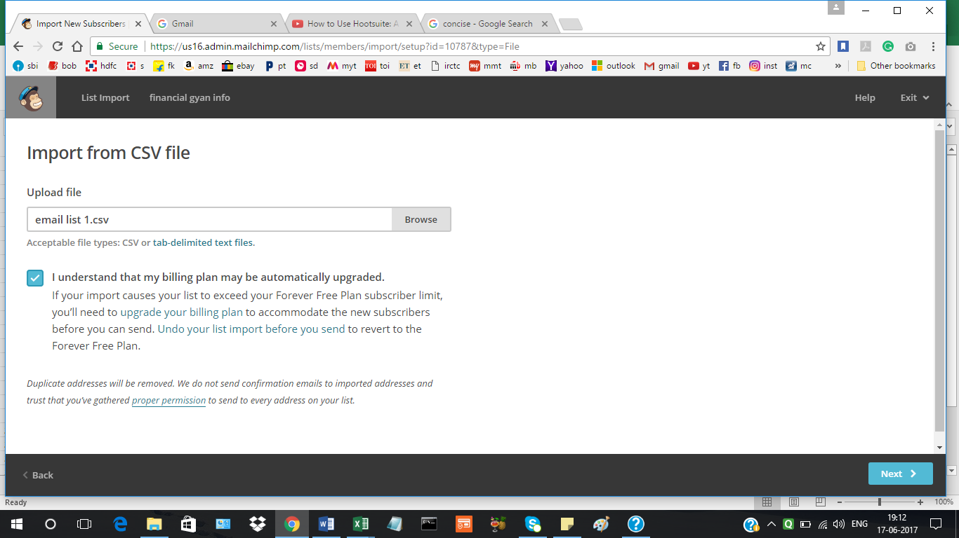

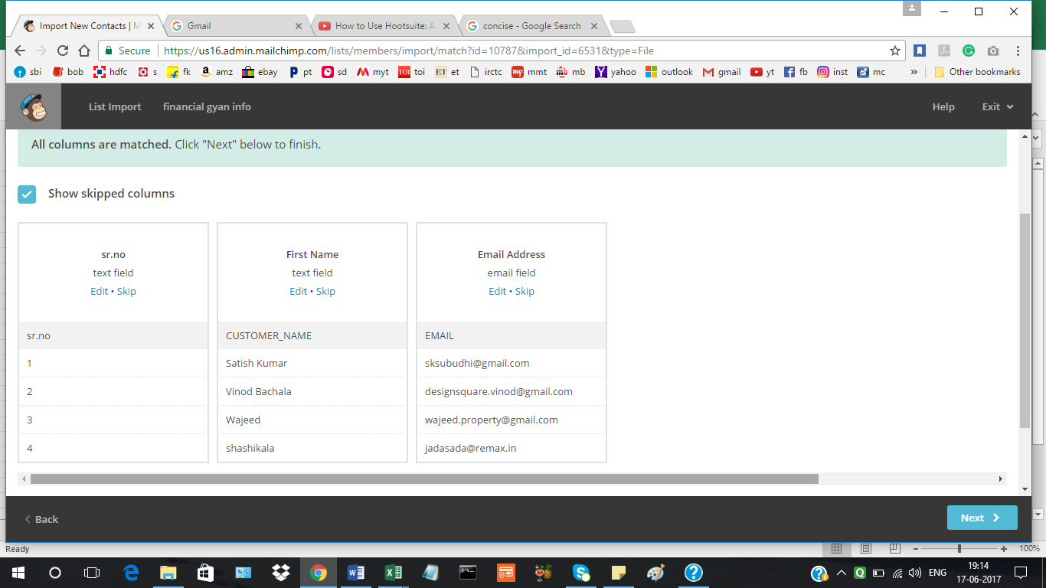

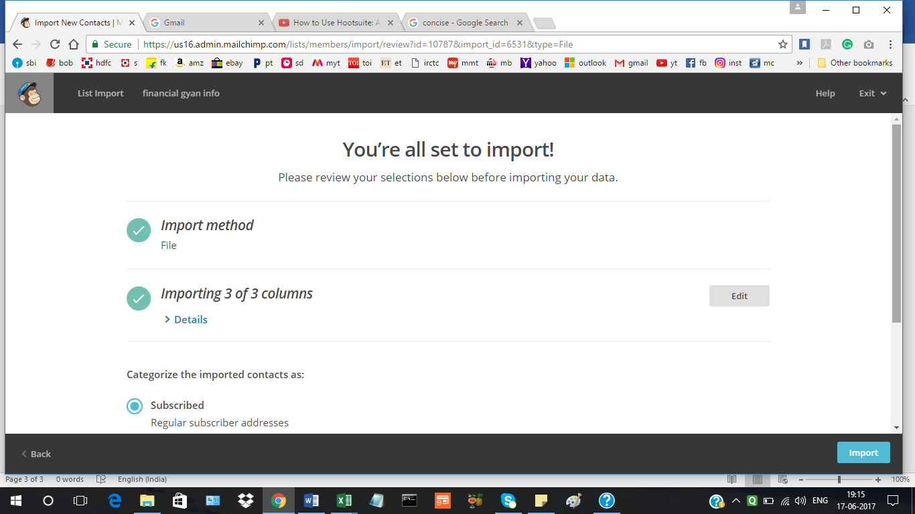

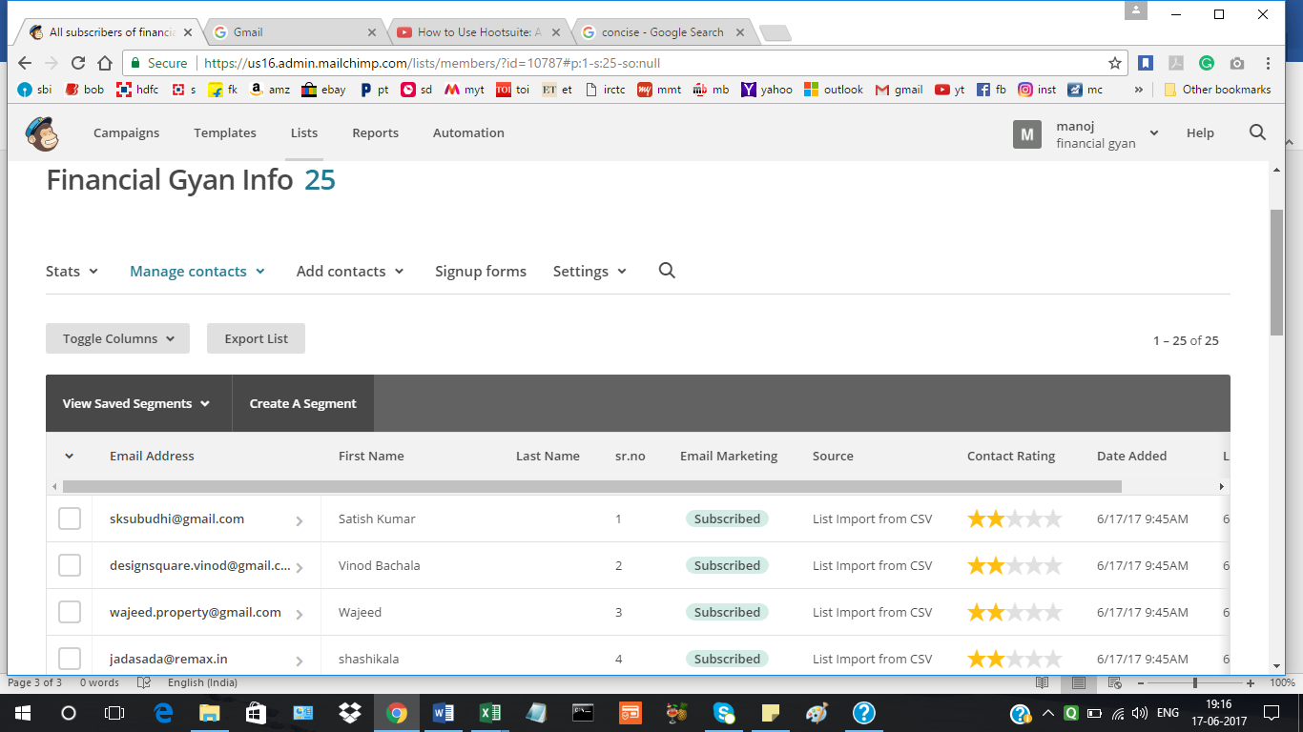

Google integrations under List setting, Google integration was also done under Campaigns:

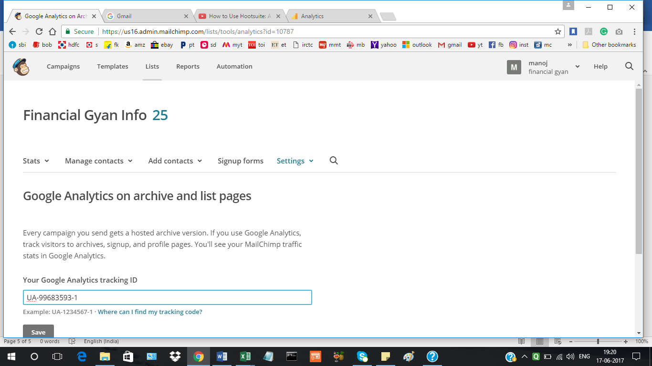

Domain Verified by Mailchimp:

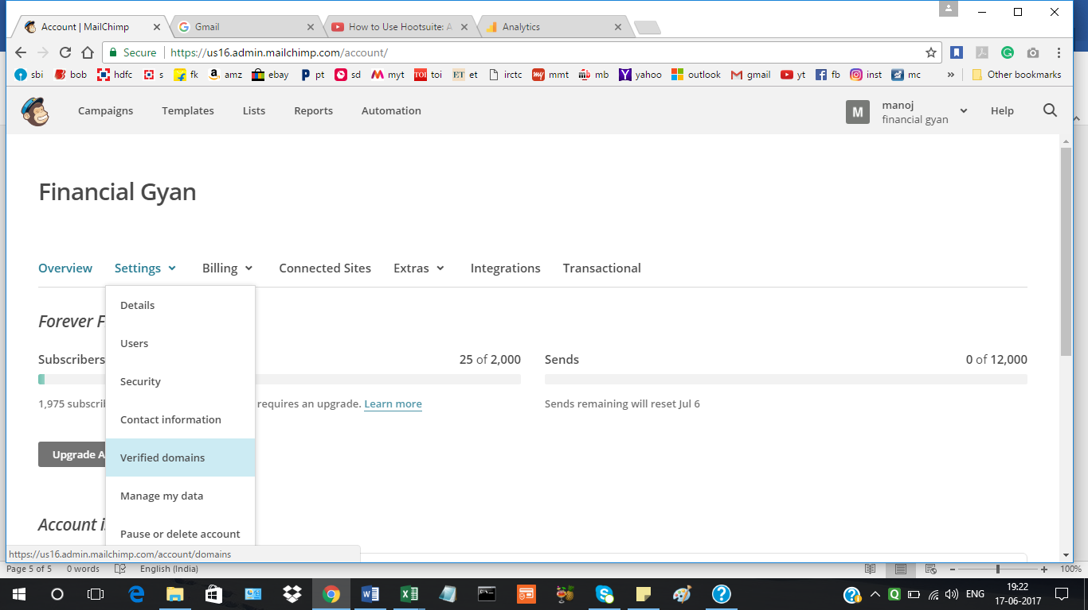

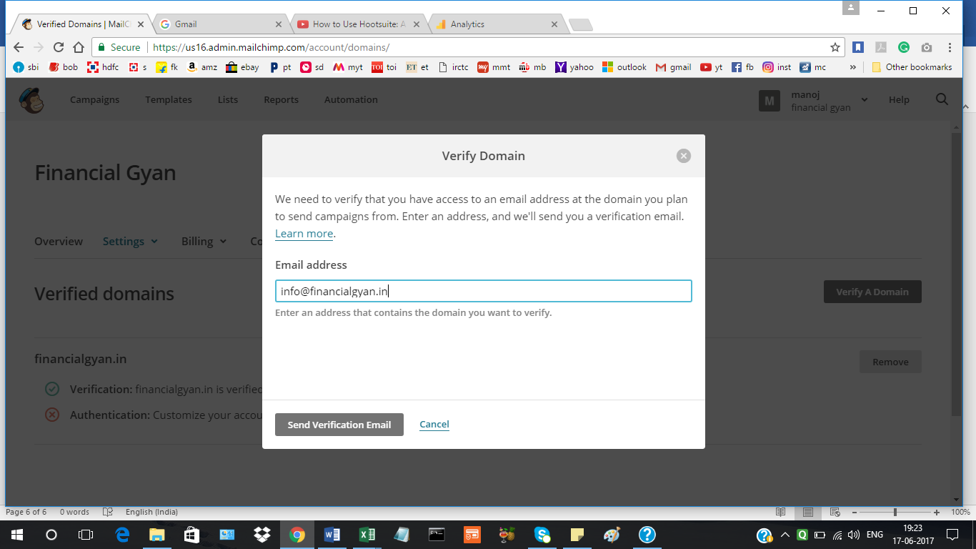

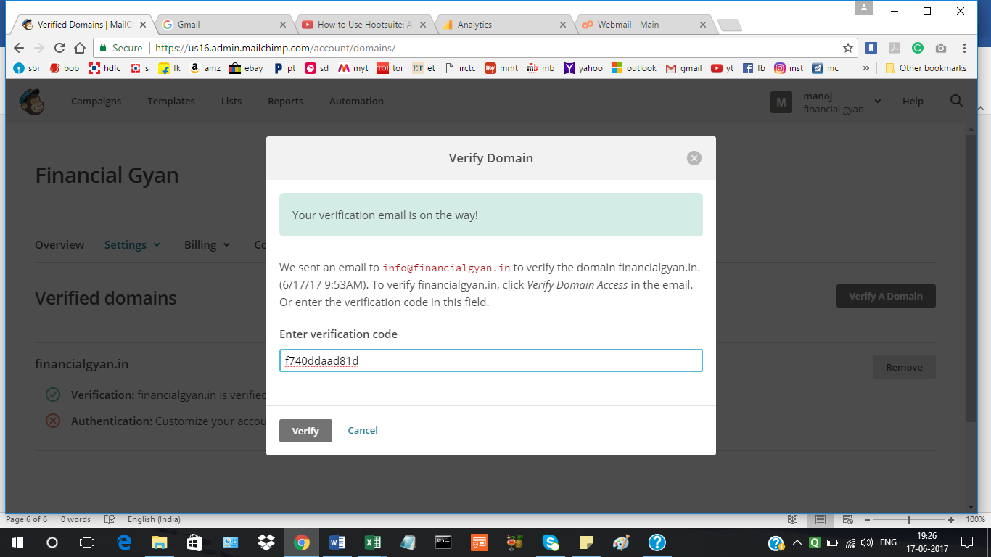

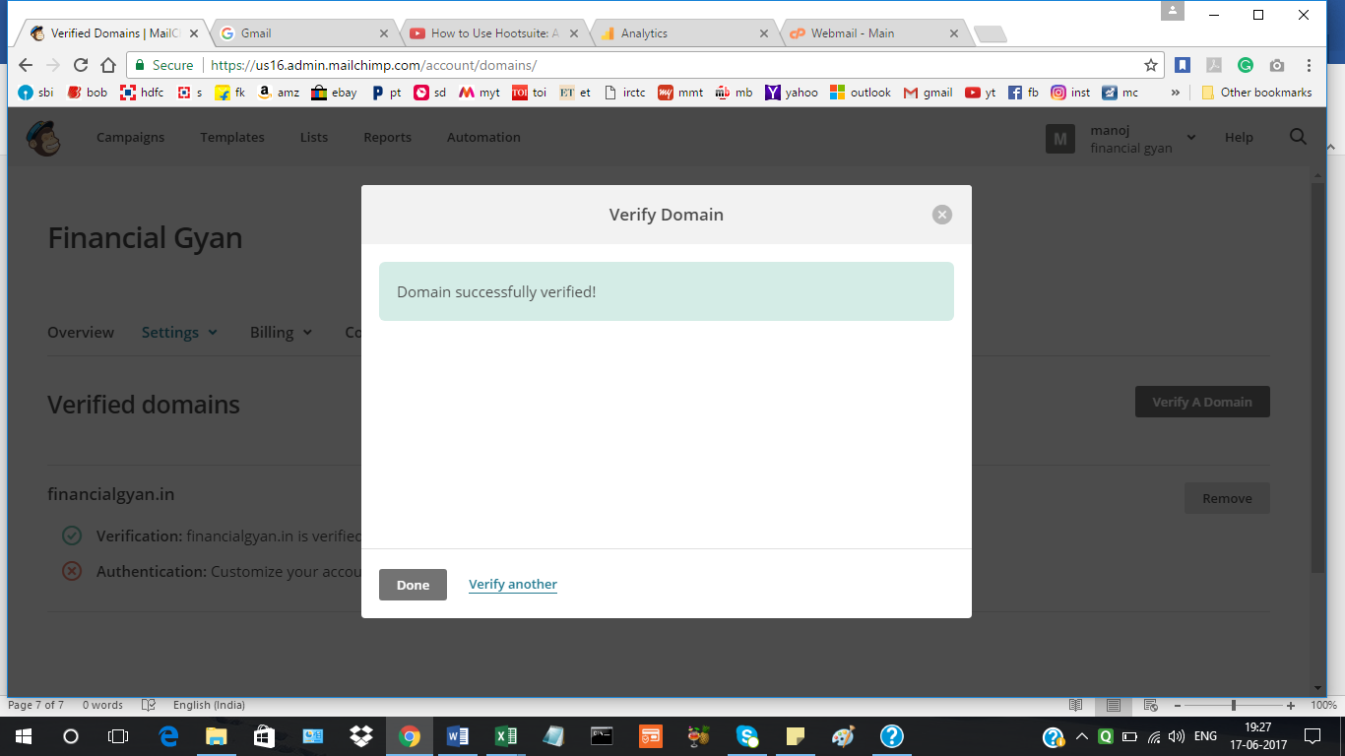

**Creating a Email Campaign:**

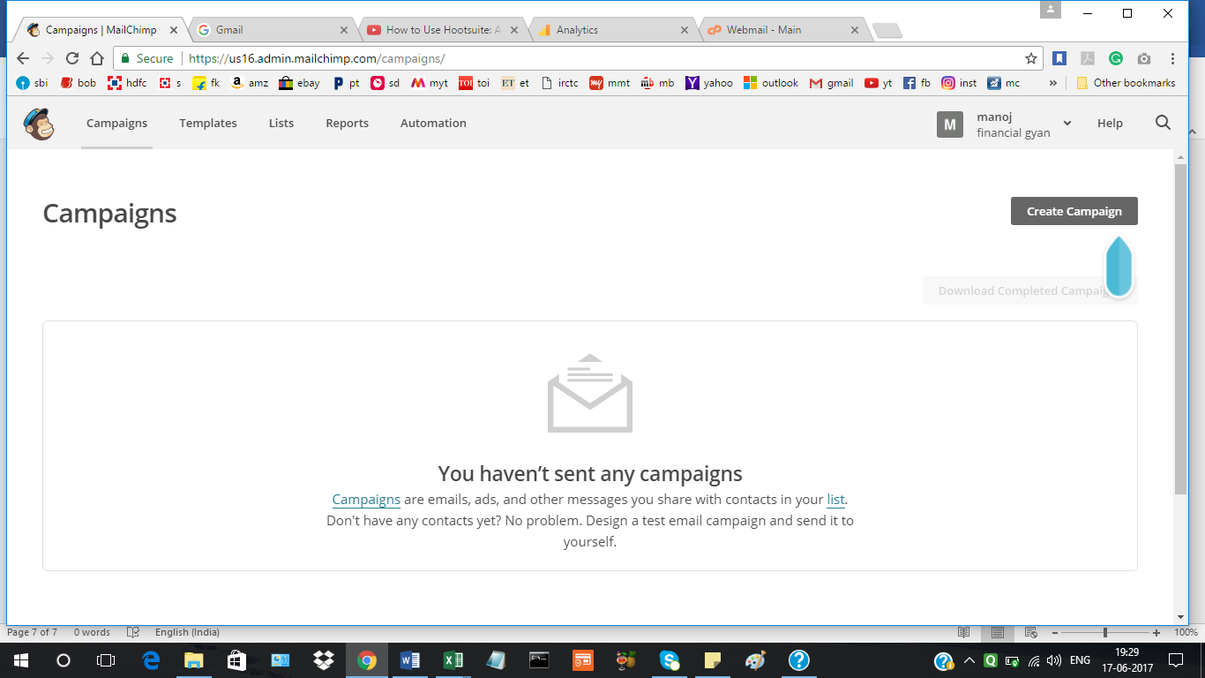

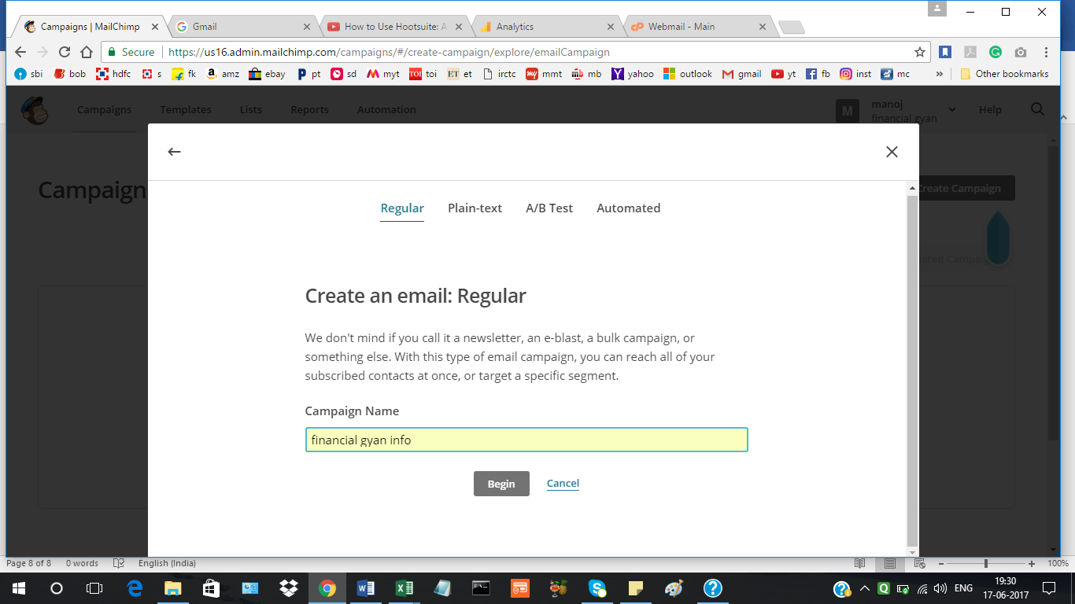

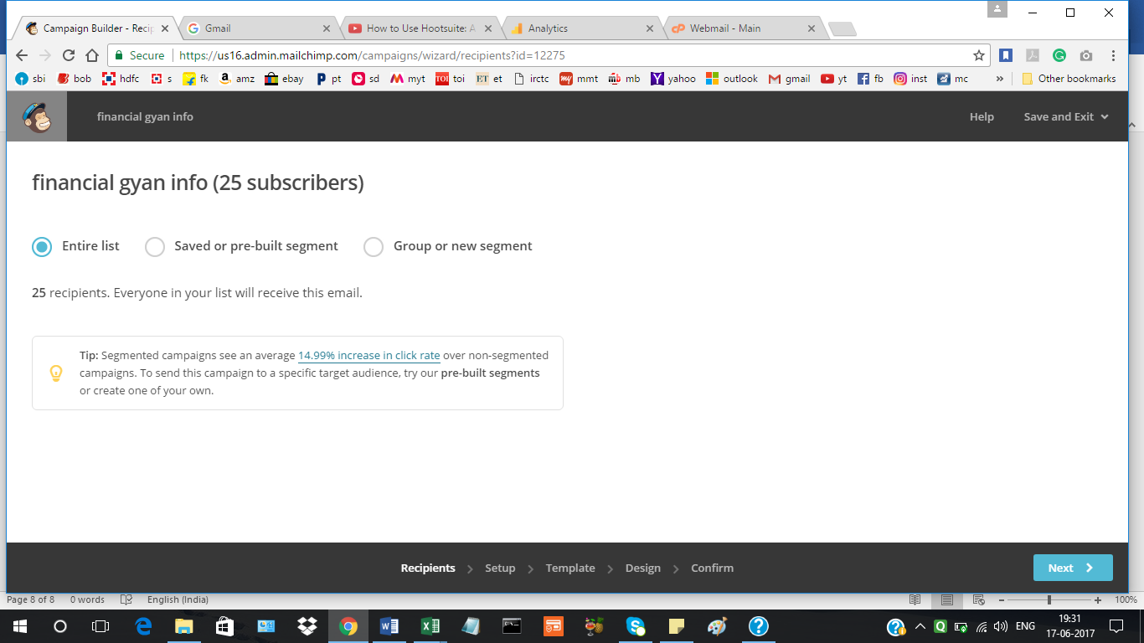

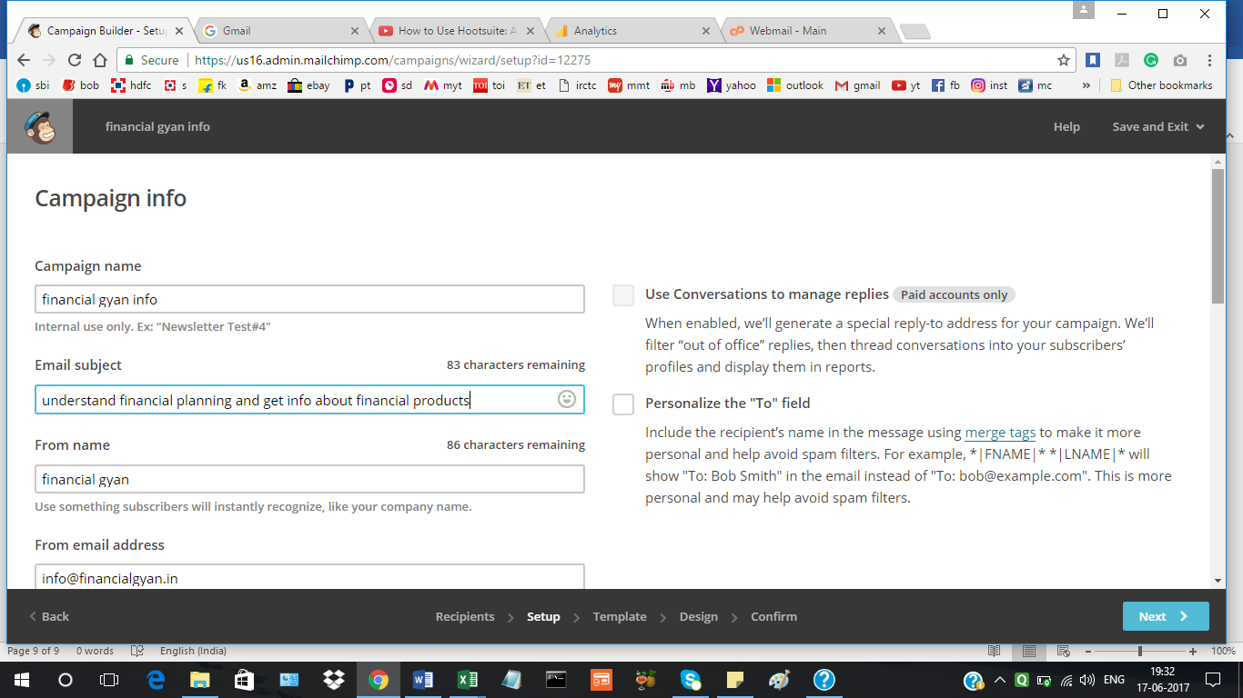

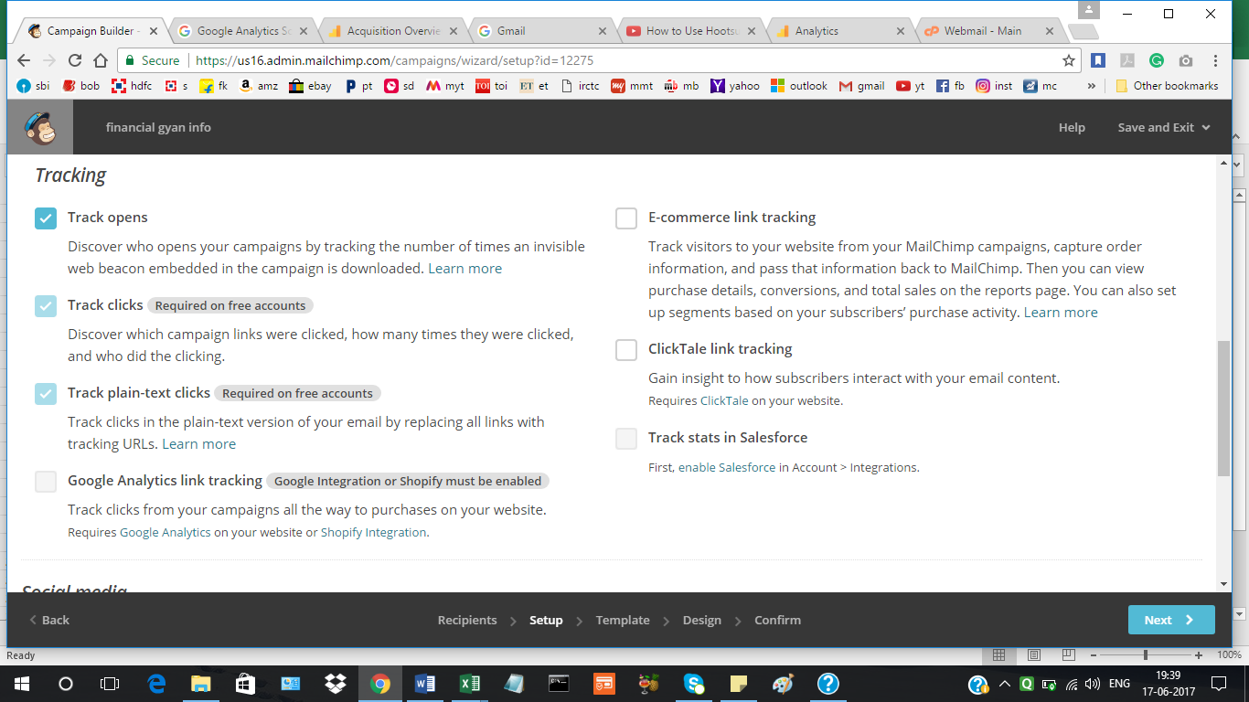

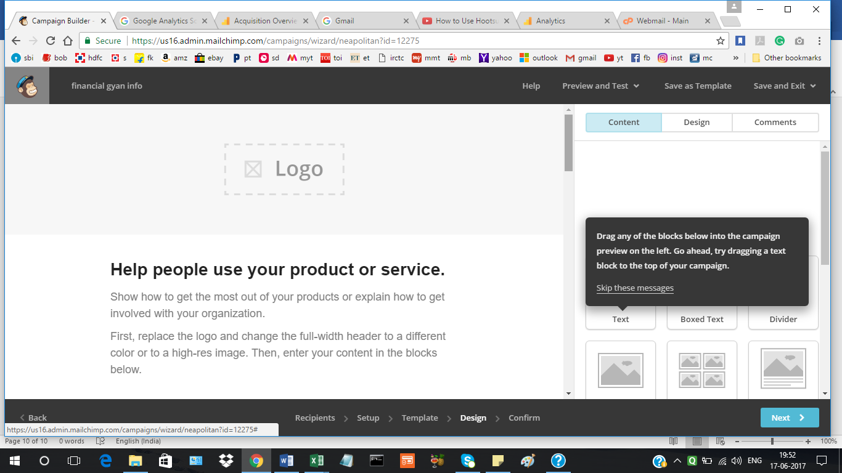

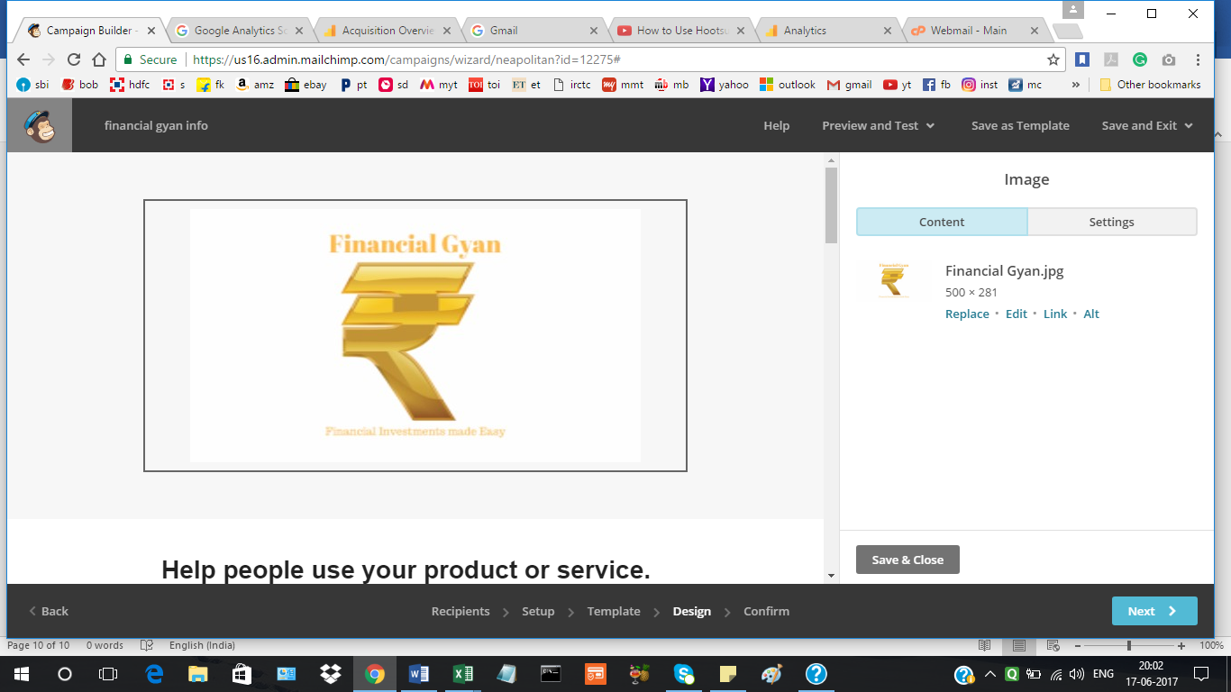

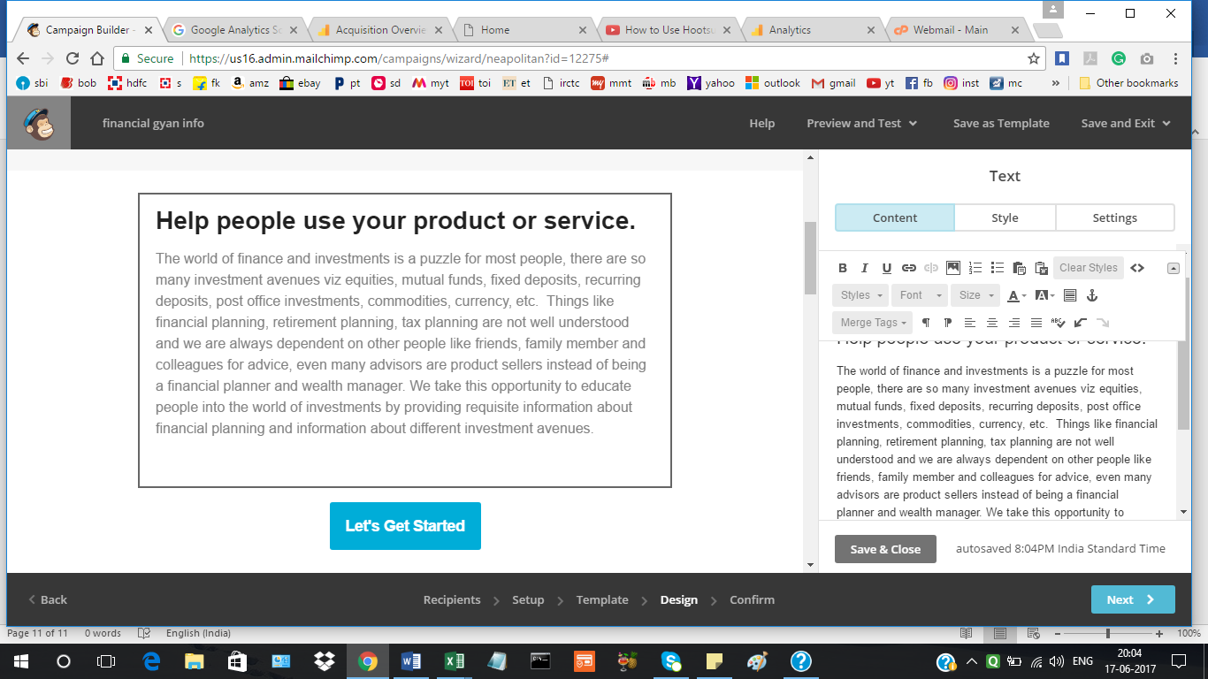

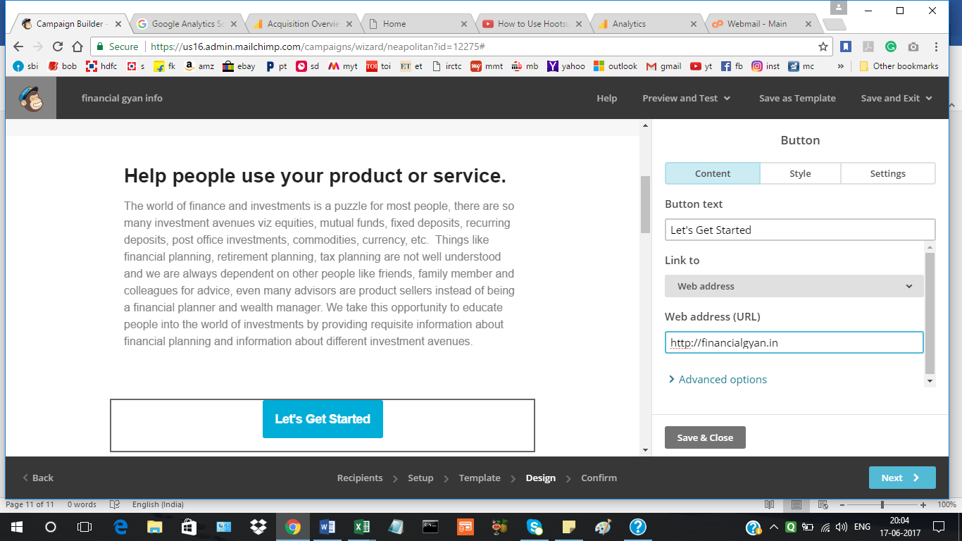

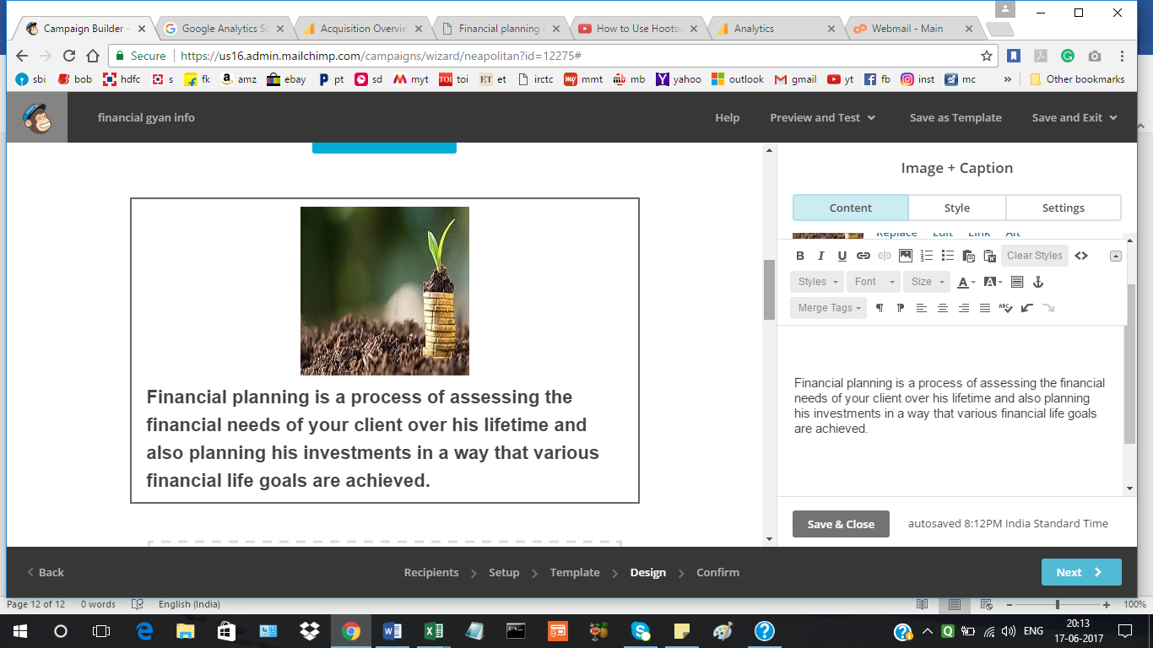

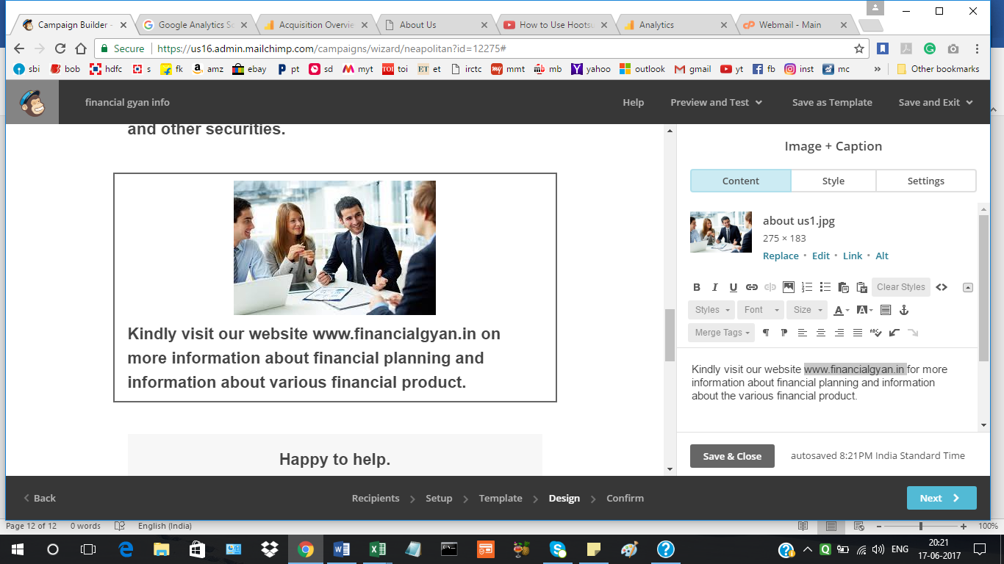

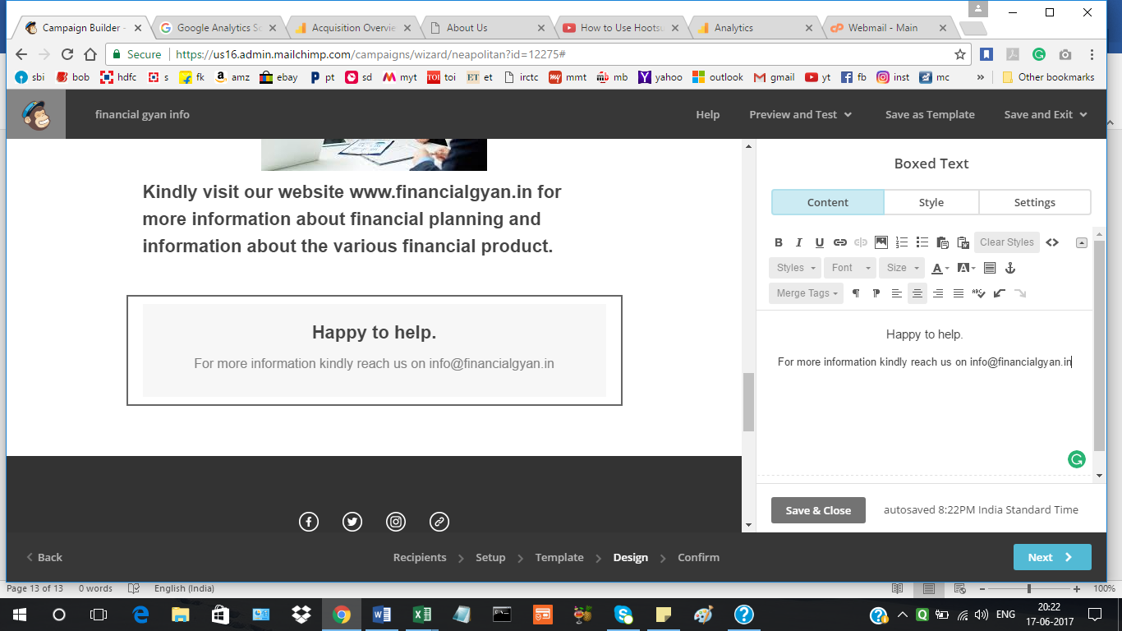

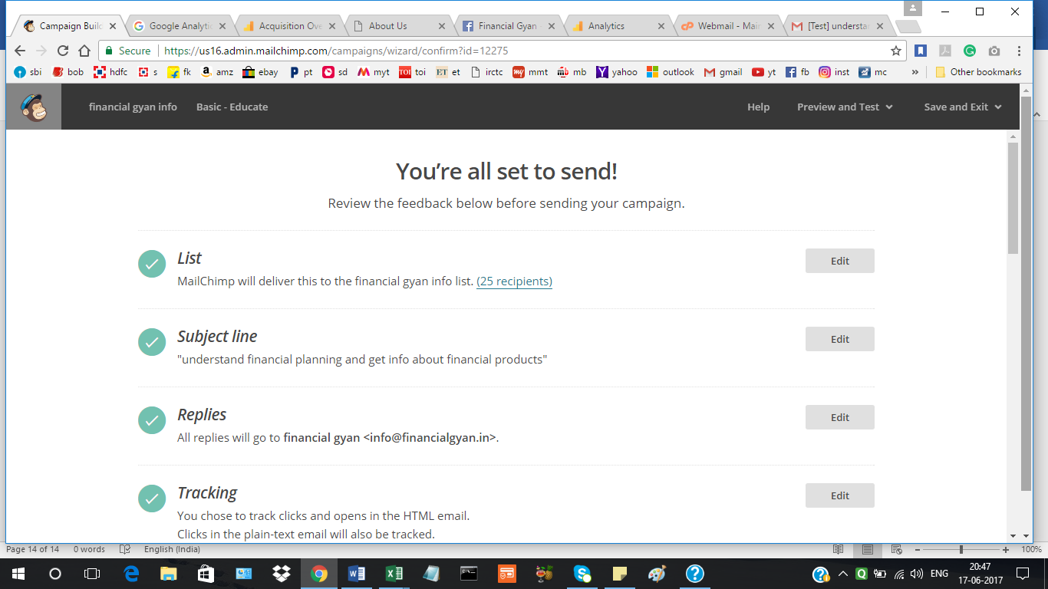

Scheduing the Campaign:

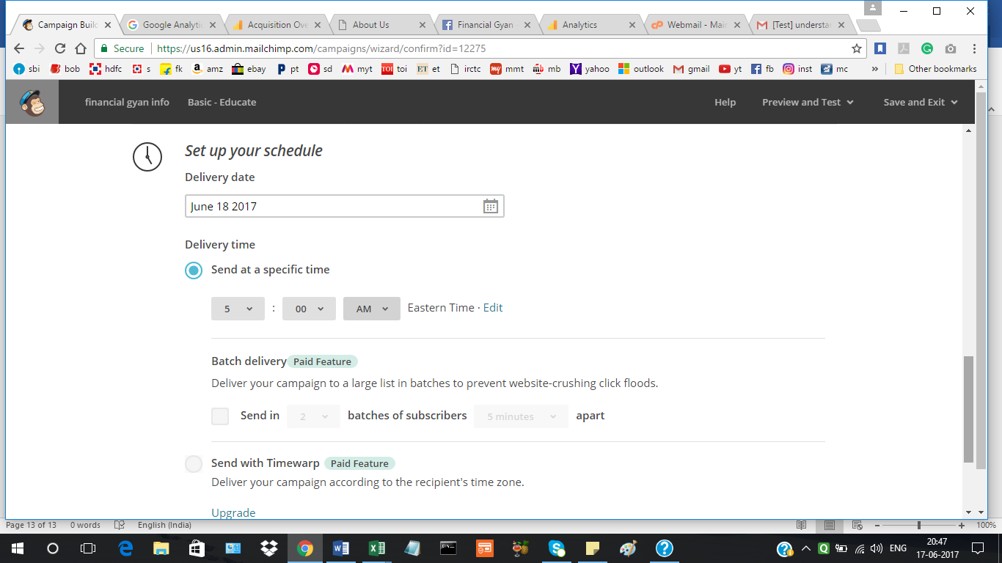

Campaign successfully schduled:

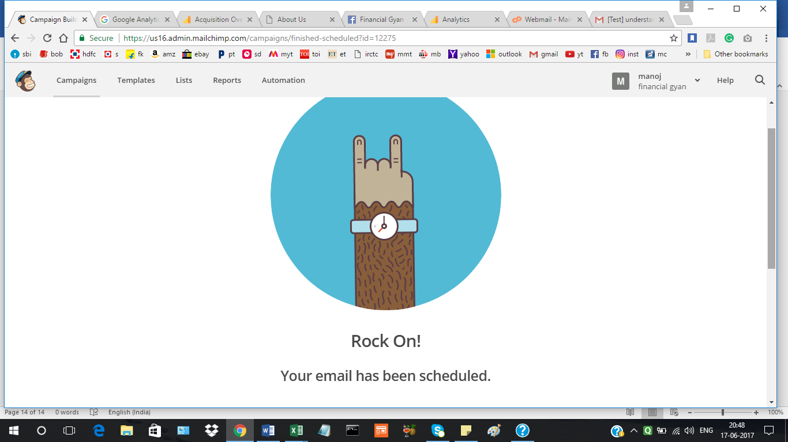

**Project 4:**

**Google analytics 15 days report and end of month report:**

**15 DAYS REPORT:**

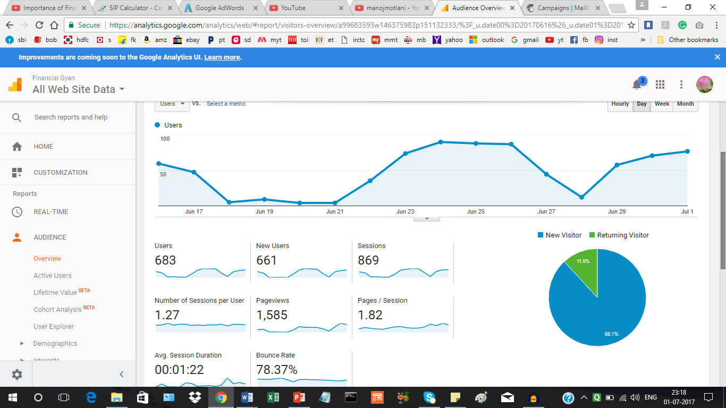

**END OF MONTH REPORT:**

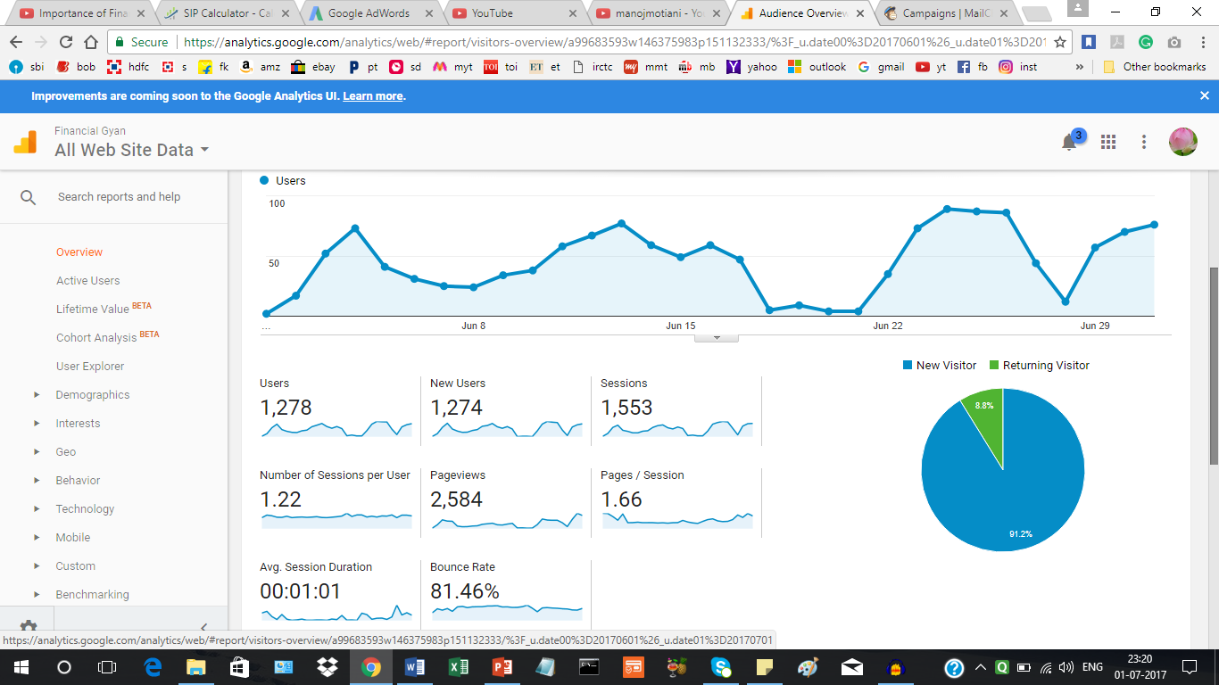

**Analysis of traffic under Acquisiton:**

**15 days:**

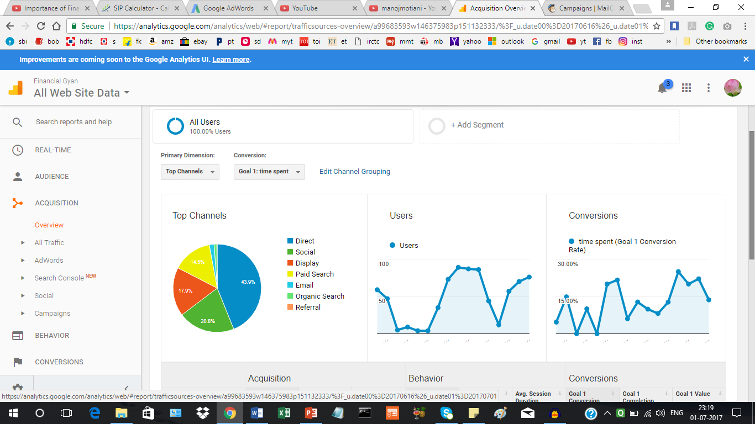

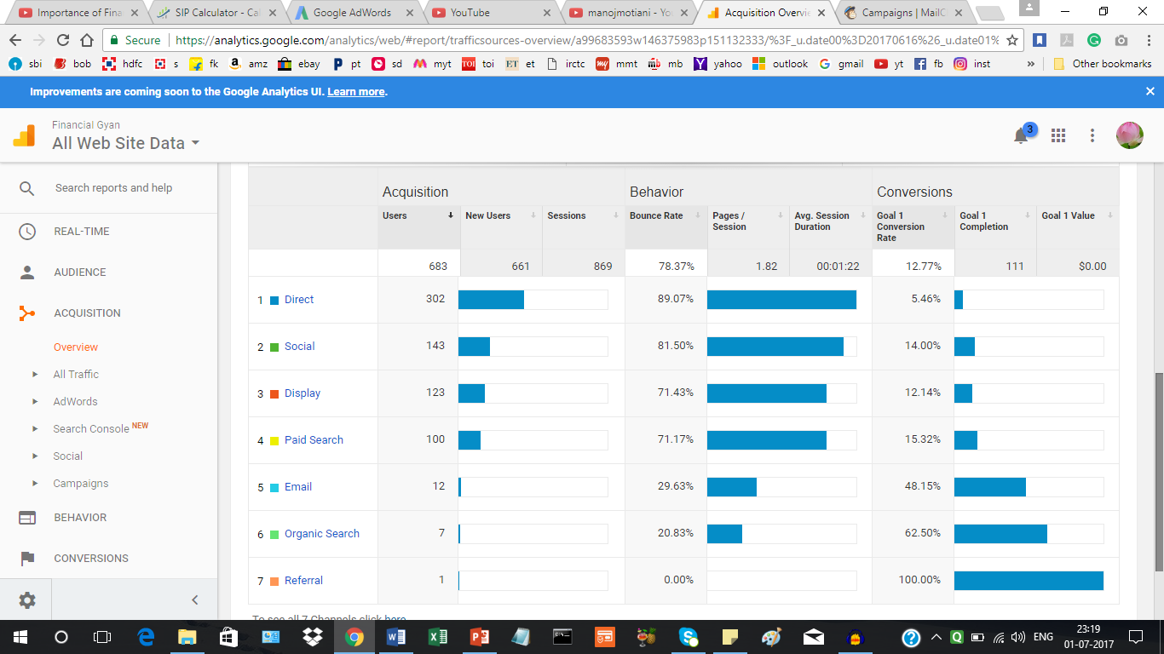

**One month traffic report:**

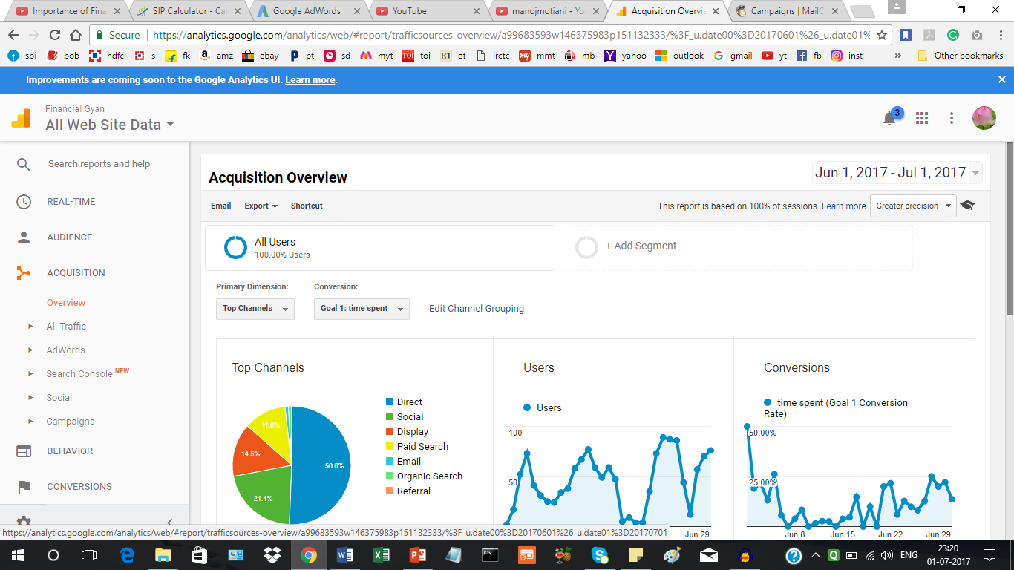

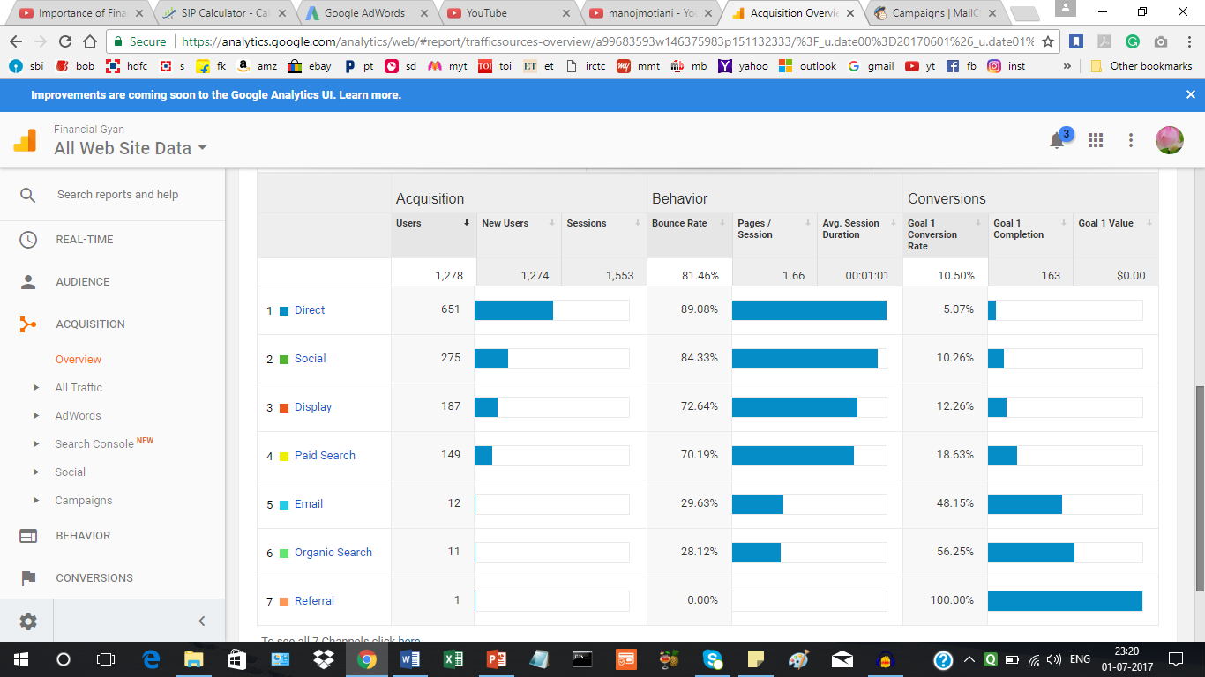

**AdWords report and effect of PPC on website’s traffic:**

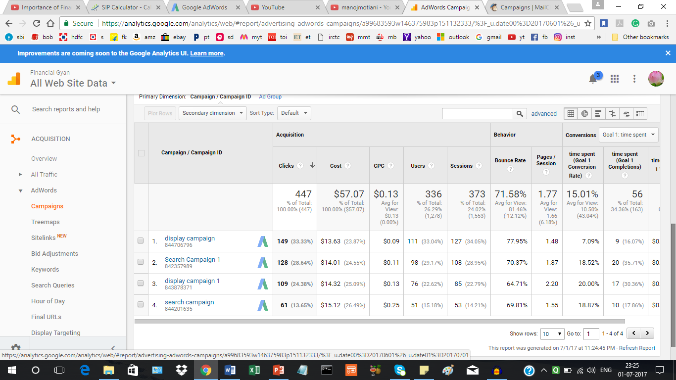

Bid adjustments in adwords:

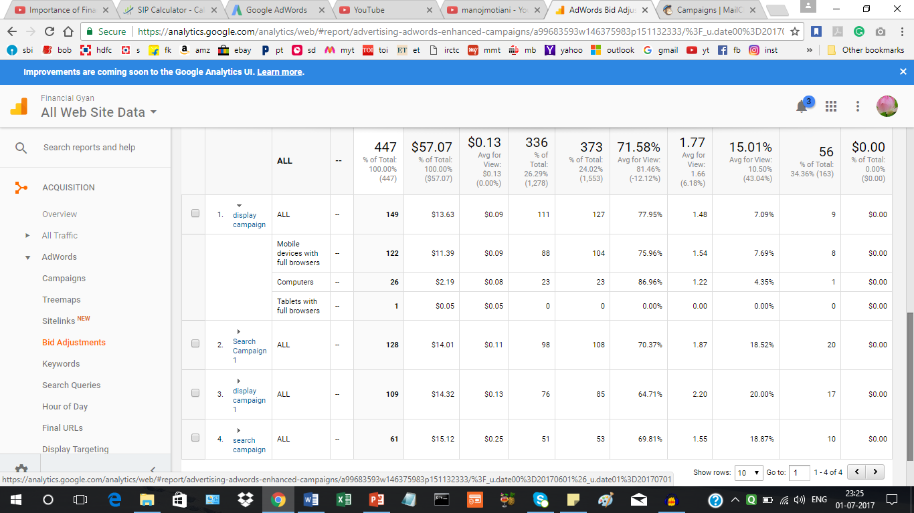

Keyword report in adwords:

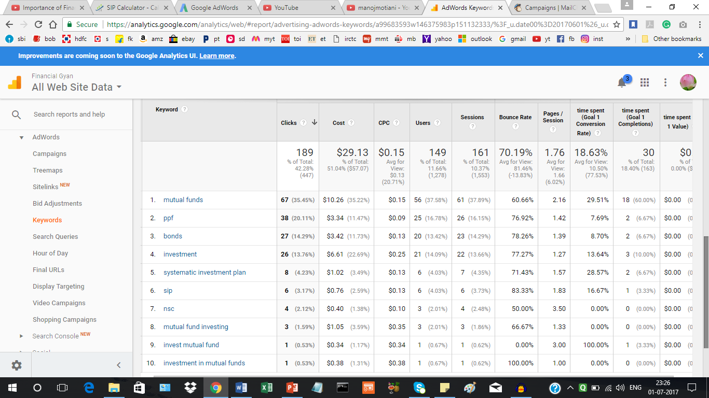

Search query:

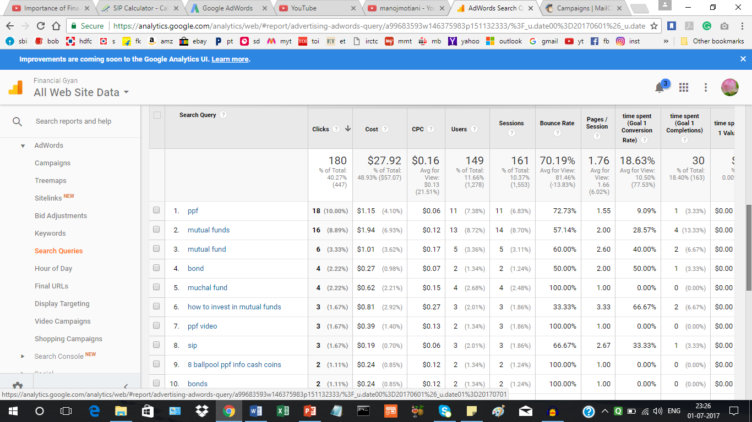

Display targeting:

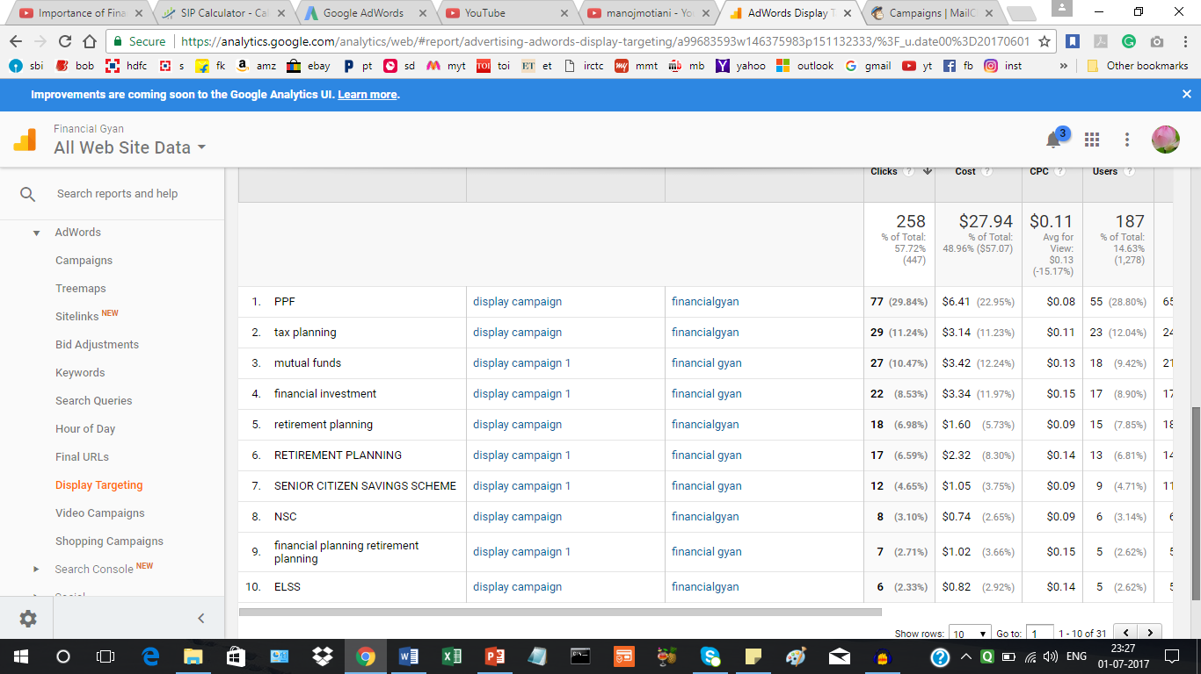

Email mailchimp report:

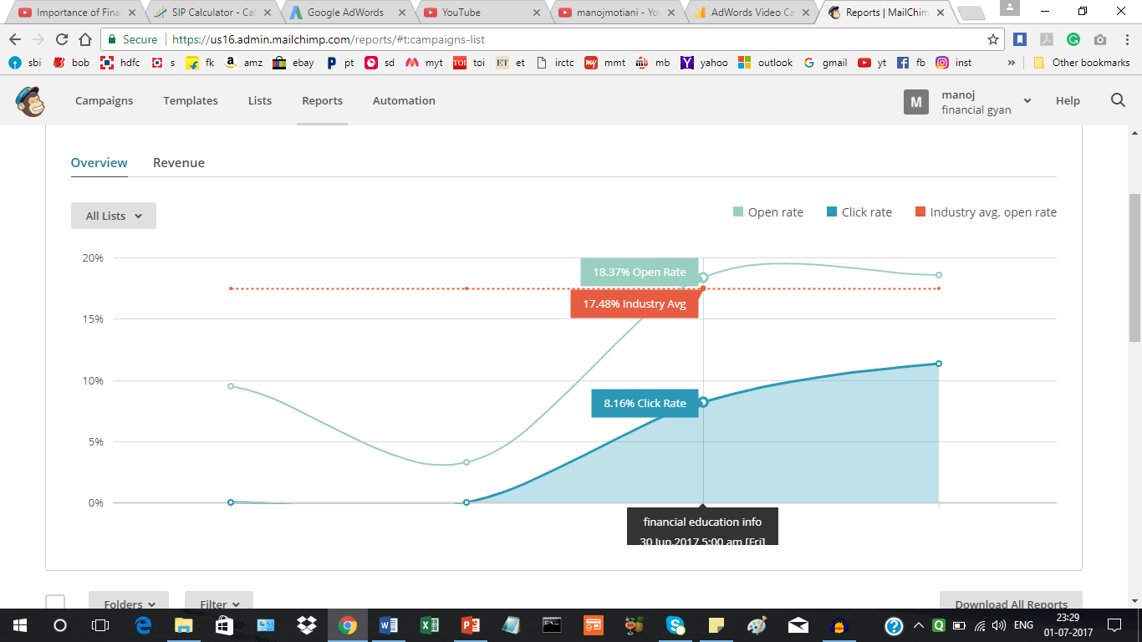

Industry average open rate: 17.48%

List open rate: 18.37%

Click rate: 8.16%

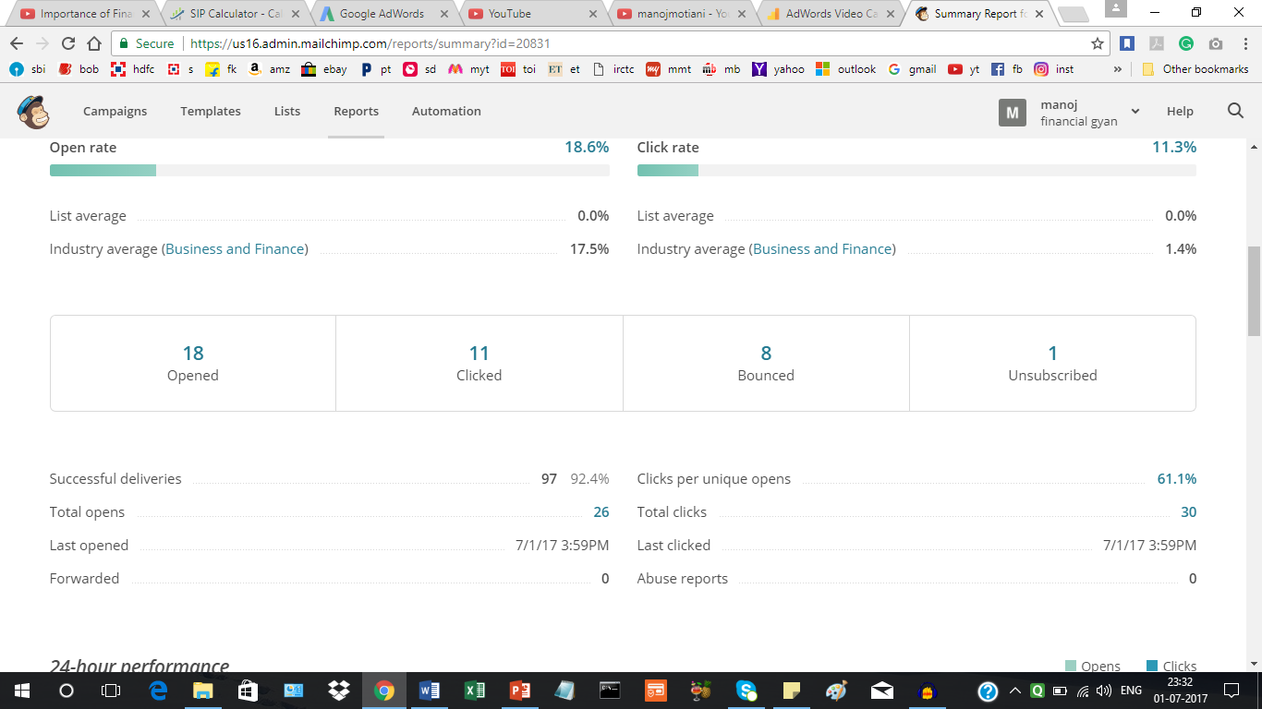

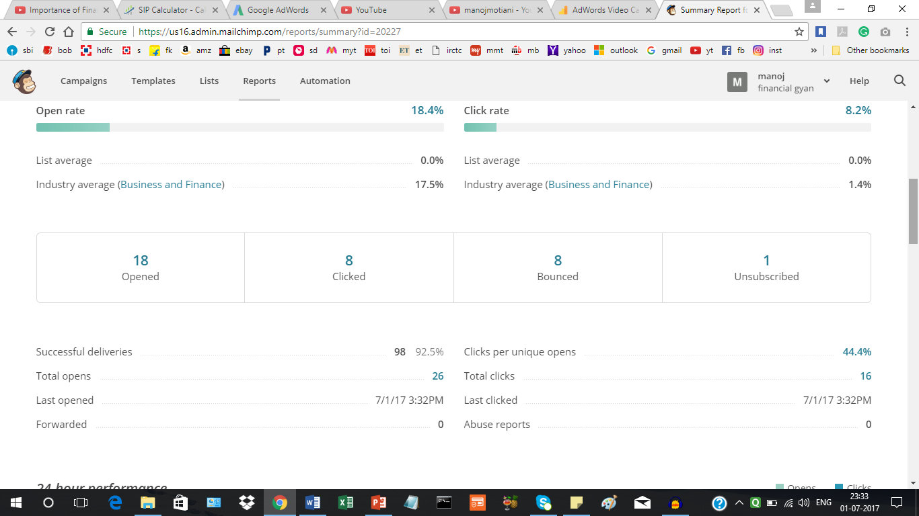

**Facebook insights report with post engagement details:**

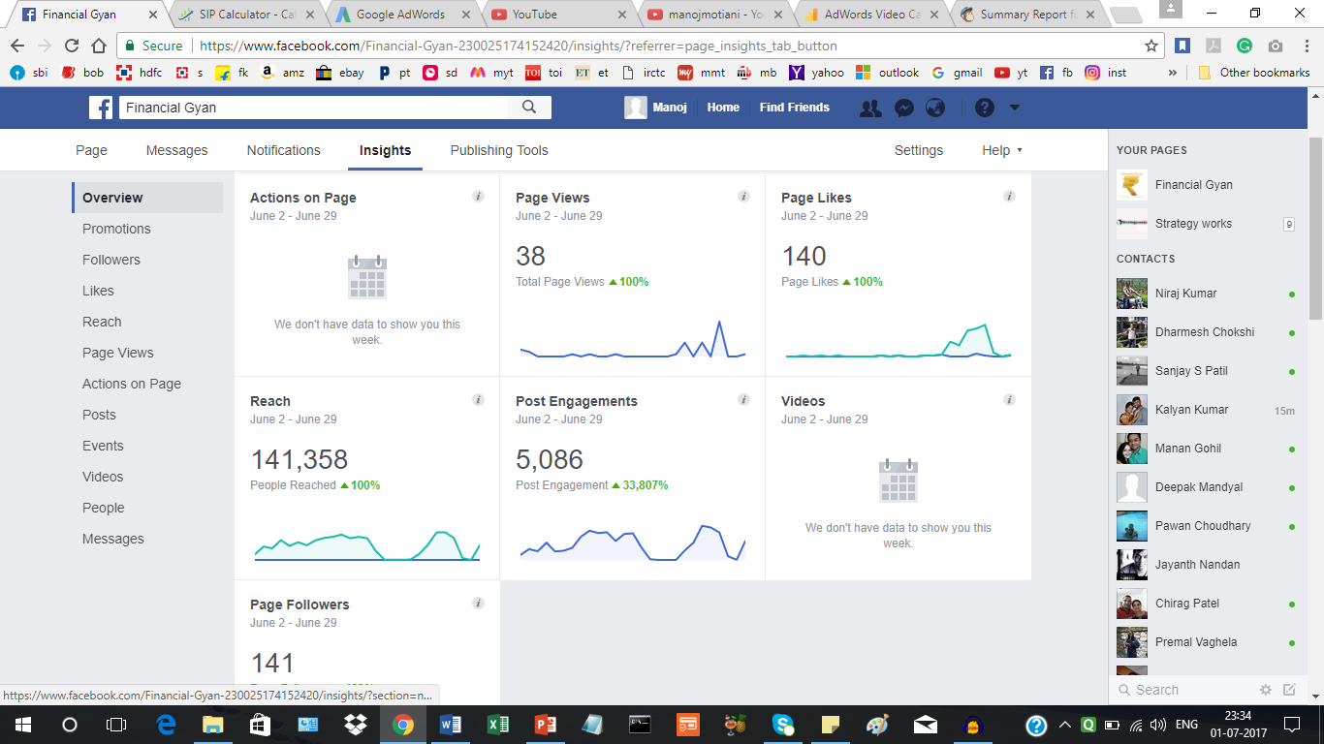

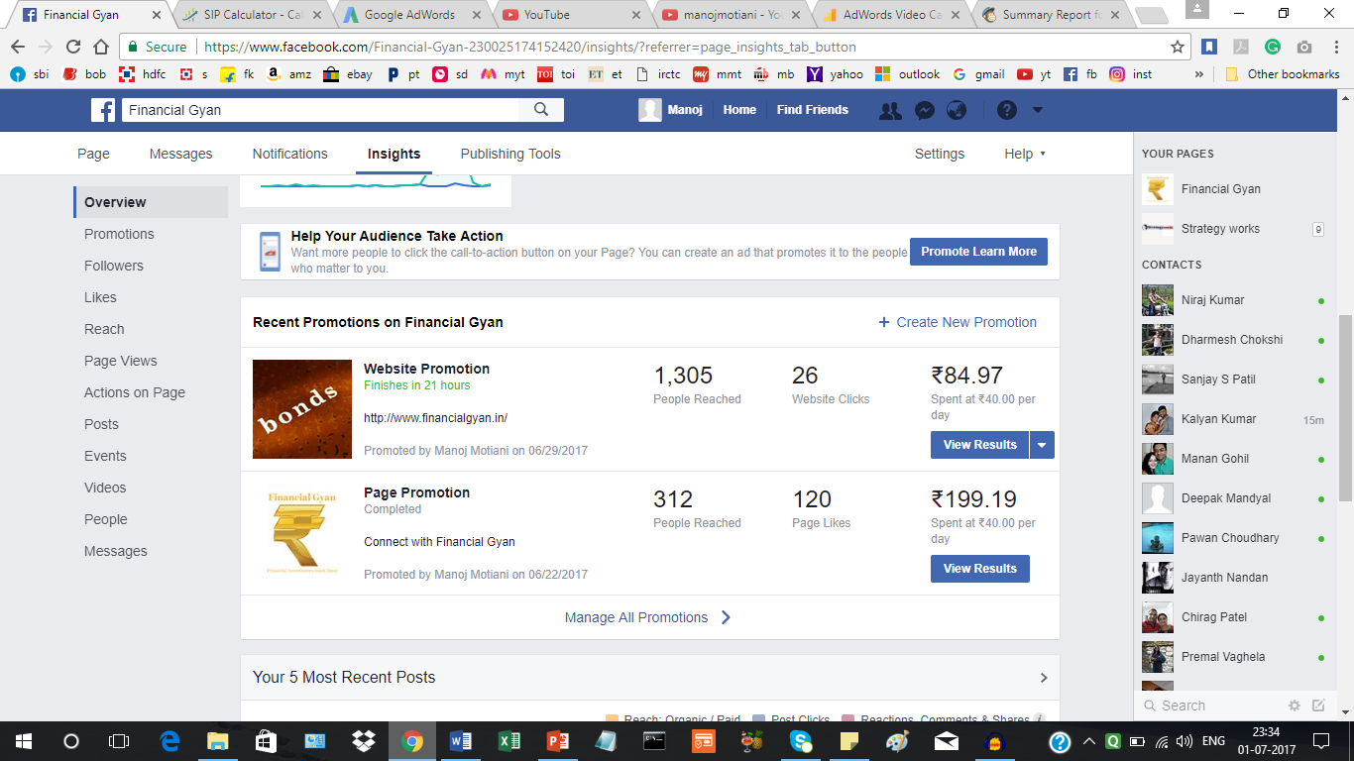

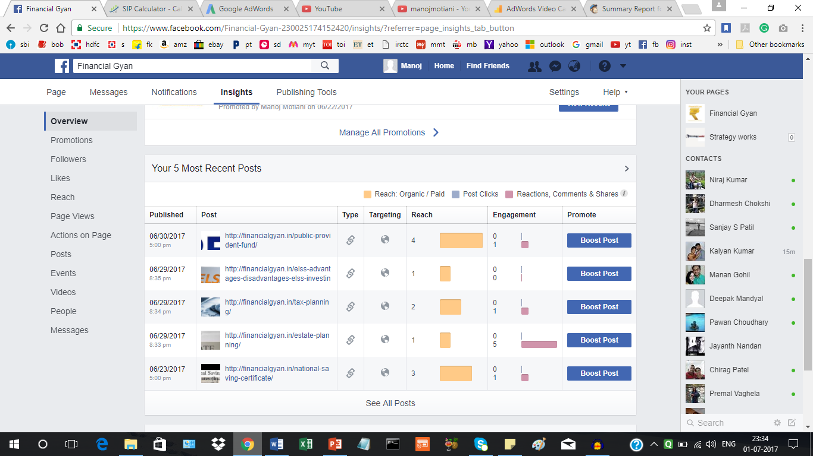

**PROJECT COMPLETION:**

15 days report:

The following format is used to track the progress of digital marketing campaign:

|  |  |  |  |  |  |  |
| --- | --- | --- | --- | --- | --- | --- |
| Stage | Sessions | Bounce rate | Pageviews | Unique  Pageviews | Average session duration | % new sessions |
| Week1 | 174 | 70.69 | 391 | 140 | 1.19 | Not displayed |
| Week 2 | 262 | 74.81 | 525 | 233 | 1.11 | Not displayed |
| Week 3 | 485 | 78.97 | 775 | 337 | 0.59 | Not displayed |
| Week 4 | 416 | 74.52 | 900 | 310 | 1.50 | Not displayed |
| Final | 1337 | 74.75 | 2591 | 1020 | 1.1 | Not displayed |

Final Report:

The following report is used to submit channel wise progress of digital marketing campaign:

|  |  |  |  |  |  |  |  |
| --- | --- | --- | --- | --- | --- | --- | --- |
| Channel | Sessions | Bounce rate | Page/session | Unique pageviews (new users) | Average session duration | % new sessions | Goal conversions |
| direct | 770 | 89.09 | 1.27 | 640 | 0.72 | Not displayed | 39 |
| Social (fb) | 352 | 84.38 | 1.55 | 273 | 1.15 | Not displayed | 36 |
| Display (adwords) | 213 | 72.77 | 1.77 | 188 | 0.55 | Not displayed | 26 |
| Paid search (adwords) | 161 | 70.19 | 1.76 | 149 | 1.10 | Not displayed | 30 |
| Email | 27 | 29.63 | 4.30 | 8 | 3.48 |  | 13 |
| Organic | 32 | 28.12 | 8.84 | 9 | 9.25 |  | 18 |
| Referral | 1 | 0.00 | 5 | 1 | 1.26 |  | 1 |

Direct :

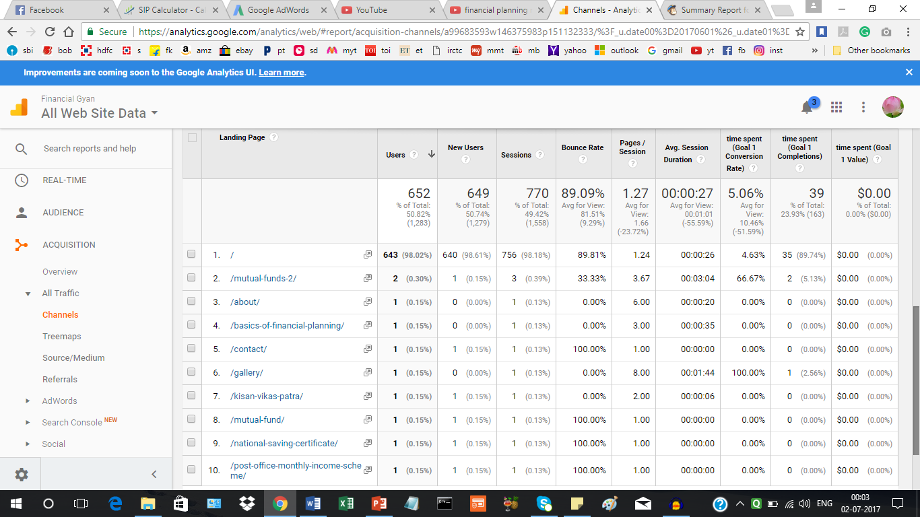

Social Facebook:

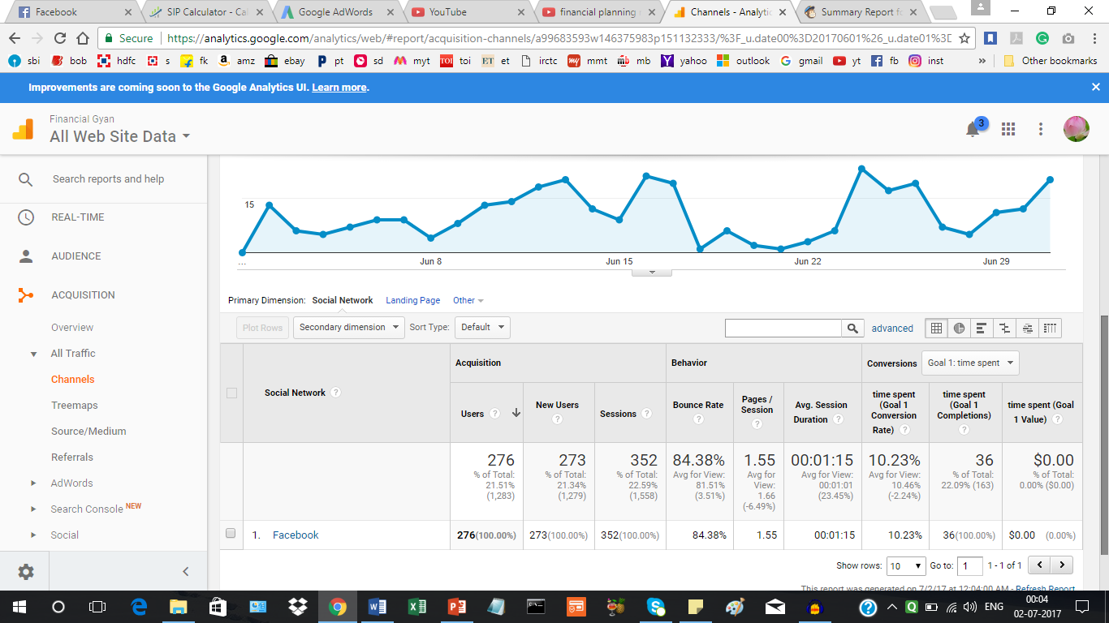

Display adwords campaign:

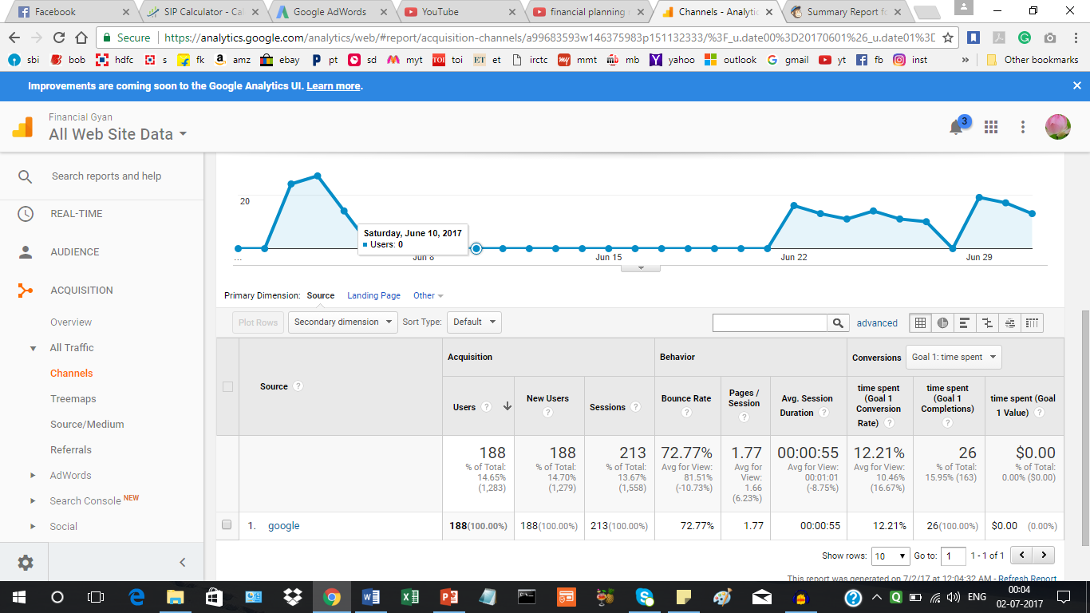

Search Campaign:

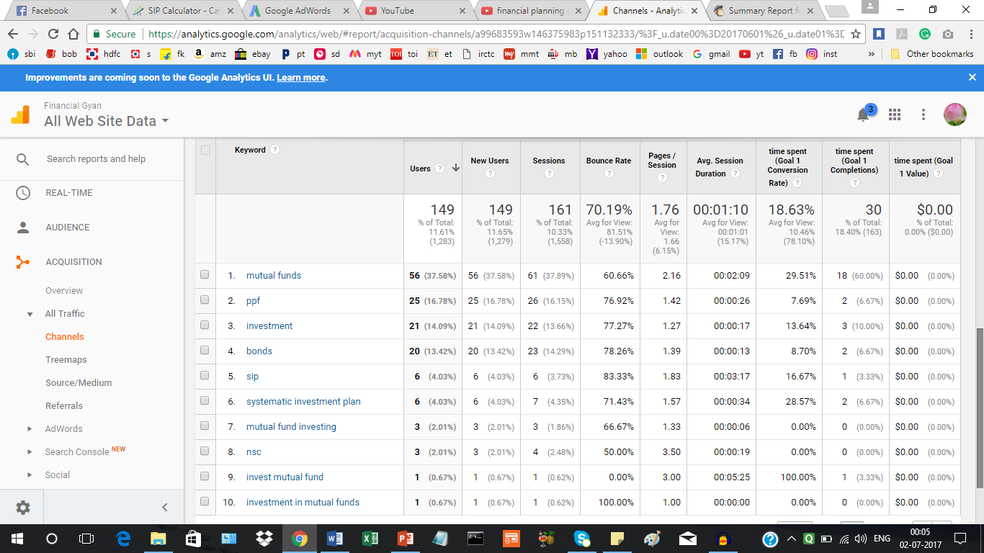

Email campaign:

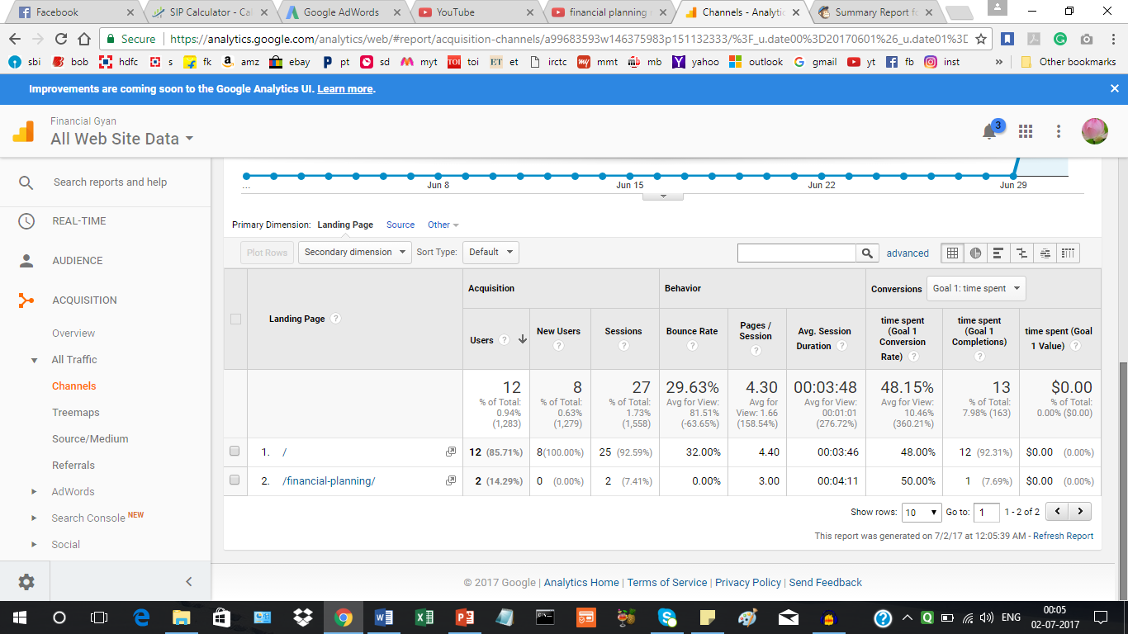

Organic search:

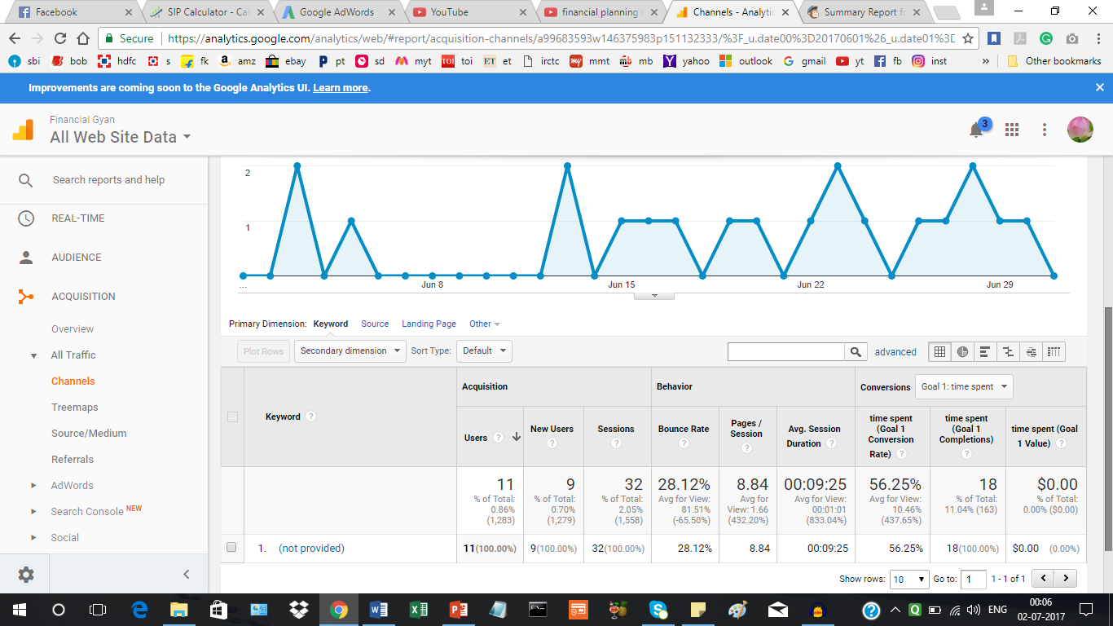

Referral:

